INTERDISCIPLINARY STEM SEMINAR SERIES

(Science Technology Engineering Mathematics)

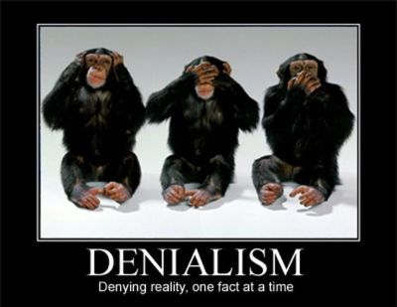

Science vs. Science Denial

Monday, September 23rd, Reuter Center, Room 102A
4:30 PM to 6:00 PM

Speaker: Howard Jaslow, OLLI

This is the first in a series of lectures on Science vs. Science Denial. This series is especially important today in light of the current state of science denial, which is having a detrimental effect on health, the environment and the progress of science.

Covered in this lecture will be the sciences denied, denial factors, and the organizations denying science and their denial strategy. Then, those advocating for science and their approaches will be presented. Finally, for the sciences and technologies that are accepted as valid, there will be a discussion on science constraints with respect to long term concerns, ethics and dangerous consequences if pursued.

Subsequent lectures will go into more detail on the value and importance of science, climate change, vaccination, evolution, and ethics.

