April 2020
Staying Well and Staying Informed during the COVID-19 Pandemic
Resources to stay informed:

California Department of Public Health - COVID-19
Website: cdph.ca.gov/covid19 Info
COVID 19 Information Line:
For General Public Information:
(916) 558-1784
COVID 19 Information Line:
1-833-544-2374

What should you do if you think you're sick?
Call ahead: If you are experiencing symptoms of COVID-19 and may have had contact with a person with COVID-19, or recently traveled to countries with apparent community spread, call your health care provider before seeking medical care so that appropriate precautions can be taken.
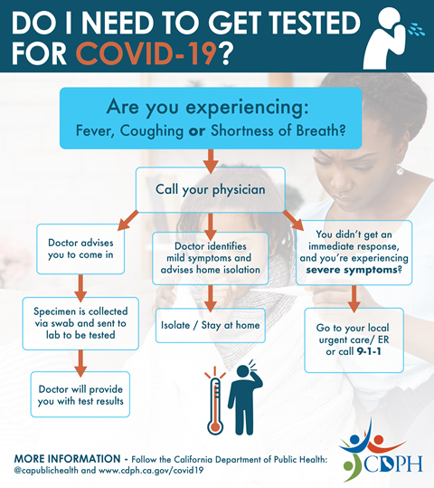
Necesito Hacerme La Prueba Del Covid-19? (PNG)

What if I don’t have health insurance and I need screening or treatment for COVID-19?
- Check with your local community health center or hospital to see if fees for testing can be waived
- See if you’re eligible for Medi-Cal
- See if you’re eligible for Covered California
https://www.sandiegocounty.gov

Relevant and Informative Resources
- County of San Diego: Coronavirus Disease 2019 (COVID-19) Website
- CDC: Mental Health & Coping During COVID-19
- CDC: Stigma and Resilience During COVID-19
- CDC: Helping Children Cope with Emergencies
- SAMHSA: Taking Care of Your Behavioral Health: Social Distancing
- California Department of Public Health: Guidance Documents
- Administration for Community Living: Adults with Disabilities and Seniors (also available in Spanish)
- CDC.gov

Online and Phone Supports

Access & Crisis Line: If you need support or are actively seeking services, please call the ACL at 1 (888) 724-7240, and an experienced counselor will provide you with a referral to meet your needs and help determine eligibility.
- 2-1-1 San Diego: Dial 2-1-1, or visit www.211sandiego.org, for access to community, health, social, and disaster services. The call is free, confidential, and available in more than 200 languages with access to 6,000+ services, resources and programs through our online database.
- SAMHSA's Disaster Distress Line: Call 1-800-985-5990 or text TalkWithUs to 66746 to connect with a trained crisis counselor
- Teen Line: Phone lines will temporarily be closed starting Friday March 13th, text lines and email will remain open. Text "TEEN" to 839863 between 6:00pm-9:00pm PST to receive person teen-to-teen education and support.
- The Peer-Run Warm Line: Call 1-855-845-7415 for peer-run non-emergency emotional support.

Local and health authorities on Twitter

Twitter Results

CDC
@CDCgov

Most people who get #COVID19 will get better at home. If you are caring for someone who is sick: Have the person stay in a separate room and use a separate bathroom (if possible). • Check how they are feeling but limit face-to-face contact. More tips: bit.ly/3a5uKZo.
Twitter · 1 hour ago

Office of the Governor of California
@CAgovernor

CA is fighting to protect those who are protecting us. Starting tomorrow, CA will provide frontline health care workers with hotel rooms at no-or low-cost & free flights for CA's Health Corps. #StayHomeSaveLives

Mary Patterson
Health@ninthdistrictpta.org

