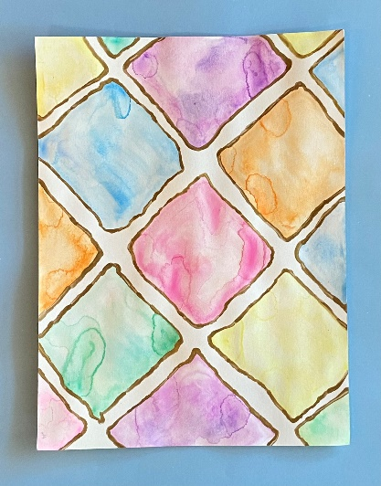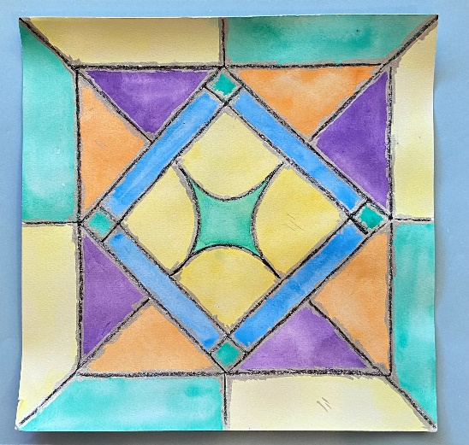

Stained glass lesson

This is a lesson for all ages! Here is a materials list by age. We will be giving away some metallic finishing supplies during the Zoom lesson so make sure to attend!
Early elementary possible supplies: crayons, watercolor
- paper plate with the middle cut out-you will need wax paper and tape
- plain white paper or watercolor paper
- construction paper
Upper elementary possible supplies: markers, watercolors, or colored pencils
- plain white paper or card stock
- watercolor paper
Middle school to adult supplies: paint pens, watercolor, Sharpies, iPad
- Watercolor paper or card stock

Copy or design a block pattern for the stained glass. It could be a simple block pattern that you draw ahead of time for little kids to paint or color. Or cut blocks of construction paper to assemble between sheets of waxed paper. For older kids/adults make your design as complicated as you want! Here are some samples:
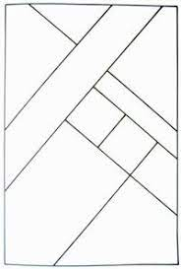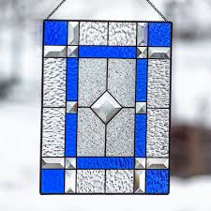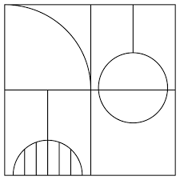

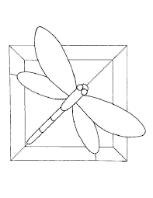

If you use crayon or oil pastel for your lines, and then paint with watercolor, the paint will not jump the lines. You can color with markers, colored pencils, crayons-whatever you have.

After the lines and sections are filled in, you can finish by coloring some metallic silver or gold around the lines to make it look more like stained glass.

