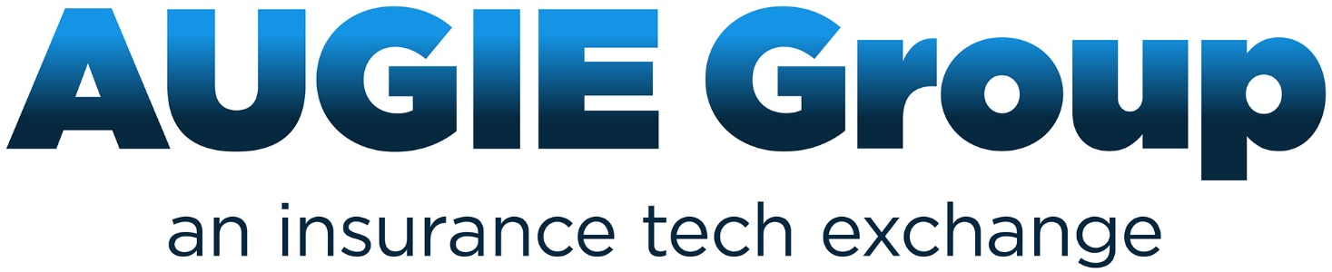

Claims Download:

Guiding

Principles

ABOUT AUGIE Group
AUGIE Group is a community of communities who support the discussion and implementation of technology that improves the efficiency of the independent agent and broker distribution channel.
AUGIE Group is the only forum where agents, brokers, carriers, MGA/Wholesalers, solution providers, association representatives and others may come together to discuss industry issues and opportunities. AUGIE Group forum topics include
- Key industry subjects
- Efficiency issues that may be resolved through technology. For example the sharing of data, documentation and information, by industry partners
- Advocacy, communication, and how to reach more of the industry to assist them in understanding the business reasons for implementing and/or using the technology available to them
AUGIE Group engages Ambassadors. AUGIE Group Ambassadors are individuals who assist in communicating, educating and speaking at industry events, on the topics discussed and documents developed by the AUGIE Group members.
Individuals become members of AUGIE Group to be “in the know” and advance a great cause. Everyone who participates in AUGIE Group is considered a member and there is no fee to participate in AUGIE Group. Anyone, who has touch points in the independent agent and broker distribution channel, is invited to be a member of AUGIE.

Table of Contents
Purpose & Goal of this document 5
Key Stakeholders who should read this document 5
What is Claims Download? 6
Claims download is implemented based on six categories of information or transaction types: 6
Events that Trigger a Claim Download transactions: 6
Why is Claim Download important to the industry? 6
For agents: 6
For carriers: 7
For vendor partners 7
How often are claims download be sent? 7
What is the difference between Claims Download, eServicing (Real-Time), eDocs &/or Messages? 8
Does Claims Download save time? 8
Overall Industry statistics 8
Time savings specific to the agency - the IVANS Download Calculator 8
Guiding Principles for development and implementation (carriers & vendor partners) 9
For all Transaction types: 9
Transaction Categories 10
Claim Number Assignment (CLN) Transactions: 10
Claims Information (CLI) Transactions: 10
Adjuster Assignment (ADJ) Transactions: 10
Claim Reserve (RES) Transactions: 11
Payment Information (PMT) Transactions 11
Claims Status Update (CLS) 11
Certification 11
What can agents expect to receive with each transaction type? 11
Claim Number Assignment (CLN) Transactions 11
Claims Information (CLI) Transactions: 12
Adjuster Assignment (ADJ) Transactions: 12
Claim Reserve (RES) Transactions: 12
Payment Information (PMT) Transactions: 12
Claims Status (CLS) Transactions: 12
What should an agency do to get started with Claims Download? 13
What should agencies do when they identify an issue or errors with your claims download? 13
Frequently Asked Questions about Claims Download 13
Appendix: 16
AUGIE Group Excel 16
Links to: 16
Acknowledgements: 16

Purpose & Goal of this document

The members of AUGIE group identified claims download as one of its high priority initiatives to advance, improve and promote industry wide. They have discussed a number of opportunities to improve claims download which include but are not limited to:
- Inconsistent implementation of the data fields documented in the industry standards
- Low adoption by carriers and vendors
- Slower than expected usage by agents and why
Members of AUGIE Group recognize the value of claims download and its great potential for improving efficiencies in agent’s offices, reducing expenses for carriers and offering the end consumer a much improved customer experience. This initiative has brought together industry volunteers who are identifying the major pain points, providing the industry with guidance and advocating for expanded consistent implementation of claims download by the carriers and vendors. As well as educating the agents on what to expect when they receive claims download to increase usage by agents and brokers.
This document provides:
- Agencies with a comprehensive guide to understand how to maximize use of claims download, and advocate for improved claims download, so they can offer their clients the best service possible during stressful or traumatic times.
- Carriers and vendors with the materials needed to develop a high quality claims download solution their agents will want to utilize, that is consistent across the industry so that independent agents have a similar workflow with all partners.
Key Stakeholders who should read this document

Stakeholders | Agencies | Carriers | Vendors
- Management | - Agency Principals  - Office Managers | - Carrier management  - Decision makers | - Vendor Management
- Staff | - Agency CSRs  - Claim staff | - Technical implementation Teams | - Technical implementation Teams

What is Claims Download?
Claims download is data that is sent electronically from a carrier’s claim system directly into the agent’s management system. It allows a company to share claim information to keep agency personnel up-to-date throughout the claim lifecycle.

Claims download is implemented based on six categories of information or transaction types:
- Claim Number Assignment (CLN) - This data is sent when a claim has been reported directly to the carrier and the claim is first opened.
- Claim Information (CLI) - This category is used to provide generic data that has not been handled by the other categories of codes. For example if you add a claimant, don’t send a CLN, update the date of loss or want to send the entire claim record.
- Adjuster Assignment (ADJ) - This data provides adjuster information and adjuster updates.
- Claim Reserve (RES) - This data is sent when the reserves are set or changed.
- Payment Information (PMT) - This data is sent when any type of a payment is processed.
- Claim Status Update (CLS) - This data is sent because the claim is closed or re-opened.
Note: Attachments are not supported in the claims download standard. Claims documents and supporting collateral may be downloaded using eDocs and/or messages.

Events that Trigger a Claim Download transactions:
- Open, close, reopen claims
- Assign, update/change adjuster info
- Assign, update/change claimant info
- Make a payment. Indemnity or expense
- Receive salvage or subrogation payments
- Set or change reserves

Why is Claim Download important to the industry?

For agents:
Think about this scenario: Practically every day we hear on the news how climate change is causing increasingly worse natural disasters. Hurricanes, tornadoes, forest fires, mudslides, massive snow and ice storms. When (not if) these catastrophes occur in your area, what do you want your staff doing? Rekeying massive amounts of claims information into your agency management system to keep it up-to-date or helping your clients during a very stressful and traumatic time?
Many of your clients report the claim directly to their carrier. The carrier lets you know about the claim through claim email notifications of some sort. You may then be encouraged to secure more information on the carrier’s website. You review the information by signing into the carrier’s website, or using eServicing (Real Time) claim inquiry. This is a way for you to view the client’s claim only. It does not update your management system with any claim data. It could provide an activity that you inquired to the status of the claim on the carrier’s website if you have opted to enable an activity for that Real Time transaction. The alternative is to use claims download which provides the data about the claim directly into your agency management system.
Many carriers are starting to introduce “near real time” or “instant” claims download so agencies receive updated claim information multiple times throughout the day. In addition, this supports the concept of extending the claim information to an agency’s customer facing portal (once again, without any rekeying) in order to support the ever increasing need to offer “e-Service” capabilities to your insureds.
In order for independent agents to compete successfully, they need to operate as efficiently as possible and take full advantage of all tools available to them. Claims download, when provided by all the agent’s carriers, will allow agencies to have one consistent workflow in their offices. Agents currently have to deal with multiple workflows, which include emails, faxes, logging into carrier websites to piece together the current status of a claim, or finding it in their agency management system. Information in the agent’s agency management system improves the conversation with the client when they are on the phone waiting for answers.
As more and more carriers make claims download available to their agencies, the closer we become to eServicing all of our client’s needs.

For carriers:
Carriers offering claims download receive less phone calls from agency personnel looking for claim status or claim adjuster contact information, therefore, reducing claims handling expenses. In addition, their agents are able to review loss reporting within their own systems, which allows them to improve on loss ratios and council clients with high claim frequency well before the carrier sends them a quarterly report.

For vendor partners
Vendor partners who support claims download help independent agents service their customers and compete with direct writers making their investment in their Agency Management System more valuable to them.
This guide will provide you with information on how to implement a quality claims download.

How often are claims download be sent?
Typically, most carriers send at a minimum of once per day. However, there is a growing trend to send more frequently or “near real-time”. Some send three to four times per day or as often as hourly. This allows the agency to always have the most current information which is especially important during a catastrophe situation in their area or to be notified very quickly of a time sensitive claim i.e. a house fire or fatal car accident allowing the agency to be proactive in the situation

What is the difference between Claims Download, eServicing (Real-Time), eDocs &/or Messages?
Note: the industry is moving from the term Real-Time to eServicing.
- eServicing (Real Time) Claims Inquiry: This feature allows a user to initiate a transaction from within their agency’s management system in real time and either receives an immediate response back from the carrier or the user is navigated to the appropriate place within the carrier’s “agent only” website to obtain the information.
- eServcing (Real Time) Loss Runs: Follows the same process as any other inquiry transaction with the agent’s system. In this case the agency management system initiates the transaction that provides back a PDF of the historical loss run report. Agents use this for remarketing an account.
- First Notice of Loss (FNOL) Upload: This is a real time transaction that allows an agency to file a claim with a carrier on their client’s behalf by reusing data already captured within their client record, in their agency management system.
- Claims download: Allows carriers to send pertinent claim data to the agent’s management systems.
- Claims eDocs &/or Messages: A type of download that returns a document or message in the download file. It is information that supports the claims download, provides additional information that may have previously been sent, for example through email. Note: Additional information about eDocs &/or Messages may be found on www.augiegroup.org
- Carrier claims status eMail Notifications: Some carriers offer email notifications of claim activity. There is no established standard for these notifications so what is sent and when will vary by carrier.
Note: Not all Agency Management Systems support all these transactions. State exceptions may also exist. Check with your vendor partner for more information on what they support.

Does Claims Download save time?

Time savings specific to the agency - the IVANS Download Calculator
Is your agency using download to the fullest extent? If not, you’re leaving valuable time and money on the table. By using all of the download connections available, your agency can realize significant time and cost savings. To find out just how much your agency can save, click on the link to the calculator below to compute total weekly savings in both hours and dollars

IVANS Download Savings Calculator
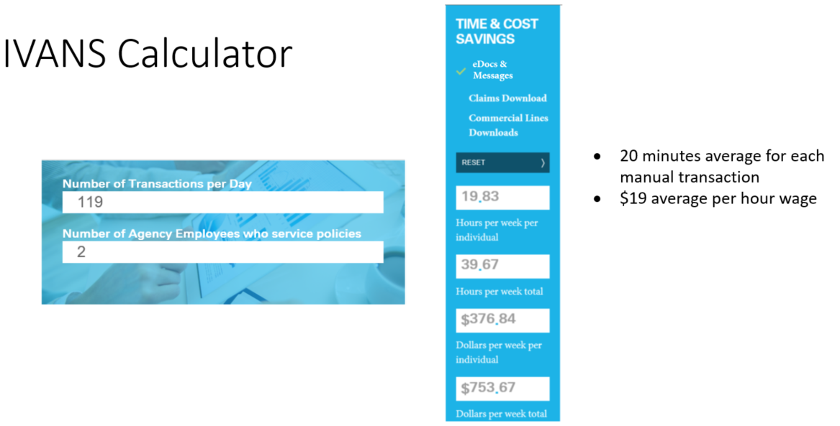

Guiding Principles for development and implementation (carriers & vendor partners)
The following are identified “guiding principles” recommendations to keep in mind when developing or modifying a claims download solution. It is recognized that carriers and vendors, may not be able to implement all of the recommendations but instead serve as a goal our industry can work towards over time.

For all Transaction types:
- Validate with your agents or technology council, what data they would like you to send
- Determine if you are building it yourself, or hiring services to build or rebuild your Claims Download transactions
- If building it yourself obtain
  - ACORD Specifications
  - a copy of the AUGIE Group Claims Data Guide Excel
- Certify your implementation with all of the agency management systems
- Run a pilot with each system to ensure the transactions are tested.
- Allow agent’s to set preferences (or opt out) for types of Claim DL transactions they receive.
(Examples) Ability to opt out:
  - by Transaction type (ex: receive CLS but no ADJ)
  - by Persona Lines versus Claims or Line Of Business
  - by Type of claim (ex: do not send glass claims)
  - of receiving loss description or being able to retain the agent entered loss description and the carrier description
- Review this guide and supporting excel document to understand the purpose of each of the six transaction groups. Do not send transactions as CLI if another transaction type better depicts the type of data you are sending i.e. if ADJ only, don’t send a CLI as well.
- Ensure that the Information sent in claims download is the same data that is posted on your Carrier Portal for the agents to access information.

Transaction Categories
The transaction categories which are mentioned previously, build upon each other. The AUGIE Group Claims Data Guide Excel provides a guideline on what should be sent with each transaction category however; here are some “Best Practices” for use of the various codes

Claim Number Assignment (CLN) Transactions:
This data is sent when a claim has been reported directly to the carrier and the claim is first opened. It provides the claim number and the details on the claim
- The claim number assigned should be sent to notify the agent that a claim has been reported. The number that is sent in the download must match what appears in the carrier portal.
- This should be sent on all new claims vs. a CLI for easy identification for the agent that it is a “new” claim

Claims Information (CLI) Transactions:
This category is used to provide generic data that has not been handled by the other categories of codes. For example if you add a claimant.
- Use this transaction for Initial Loads
- Use this transaction for a full claim sync or update if an agency requests
- Use this transaction to update a Date of Loss or Claimant
- Don’t use this if an ADJ, PMT, CLS or RES is the only update on the claim
- Don’t send both a CLI and for example an ADJ if just the Adjuster is added or changed

Adjuster Assignment (ADJ) Transactions:
This data provides adjuster information and adjuster updates.
- Do not sent ADJ notes containing Personally Identifiable Information (PII), Sensitive Personal Information (SPI) or Health Insurance Portability & Accountability Act (HIPAA) information
- Do not send remarks longer than 500 characters.
- Check with each system provider to determine if they download remarks.
- Include Adjuster information (name, email address & phone number with extension) and date created
- Support ADJ telephone number (Carriers & Management Systems)
- Identify Inside Adjuster vs 3rd party claim adjuster
- Support a change in assigned adjuster
- Indicate which coverage part the adjuster is assigned to (ex: liability vs physical damage)

Claim Reserve (RES) Transactions:
This data sent when the reserves are set or changed.
- Reserve amount should be replaced, not the difference
- When a claim is closed, the reserve amount should reflect “0”
- When a payment is, updated reserve amount should also be sent (including reopens)
- Salvage & Subrogation recoveries should be separated out from other reserve adjustments

Payment Information (PMT) Transactions:
This data is sent when any type of a payment is processed.
- Connect payments with claimants when possible
- Back out payments
  - No match on check number – send negative amount of previous positive amount
  - Match on check number – send zero
- If payee name cannot be included due to privacy or legal reasons, send “3rd party” instead of blanks.
- Send both Indemnity as well as Expense payments and identify each type
- Send Salvage and Subrogation payments and identify each type
- When sending payee name that is a claimant, label as claimant
- Expenses should be separated out when sending payment transactions

Claims Status Update (CLS)
This data sent because the claim is closed or re-opened.

Certification:
The transaction must be certified by the partners to ensure a quality download.
- Send a broad range of files to the agency system providers to certify that includes multiple lines of business and transaction types
- Re-certify every two years

What can agents expect to receive with each transaction type?
Specifically, what data is sent with each transaction type can vary by carrier and agency management system. However generally speaking, agents should receive the following.
Claim Number Assignment (CLN) Transactions:
- All the information the carrier has knowledge of at time of First Notice of Loss Reporting, including but not limited to:
  - Claim number assigned by carrier
  - Carrier Info – Issuing & billing company
  - Policyholder info – Name & Address
  - Policy info ex: policy number, LOB, Effective/Expiration Date, NAIC
  - Claim Type: Auto, Liability, Property or Work Comp
  - Claim info - ex: Date of Loss; Date reported, status, loss description
  - Adjuster info – ex: Name, phone #
  - Claimant info – ex: name, address, phone

Claims Information (CLI) Transactions:
- When applicable after a CLN has been sent or if one has not been sent and any updates to the following should be included:
  - Carrier Info – Issuing & billing company
  - Policyholder info – Name & Address
  - Policy info ex: policy number, LOB, Effective/Expiration Date, NAIC
  - Claim info - ex: Date of Loss; Date reported, status, loss description
  - Claimant info – ex: name, address, phone

Adjuster Assignment (ADJ) Transactions:
- Adjuster’s name
- Adjuster’s phone number including extension
- Adjuster assigned date

Claim Reserve (RES) Transactions:
- Reserve amount
- Change in reserve amount

Payment Information (PMT) Transactions:
- Amount of payment
- Payee name
- Date of payment
- Payment type – expense, indemnity

Claims Status (CLS) Transactions:
- Claim opened, closed, reopened, subrogated or declined

What should an agency do to get started with Claims Download?
–TEST TEST TEST
- Check with your agency management system vendor to verify they support claims download.
- Document how the process will change, once you use claims download. Many times the Agency Management System Users Groups can provide insight on the processes.
- Identify the individual that will lead the advocacy, education and implementation of claims download in your agency.
- Use your IVANS Connections report to determine which of your carriers offer claims download.
- Check the carrier’s Agent’s Portal or contact their interface support unit to find out what lines of business and/or states they support for claims download
- Turn on claims download one carrier at a time, and test a few transactions. Provide feedback to your carriers and agency management system vendor on what features you like or suggestions for enhancements
- If something is not working as you expect, look for a work-around that would allow for your agency to still get the benefit of claims download

What should agencies do when they identify an issue or errors with your claims download?
- First, document the issue. Clearly describe what is occurring, and what you believe should have occurred.
- Include claim number, policy number, insured’s name, screen prints, transaction date.
- Report the issue to your agency management system provider in a timely manner. If issues are reported late, sometimes they can’t be recreated and researched.
- The agency management system provider should determine if this is an issue originating from your system or if it is a carrier issue.
- If it’s a carrier issue, your system provider should report it to the carrier to research and hopefully resolve.
- If it’s an agency management system implementation issue, they should address the issue and work on an enhancement to rectify as soon as possible.
- Notify your Agency Management System Users group so they can be your advocate for any Agency Management System specific issues.

Frequently Asked Questions about Claims Download
Q. What is Claims Download?
A. Claims download occurs when a carrier sends data about a claim to the agent’s management system.
Q. What Agency Management Systems support Claims download?
A. Here is a list Column
- Agency Matrix
- AgencyPro
- AgentDesk
- Applied Epic
- Applied TAM
- Applied Vision
- Applied CanaryAMS
- EZLynx
- Hawksoft
- NASA Eclipse
- Nexsure
- PowerManage from Quomation
- Partner Platform
- Vertafore AMS360
- Vertafore QQCatalyst
- Vertafore Sagitta
- Xanatek
Q. Which carriers support claims download?
A. Here is a list found on IVANS Exchange [need link]
Q. What type of set up is required in my Agency Management System to support Claims download?
A. Check with your Agency Management System provider. Also, if you have an Agency Management System User Group, they may have helpful information.
Q. Is there a cost for an agency to receive Claims Download?
A. No, there is no cost to agents & brokers to receive Claims download provided they are set up to receive download in their agency management system.
Q. What types of claims are supported by Claims download?
A. This may vary by carrier. The industry standards support all Auto, Property, Liability and Work Comp claim types across all corresponding lines of business.
Q. If I am not receiving any download today, can I still receive Claims download?
A. You need to work with your agency management system provider. As each Vendor handles differently a few items you will want to check on:
- Do you have an IVANS Y-Account? If not, one of your carriers will need to set one up for you.
- If you have a Y-account and want to add Claims download, see additional resources below on using IVANS Exchange and adding download types from different carriers. Or email Connections@ivansinsurance.com for more information.
- Are you with a vendor who has a different type of configuration to receive claims download i.e. AMS360 uses TransactNow for the receipt of Claims Download (we can have Nellie or Kristen review this)
Q. Can I receive Adjuster Notes through Claims download?
A. This varies by carrier but many carriers offer Adjuster notes.
Q. How often will I receive Claims download?
A. This varies by carrier, however, many carriers are starting to send claims download more than once per day.
Q. Can I choose which transaction types or lines of business I receive claim download for?
A. Most carriers do not offer claims download by transaction type or line of business, however, check with your carrier to confirm what they offer. Some do have capabilities to include just Personal or Commercial claims.
Q. Will claim download overwrite data in my agency management system?
A. If your agency is currently manually entering data into the system prior to a carriers download, please check with your agency management system provider to learn how your claims download will work.
Q. If I’m not sure who to contact for a specific carrier to find out more about Claims download how can I get this information?
A. The IVANS Connections team has contact information for hundreds of carriers. You can email them at: Connections@IVANSInsurance.com

Appendix:

AUGIE Group Claims Data Guide Excel
The AUGIE Group excel contains information that will assist interested parties in knowing what elements will be sent in a transaction category. Columns have been added to recognize the following:
- AUGIE Group Recommendation - Industry volunteers have determined the following:
  - Recommended – AUGIE Group recommends that the element is sent. In columns F-K, you will see an (S).
  - Required – AUGIE Group has identified what they feel is required. In columns F-K, you will see an indicator for what is necessary (X) for the transaction to be processed, or if there is value for the agent to receive (S) the data.
  - NOTE: this is a guideline until the “Platinum Download” program is initiated by IVANS. At that time, there will be industry measurements defined to validate the overall quality of the carriers download.
- Category – The claim data elements are split into categories. The excel may be filtered to recognize the elements that fall under the categories below
  - AdjusterInfo - ?
  - ClaimantInfo - ?
  - ClaimInfo - ?
  - InsuredInfo - ?
  - PaymentInfo - ?
  - PolicyInfo - ?
  - Required – this is a system requirement
- Value of the element – The value of the data to the agency has been indicated
  - Service
  - Service & Analytics
  - System Requirement
- Columns “F through G” have been added to allow AUGIE Group to develop a grid showing why the element should be sent or not under the six transaction types. Each element has one of the indicators listed below.
  - “X” identifies the element that should be sent with the transaction.
  - “S” identifies information that is supplemental to the transaction that is being sent.
  - “N” identifies information that should not be sent.
  - NOTE: If there is a specific code that would be sent, it is also indicated.
- Description – is a general description of the element
- Comments have been added to provide additional information.
- Columns M through AG provide a sampling of six carriers who are currently sending claims download and the elements discussed by the AUGIE Group Volunteers.

Links to:
- IVANS Building Effective Messages
- IVANS Agency Management System Connectivity
- IVANS Use Case
- AUGIE - https://augiegroup.org/resources-toolkits/
- Agency management systems that support claims download:
  - Applied Systems: Report enhancements under: https://appliedsystems.brightidea.com
  - Vertafore: Report enhancements under: https://www.netvu.org/web/Online/Advocacy/IDEAS/Online/Advocacy/IDEAS.aspx?hkey=128457e7-e520-46bf-8bad-33779cfcb234
  - Others

Acknowledgements:

Glossary?

