LII JOURNAL OF ANTHROPOLOGICAL RESEARCH DISTINGUISHED LECTURE

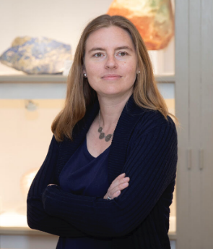

Christina Warinner
Harvard University & Max Planck Institute

Monday, March 28: 7:30 P.M., Anthropology Lecture Hall (Rm. 163)
The evolution and changing of the human microbiome
Abstract: Humans have a deep and complex relationship with microbes. Beyond disease, microbes also profoundly shape human health and behavior through their activity in the microbiome and their diverse roles in food and cuisine. And yet we know very little about the origin, evolution, or ecology of the trillions of microorganisms that call us home. Recent advances in genomic and proteomic technologies are opening up dramatic new opportunities in the field of microbial archaeology, allowing us to investigate the complex and diverse microbial communities that have long inhabited our human bodies and our food systems - both in sickness and in health. From epidemic disease to alcoholic beverages, microbes have influenced the course of human history. This talk discusses how emerging research on microbes is impacting how we investigate the human past and changing how we understand human and microbial cultures today.

Specialized Seminar: Tuesday, March 29: 12 noon, Anthropology 178
Archaeology of the invisible
Abstract: Advances in scientific technologies are transforming our vision of the past and opening our eyes to a vast new kind of archaeology – an archaeology of the invisible. This talk focuses on recent microscopic and biomolecular discoveries that are revealing unprecedented detail about the human past and expanding our understanding of ourselves and the ancient world.

CURRENT UNM COVID 19 REGULATIONS REQUIRE PROOF OF FULL VACCINATION (UNM ID OR VACCINATION CARD) AND INDOOR MASKING AT ALL TIMES.
Both events are free; wheelchair-accessible. If you do not have a UNM permit, please park in a metered space along Redondo Rd. or Las Lomas to avoid a fine. The Journal of Anthropological Research has been published quarterly by the University of New Mexico since 1945.
To subscribe: journals.uchicago.edu/JAR Distinguished Professor Lawrence Guy Straus , Editor-in-Chief.

