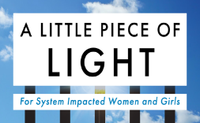
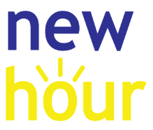
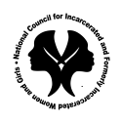

Reimagining Communities Through Clemency
The National Council for Incarcerated and Formerly Incarcerated Women and Girls is Reimagining Communities Through Clemency. We are compiling the names of women incarcerated in state prisons throughout the country who are elderly, long-timers or infirm to include them in a national state prison clemency campaign. Please provide the following information if you would like to be included on our national clemency quilt. We will contact her and include her in the national campaign.
Your Name (Last, First) ________________________________
Contact Information (email and phone) __________________________________
Incarcerated Woman’s First and Last Name______________________________
DOC #_________________ Race ______________ Age _________
Where the incarcerated person is located (city, state, name of prison) ________________________________________________________________________
Are you from the state you are incarcerated in? (If not, what state are you from?) ______________________________
Reason Needing Clemency
⬜ Long Timer (person has served a minimum of 10 years) ⬜ Elderly person
⬜ Infirmed (Sick Person) ⬜ Survived and Punishment ⬜ All of the above
⬜ Other (explain) ______________________________________________________________
Date of Conviction? ____________________ Length of Sentence ____________________
What was the person convicted of?
____________________________________________________________________________
Have you previously applied for clemency? If so, when? ____________________________
If you have applied for clemency, is it still pending? ____________________
Please give us any other information you think may be pertinent
_______________________________________________________________________________________________________________________________________________________________________________________________________________________________________________________________

