EXHIBIDOR FEST ARG IN FOCUS
CEOs FROM VIRGINIA AND ARGENTINA WILL VISIT THE STAND OF THE FESTIVAL ARGENTINO USA AND ARTIST SHOW.

On Friday, June 1st, the CEOs of the Northern Virginia Delegation, Art Galley Espíritu Parrillero from Argentina, will visit the Embassy of Argentina as part of a preview visit to the Argentine Asado & Artist Show Festival. Subsequently, on June 1st, the main event will take place at Kenmore School of the Arts. The 37th Argentine Festival will feature performances by international artists and facilitate meetings between Argentine exhibitors and their Latin American and American counterparts, who will participate in both the Argentine stand and the Exhibitor Fest.
After two editions, this year the festival returns to its traditional format with notable improvements, attracting an estimated participation of around nine hundred people and over 37 exhibitors. Argentine authorities, including the Consul of Washington DC, Minister Juan M. Cortelletti, along with officials from Fairfax, Arlington counties, and the District of Columbia, will tour the Argentine-Latin American stand, exhibitions, and festival activities.
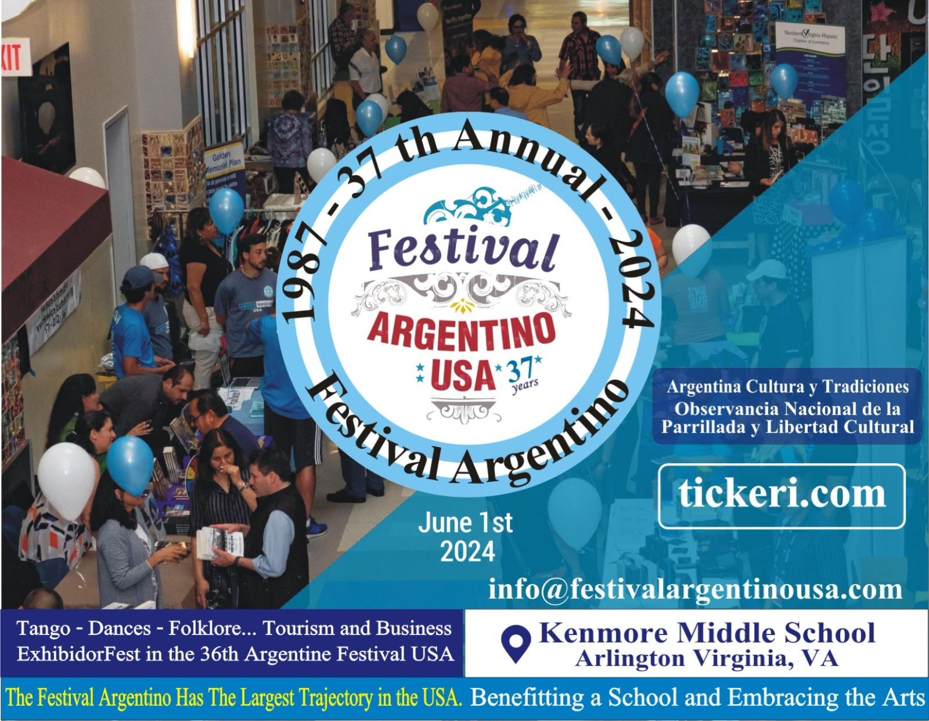
The Argentine Asado & Artists Show Festival boasts the fair with the widest trajectory in the capital of the USA.
This important event is primarily aimed at the American community, the Latin American community in the United States, as well as Central and South America. It represents an excellent opportunity to establish contact with the most important counterparts both locally and on the continent. In addition to Argentina, participation from organizations from Bolivia, Colombia, El Salvador, Peru, the United States, and other countries is expected. Furthermore, the presence of visitors and participants from Argentina is anticipated in this edition of the festival.
Committee of Virginia, Arlington County, Visit Fairfax , Latino Alliance USA, will showcase 37 companies offering a wide variety of products and services. From delicious "choripanes" to tasty empanadas, tourist guide packages, and a diverse range of artisanal products and services will be available for visitors.
Argentine stand at the Exhibitor Fest & Artist Show.

