Become an Exhibitor

15 spots left!
On Saturday, Sep 18, 2021, the Greater Washington business community and the Festival Argentino are hosting Promoting Artists and Arts Cultural Equity at Exhibitor Fest targeting those interested in connecting with visual arts, crafts, tech, product & services, music performances, networking and more.
Simultaneously, vendors from the DMV will be able to speak to some of the best and brightest participants from DC Metro, Arlington National Landing and Events DC support!
Join the ranks of reputable vendors already gaining visibility from their sponsorship or exhibitor package.

Why Exhibit?
The Festival Argentino USA and Exhibitor Fest provides an opportunity for participants to speak with more than 1,000 attendees about their products and services.

Showcase Your Business
Display your Products Showcase your services Connect with clients and so much more
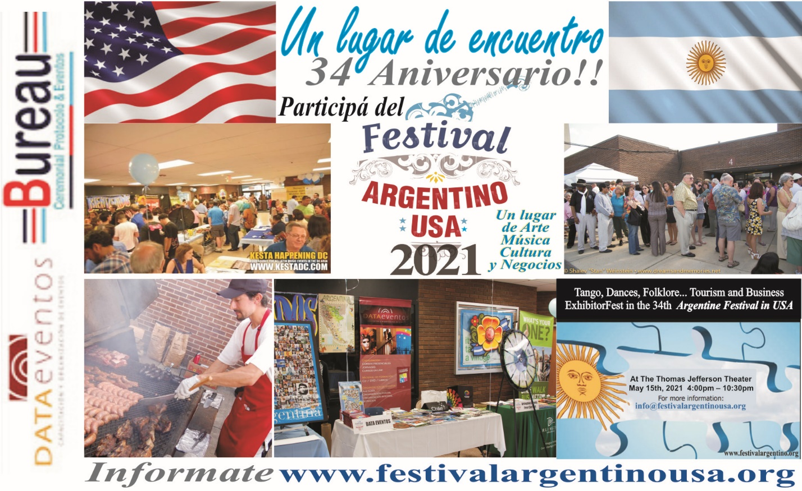
Learn more about how being an exhibitor or being a sponsor can bring your company new visibility & leads. Profile Exhibitor Fest and Profile Excellency
Sep 18 is quickly approaching...so don't wait!
If you have already signed up as an exhibitor or sponsor for the 34th Festival Argentino 2021, then thank you so much! We truly appreciate you and look forward to seeing you at the Exhibitor Fest
Also, if you haven't done so already, don't forget to answer by email to attend the event!
In service,
The Festival Argentino USA Team
Greater Washington Business Community and Festival Argentino USA and more…
Arlington County Univision El Imparcial Gestion Argentina Data Eventos and more to be confirmed

PRESENTING SPONSOR

Giant

SUPPORTING SPONSOR

Yas Media

GAUCHO SPONSOR

Come and shop with your family and friends. Are you a sponsor, vendor, artist, or crafter seeking detail festival & event info to sell work? Learn more by writing to Info@festivalargentinousa.org or 703.212.5850
Retail Booths… Opportunities and Growth

Sep 18, 2021 • 4:00pm - 9:00pm – Thomas Jefferson Theatre

Ticket-Donator-Raffle Admission!

The Argentine Festival Exhibitor Fest. An event for showcasing arts and crafts, businesses and building connections face to face. This annual event will help your business to find new opportunities in our expanding festival! The fest has served since 1987 about 33,605 individuals. The longest trajectory in the USA!

What to do at the Fest Exhibitor Fest?

-Connect with Local and International Community
-Attend Annual Festival - -Explore new opportunities with diverse audience
- Argentina Festival in the Thomas Jefferson Community Center
Exhibitor Fest, Exhibitor Fest, and Exhibitor Fest — Join us for the ExhibitorFest
At the Hall of the 125 S. Old Glebe Rd , Arlington, Virginia

SEP 18th 2:30pm set up Opens at 4pm ending exhibits up to 10:50pm
Type of craft or merchandise that I will sell ____
From what Country:
- One table reserved this includes a table, 6-8 feet rectangular, two tickets, one chair, tablecloth and cartelito/sign with your business name. Here is the cost: $250. It is already discounted! (Includes ticket for two booth attendants). Should you need extra ticket for attendance you must pay extra $20 dollars.
- See attached file so called Exhibit Booth Instructions.

- I did not reserve a table but will bring my own tent, set up 6-8 feet rectangular table, including maximum one Chair. The cost will be $ 125 SPECIAL LOYALTY DISCOUNT. (Includes ticket up to two attendants). The extra cost $20 dollars if you need additional person).
- See attached file so called Exhibit Booth Instructions

I understand that this event is scheduled to take place, rain or shine, and that there will be no refunds. Routine Release of Liability. I, or any of my agents will hold no one responsible, including Arlington Co. employees, as well as volunteers organizing Argentina Celebration on Sep 18, 2021, for any personal or property loss incurred.

SIGNATURE PARTICIPANT

We thank you for your participation, and we look forward to a delightful day of fun and celebration. Note: If you bring your own table cover, preferably light blue or white. It is not mandatory. Your participation is Tax Deductible!!!!

Organizer Daniel Manzoni
info@festivalargentinousa.com
Telephone: 703-212-5850 / Reserve ASAP Limited Capacity

Festival Argentino (payable) 123 Jasper Place, Alexandria, VA 22304

You must first confirm ASAP Deadline Payment: August 1, 2021
Please respond back as earlier as possible regarding your interest so that we can ensure that we have enough booth space and time to print marketing material to begin our promotion campaign.
Interested in exhibiting, sponsoring or attending? Visit Tab Sponsor kit www.festivalargentinousa.com

Benefits of Our Program Gran Festival Argentino 2021
Please talk to us…

Communications materials: brochures, flyers post cards, posters, newsletters eblast and eblast teams that are distributed as a team with embassies and partners.

Public relations: press releases campaigns, digital press conference, photo opportunities day of event and met the press on the day event.

Advertising opportunities: print, radio, television, outdoor, and web based.

Onsite visibility: banners, areas, booths, naming opportunities, sampling, concessions opportunities.

Event component opportunities: naming rights, sampling, activities, hospitality, facilities, tours, venues, entertainment options, services, sales.

Promotional opportunities: pre-event TBC, post event at Embassy of Argentina and Eblast emails, official category designation, use of logo or trademarked name.

Deeper access with audience: transmitted from our database special promo or special offers. Or, at entrance of the day of the event face to face with the participants.

Mission-related (for nonprofit organization), enriched connection to philanthropic efforts such as benefit a school and possible one-year scholarship of primary school.
Daniel Manzoni: Should you have any questions email me at info@festivalargentinousa.com or, you can call me at 571-2432614.
Thank you for your support and feedback!

