Practice Exams with DECA+

Two options:
Click Online Practice Exams
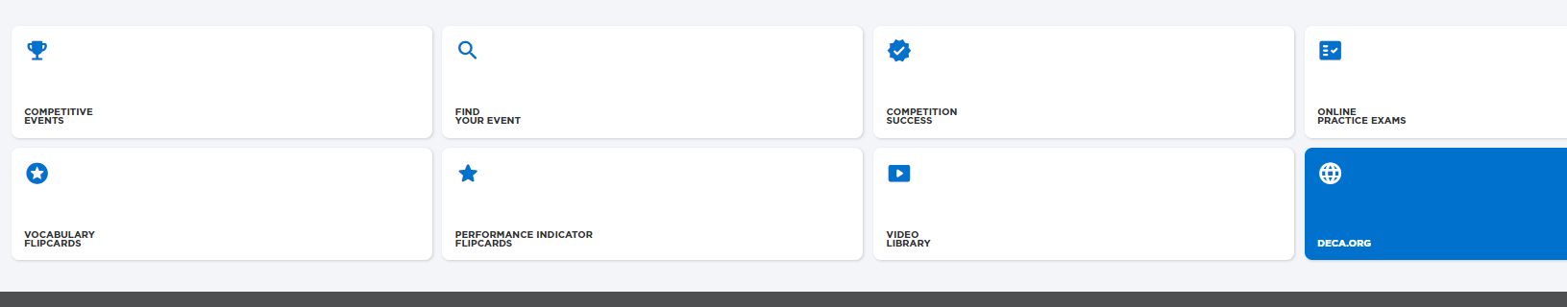
Then select Career Cluster (example Marketing)
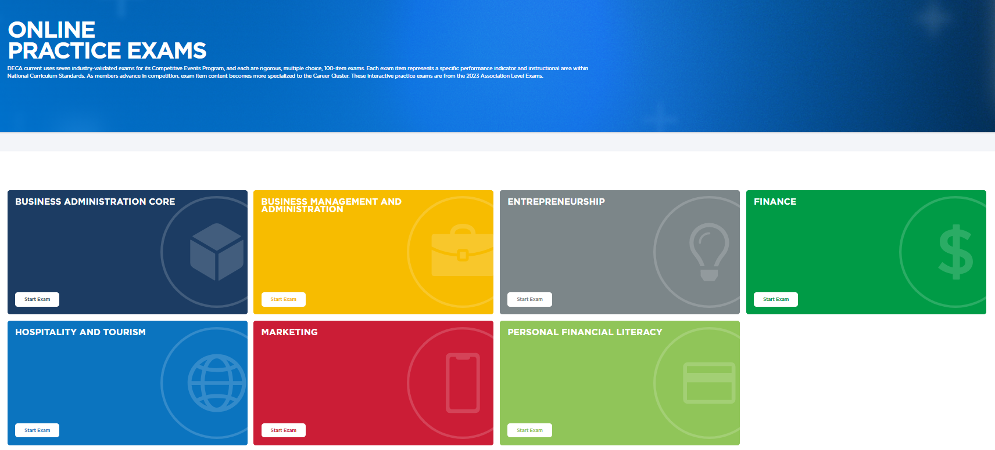

Student then selects # of questions they want to take (example 10)
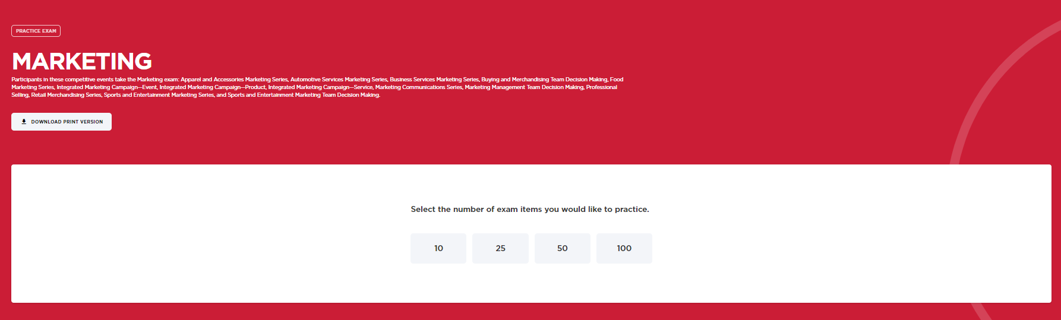

OR Select Competitive Events/Select Event/Scroll to samples exams from Area/State/ICDC to see entire exam.

