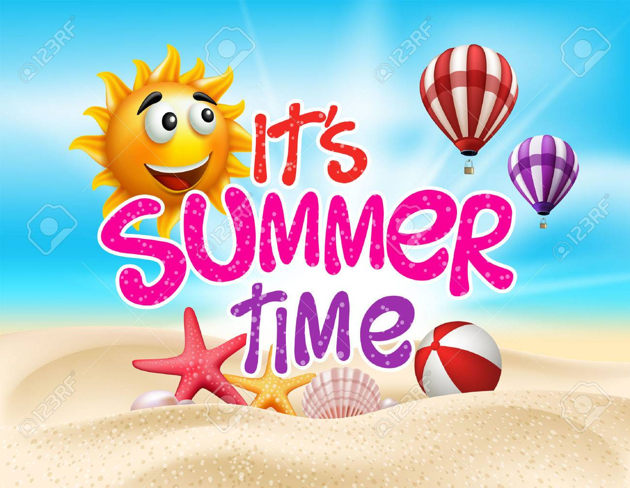

Dear Capital Prep Family,

It’s summertime!!! I truly wish you all the best during this time - enjoy the beautiful weather and time with your families. While there are always lots of things happening at this time, it is important to keep the upcoming school year on the horizon. In order to maintain and increase student skills, it is important that every member of the Capital Prep Family to continue to sharpen their skills throughout the summer. The brain is like every other muscle in the body - it must be used appropriately or we will lose our skills. Therefore, we have some work to do this summer. Attached is your summer project to be completed by August 12th at 7:30 am.

The intent of this project is to keep students progressing academically and keep their minds growing as they create lifelong study habits and work ethic. Current research points out that programs infused with these types of projects reduce summer learning loss. Former Secretary of Education, Arne Duncan, has stated: “A key step toward stopping the summer slide is the development and launch of high-quality programs that take advantage of time outside the school day and year to help children learn, grow, and develop” (Elling, 2009). It is the duty of educators and families to ensure that our scholars are constantly growing and progressing academically. I can’t wait to see your hard work!

Have a warm and safe summer; I cannot wait to see you when you return!

Best Wishes,

Dr. Ayanna Carter

Principal

PLEASE CLICK THE LINK FOR THE NOVEL

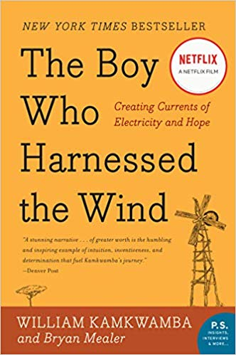

Name:___________________________________________________ Date ____________________

The Boy Who Harnessed the Wind
Summer Project 2019
Science
Wind Power: An investigation

Step 1: Build a windmill/propeller. Use one of the links below to guide your construction. Make sure your windmill can actually spin!

https://www.idealhome.co.uk/diy-and-decorating/how-to-make-a-paper-windmill-easy-step-by-step-instructions-51144
https://www.youtube.com/watch?v=xUpCuwf3JEg
https://www.wikihow.com/Make-a-Pinwheel

Step 2: Test your windmill to determine which orientation of the windmill would be best for energy production. Follow the procedure below to run your test.

- Mark one blade on your windmill with a large dot
- Line up the blade with the large dot with the stem of your windmill.
- Set up the windmill directly in front of the wind source (your breath or the hair dryer or fan)
- Using your own breath, fan, or a blow dryer, blow on the windmill for 1 minute. Count how many times the blade with the dot passes the stem on your windmill in that minute. Record your data in the data table.
- Repeat steps 2 and 3 two more times. Record all data.
- Set up the wind source on the side of your windmill.
- Then, using your own breath, or fan, or a blow dryer, blow on the windmill for 1 minute. Count how many times the blade with the dot passes the stem on your windmill in that minute. Record your data in the data table.
- Repeat steps 6 and 7 two more times. Record all data.

 | Number of turns in 1 minute
Wind Orientation | Trial 1 | Trial 2 | Trial 3 | Average
Straight On
From the Side

Step 3: Calculate averages and graph them.
Calculate the average number of spins for each wind source and record in the data table above. Then graph those averages below. Make sure to include a graph title, axes labels, and appropriate scales.

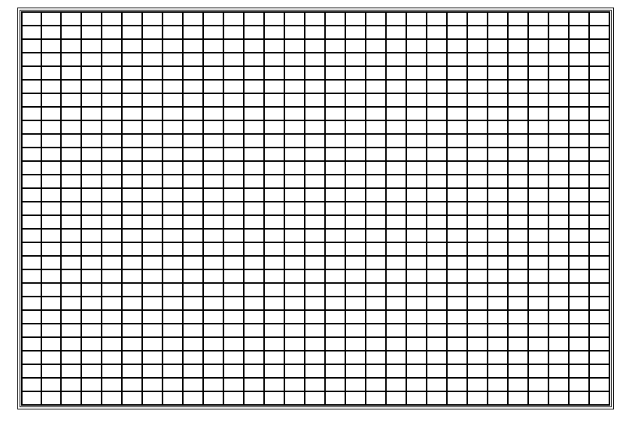

Step 4: Draw Conclusions
Answer the questions below to draw conclusions from your data.

- Which orientation for wind worked the best? How did you know?

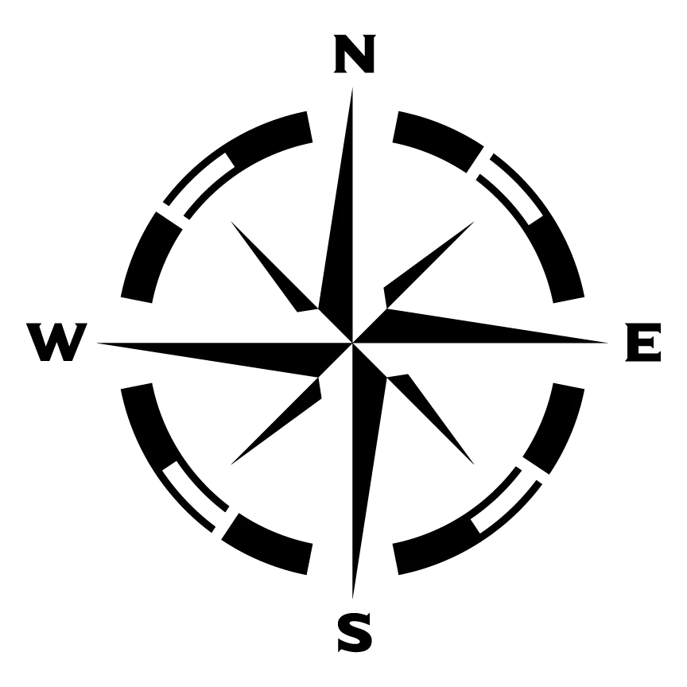
- When constructing windmills to harness wind energy, like William Kamkwamba did in The Boy Who Harnessed the Wind, scientists and engineers have to consider the orientation of the windmill in order to make sure they are making as much electricity as possible. Pretend you are an engineer building a wind farm here in Connecticut. You know that the wind most often blows from West to East. Based on the data from your experiment and your knowledge about the wind, which direction should your windmill face? North, South, East, or West? Explain your thinking using A?FeWiAar format.
A?
Answer the question directly in 12+ words
Fe  Provide a piece of evidence from your experiment that supports your answer to the question | For example…
Wi  Explain why your evidence is important to your answer | This evidence is important because…
Aar  Conclude your writing by summarizing your points or making a larger connection | As a result…

Step 5: Return the windmill you constructed and all of the work you completed to your science illuminator when school begins again in August!

Rubric

Standard | EMERGING | APPROACHING | MEETS STANDARD | ADVANCED
WHST.2 Information Text (Part 1) | Student attempted to answer questions but is mostly incorrect | All 4 questions are answered. Some parts are incorrect or missing. | All 4 questions are answered correctly based on the text provided. A? & Fe sections are correct and complete in number 4 | All 4 questions are answered correctly based on text provided. Student uses evidence to support answer to #4 and Wi and Aar demonstrate thorough understanding of the topic
RST.7 Data Analysis & Graphing (Part 2) | Student attempts to calculate averages and graph them but is mostly incorrect/most parts of the graph are missing | -Student has a completed data table, some calculations might be incorrect  -Student has a graph of averages, some of the following might be missing: graph title, axes labels, appropriate scales | -Student has completed data with correct averages  -Student has a graph of averages w/ graph title, appropriate scales, & axes labels | Student does everything to meet standard + includes a caption with the graph that explains the data and what it means
RST.9 Conclusion Writing (Part 2) | Student attempts to answer conclusion questions but is mostly incorrect | -Student identifies which wind direction is best but does not explain thinking  -Student identifies direction of windmill correctly but does not provide data to support responses | -Student identifies which wind direction worked the best and explained their thinking  -Student correctly identifies direction of windmill and uses data from their experiment to justify their answer | Student does everything to meet standard + Student explains their evidence and conclusion eloquently in A?FeWiAar format + student brings their windmill to school

Name:___________________________________________ Date ____________________

The Boy Who Harnessed the Wind
Summer Project 2019
English
Part 1:The Boy Who Harnessed the Wind is a testament to the individual curiosity, determination, and intelligence of a young Malawian boy. Yet, the book also states that William “sulked under the mango tree, until he remembered the library down the road, a gift from the Americans” and that he used an English dictionary to figure out the information in the books.

1. Does this mean that William would not have been able to succeed in bringing electricity and running water to his village without the help of the United States?

2. What role does the U.S. play in helping the people of impoverished countries? What role should it play?

3. What benefits and consequences does the U.S. presence–whether in the form of personnel, financial backing, or material “gifts” have on the receiving country? What are the benefits and consequences to the U.S.? To the world?

*Use evidence from the text and any resource your find online to support your answer.*

Part II: Theme
Name 3 possible themes in the novel The Boy who Harnessed the Wind.

1. _____________________________________________

2. _____________________________________________

3. _____________________________________________

Write a paragraph in which you explain and provide evidence of the theme, answering the following question: What is the central theme of the novel and impact of this theme as it pertains to science, history, and society?
PARAGRAPH WRITING ORGANIZER

A?
Answers Question
Restate the question and provide a concise answer
Fe
For Example Introduce quote and cite evidence from your article
Wi
Why Important “This is important because…”explains the relevance of the evidence
Fe
For Example Introduce another quote and cite evidence from your article
Wi
Why Important “This is important because…”explains the relevance of the evidence
As A Result
Conclusion

Short Response Rubric

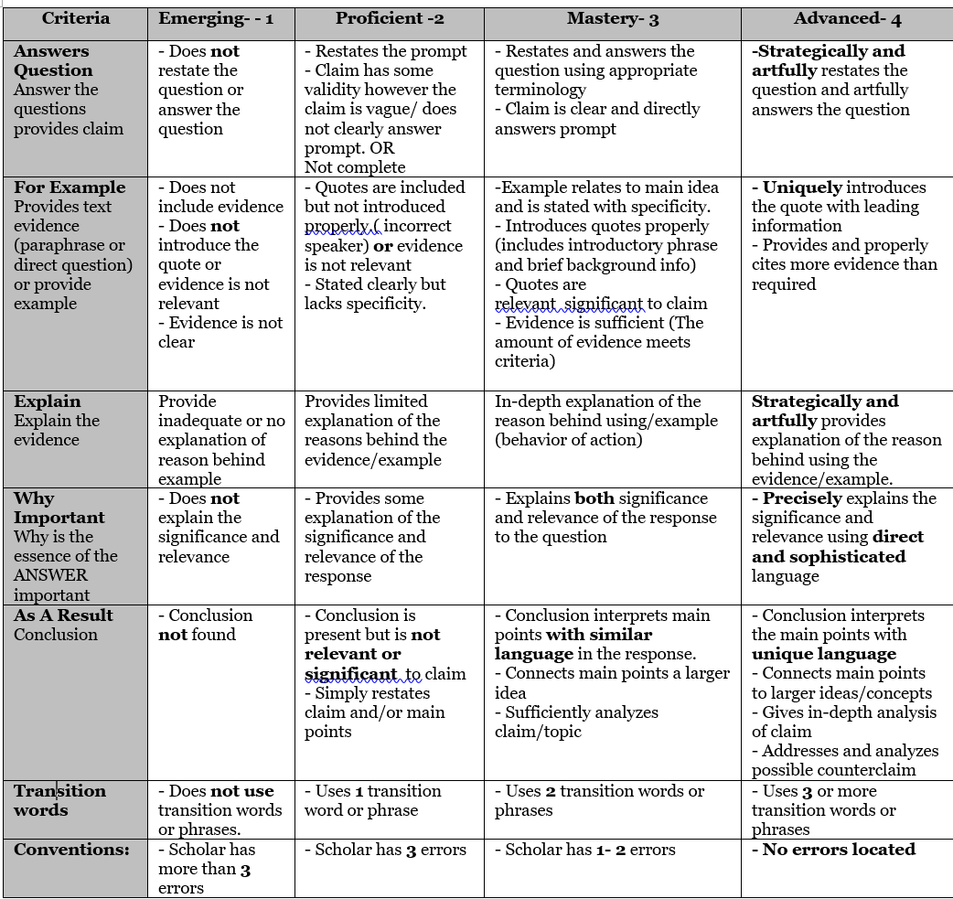

Watch the following TEDTalk: https://www.ted.com/speakers/william_kamkwamba
Rules for creating TED Talk- https://ltlatnd.wordpress.com/2014/08/06/assigning-students-a-ted-style-talk/

Create your own ted talk from William’s perspective :
1. What topic would William choose?
2. Write a script in which you, as William, share a problem and solution.
3. Create the PowerPoint slides to go with your presentation.

Outline for the script:
a. Introduction/HOOK your audience:
i. Who is your target audience? ______________________.
ii. Start by making your audience car using a relatable example or intriguing idea.

b. Body: What is your idea with clarity.
c. Describe your evidence and how and why your idea can be implemented.
d. Conclusion: What will you say to leave your audience feeling positive toward your idea and how might it affect their lives if implemented.

Title: | Think up a descriptive title. Try to be creative if it fits.
Audience | Who is your audience? How will you hook them?
Topic | What is your topic? How will you present it? What does the author tell us about this topic and why is it important? How does this impact us and our society?
Evidence: | What information supports your claim and idea. How does this evidence help your idea and support it in the process of being implemented?
Process: | Explain your process and discuss/show the products of your work. If there were any setbacks don’t be afraid to talk about them, too. Often, we learn from trials/obstacles. Remember that “failure” was an option, and regardless of whether your project ‘got off the ground’ to start, there was real-life learning.
Motivation: | Talk about your purpose or what the audience should learn from your project. Inspire your audience with your passion for your pursued activity. What is the future of your project?
Conclusion | Include a meaningful “take-away”/reflection for the audience.

PowerPoint slides checklist:
· Slides are directly related to the information stated
· There is a title with the presenter’s name and information, body and concluding slide.
· Slides include visuals that are clear.
· Visually appealing, easy to read, short and writing is kept minimal.
· 42 pt. font-very little text
· Any sources used outside of the novel are cited.

Wind Problems
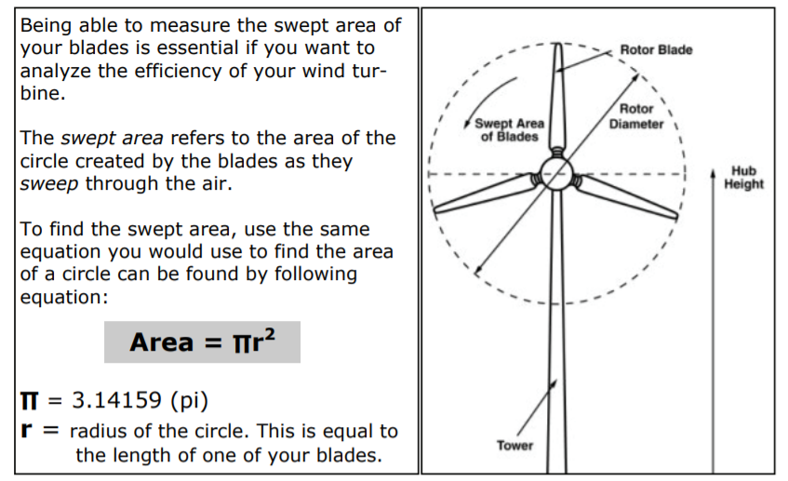

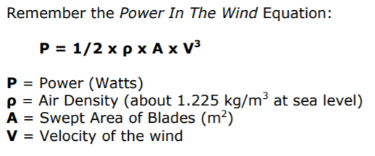
- What is the swept area of a wind turbine with 6 blades that are each 45 meters long?

2. If the wind is blowing at 10 meters/second, how much total power is in the wind hitting the wind turbine from question one (blades 45 meters long)? Assume the wind turbine is at sea level.

Volume Problems

- What is the formula to find the volume of a cylinder?

2. How much water could my well hold if the depth of the well is 30ft and the diameter of the well is 24ft?

3. If the well is filled up to 8ft full of water how much water is in the well?

4. Using your answers from questions two and three. What is the ratio of the amount of water that is currently in the well compared to the total amount of water the well can hold?

Electrical Charging Problems

- If the battery for the pump on the well charges at a rate of 12 percentage points every 10 minutes. What is the rate of the battery charging?

2. Using your rate from question one, if the battery of the pump already at a 20 percent charge. Write a linear function for percentage charge of battery, where t stands for time?

3. Use your function from question two, to create a table to show charging time (in minutes) and percentage of battery.

4. Use your table from about to create a linear line on the x-y plane below.

