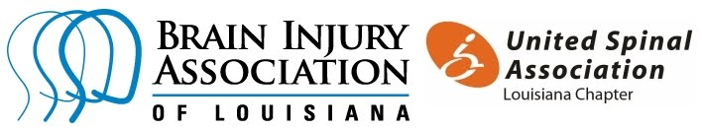

UNMASKING BRAIN INJURY INITIATIVE

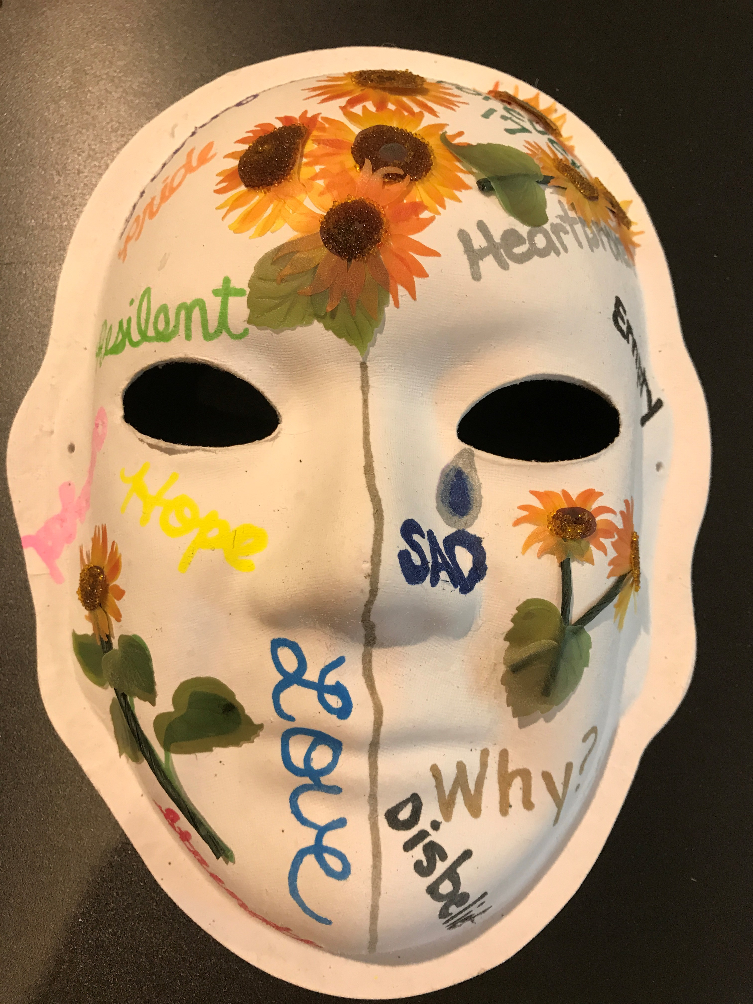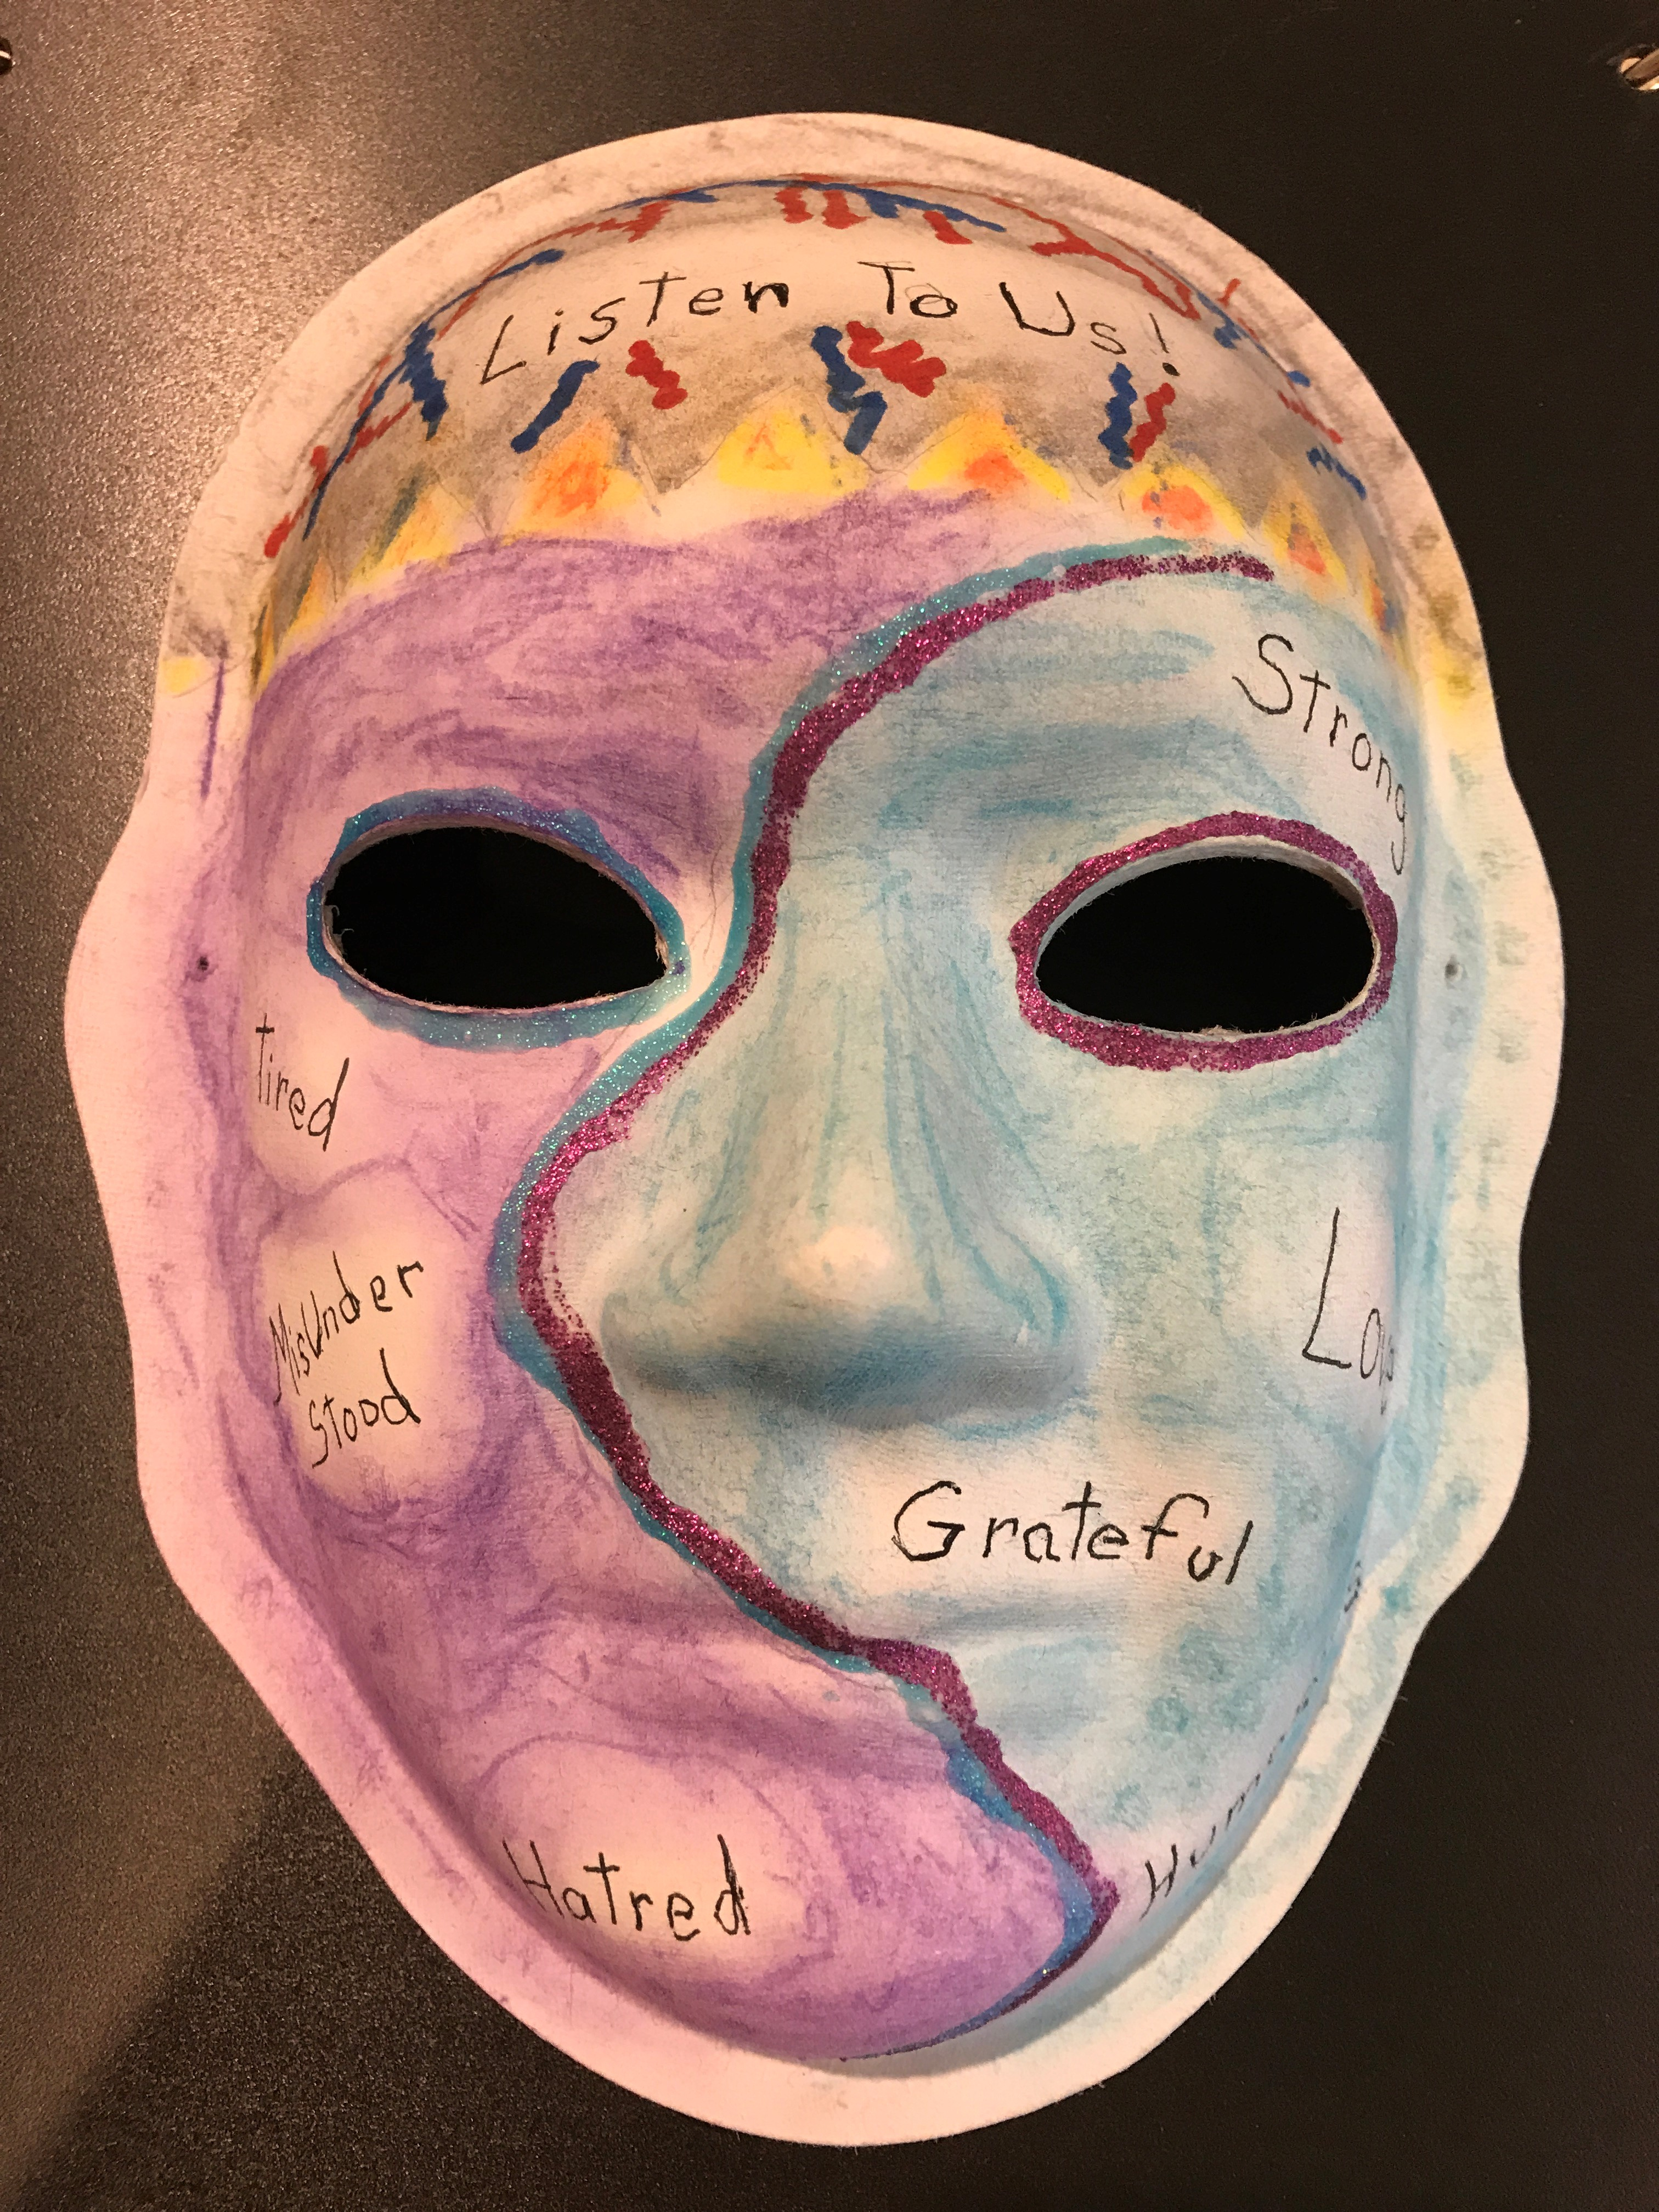

The Brain Injury Association of Louisiana is the proud Louisiana project partner of a national organization called Unmasking Brain Injury. The mission of this art-based traveling exhibit is to promote awareness of the prevalence of brain injury by giving survivors a voice and the means to educate others of what it’s like to endure and live with a brain injury.

Behind every mask is a story, and every story is told by a brain injury survivor. Brain injury survivors can participate in this worldwide initiative by artistically creating a provided mask, and writing a brief description of the emotions portrayed in their work. This striking collection helps viewers understand that people with brain injuries are deserving of dignity, respect, compassion, and should be valued as citizens in their respective communities.

Brain injury has been called the “silent epidemic” because public recognition of brain injury is extremely low despite the staggering number of people who are injured each year. The effects of brain injury are often invisible to an unknowing observer.

Currently, we have 100 masks completed, with more in progress. They are displayed on two racks that are approximately 7’ high by 6’ wide each, but can be adjusted to accommodate a smaller space. There is no cost, and all set up and break down is included. Since Louisiana’s Unmasking Brain Injury art display was created in September 2017, it has traveled to dozens of locations throughout the state.

Marketing departments have enjoyed this unique opportunity for potential media coverage and the enhanced exposure they receive for their hospital or business, while also sharing a vital role in raising public awareness of brain injuries. Ideally, this exhibit should remain in place for at least four weeks at a time in order to maximize viewership and to help your organization benefit from substantial pedestrian traffic.

If your hospital or business is interested in hosting this unique Unmasking Brain Injury exhibit, please contact Kimberly Hill at Kim@biala.org

See a sample exhibit: https://www.biala.org/unmasking-brain-injury

