
the new old age
Why Older People May Not Need to Watch Blood Sugar So Closely
By Paula Span
March 10, 2025, 1:35 p.m. ET
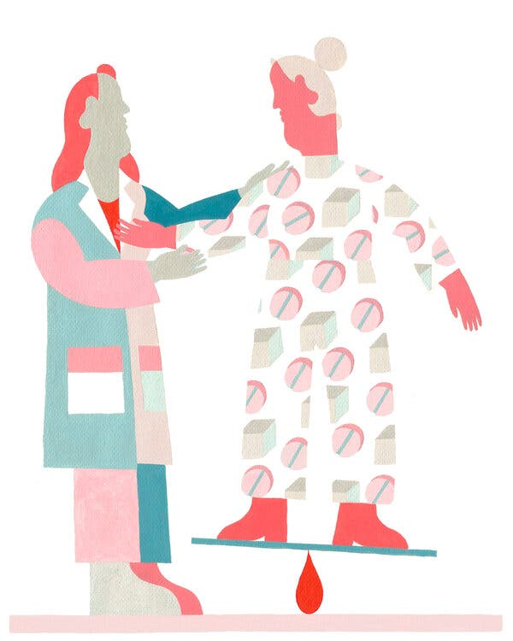
Intensive management of diabetes pays fewer dividends as patients age and raises the chances of hypoglycemia. But many people have not gotten the message.
By now, Ora Larson recognizes what’s happening. “It feels like you’re shaking inside,” she said. “I’m speeded up. I’m anxious.” If someone asks whether she would like a salad for lunch, she doesn’t know how to respond.
She has had several such episodes this year, and they seem to be coming more frequently.
“She stares and gets a gray color and then she gets confused,” her daughter, Susan Larson, 61, said. “It’s really scary.”
Hypoglycemia occurs when levels of blood sugar, or glucose, fall too low; a reading below 70 milligrams per deciliter is an accepted definition. It can afflict anyone using glucose-lowering medications to control the condition.
But it occurs more frequently at advanced ages. “If you’ve been a diabetic for years, it’s likely you’ve experienced an episode,” said Dr. Sei Lee, a geriatrician at the University of California, San Francisco, who researches diabetes in older adults.
The elder Ms. Larson, 85, has had Type 2 diabetes for decades. Now her endocrinologist and her primary care doctor worry that hypoglycemia may cause falls, broken bones, heart arrhythmias and cognitive damage.
Both have advised her to let her hemoglobin A1c, a measure of average blood glucose over several months, rise past 7 percent. “They say, ‘Don’t worry too much about the highs — we want to prevent the lows,’” the younger Ms. Larson said.
But her mother has spent 35 years working to maintain an A1c below 7 percent — a common recommendation, the goal people sing and dance about in pharma commercials.
She faithfully injects her prescribed drug, Victoza, about three times a week and watches her diet. She’s the oldest member of the Aqua for Arthritis class at a local pool in St. Paul, Minn.
So when her doctors recommended a higher A1c, she resisted. “I think it’s a bunch of hooey,” she said. “It didn’t make sense to me.”
Joseph Ouslander, a geriatrician at Florida Atlantic University and the editor in chief of The Journal of the American Geriatrics Society.
Another 2021 study, of Ontario nursing homes, found that over half of residents taking drugs for Type 2 diabetes had A1c levels below 7 percent. Those with the greatest cognitive impairment were being treated most aggressively.
Dr. Ouslander has calculated, based on a national study, that roughly 40,000 emergency room visits annually resulted from overtreatment of diabetes in older adults from 2007 to 2011. He thinks the numbers are likely to be much higher now.
A brief primer: Diabetes can cause such grievous complications — heart attacks, stroke, vision and hearing loss, chronic kidney disease, amputations — that so-called strict glycemic control makes sense in young adulthood and middle age.
But tight control, like every medical treatment, involves a period of time before paying off in improved health. With diabetes, it’s a long time, probably eight to 10 years.
Older people already contending with a variety of health problems may not live long enough to benefit from tight control any longer. “It was really important when you were 50,” said Dr. Lee. “Now, it’s less important.”
Older diabetics don’t always welcome this news. “I thought they’d be happy,” Dr. Lee said, but they push back. “It’s almost like I’m trying to take something away from them,” he added.
The risk that tight control will also set off hypoglycemia increases as patients age.
It can make people sweaty, panicky, fatigued. When hypoglycemia is severe, “people can lose consciousness,” said Dr. Scott Pilla, an internist and diabetes researcher at Johns Hopkins. “They can become confused. If they’re driving, they could have an accident.”
Even milder hypoglycemic events “can become a qualify-of-life issue if they’re happening frequently,” causing anxiety in patients and possibly leading them to limit their activities, he added.
Experts point to two kinds of older drugs particularly implicated in hypoglycemia: insulin and sulfonylureas like glyburide, glipizide and glimepiride.
For people with Type 1 diabetes, whose bodies cannot produce insulin, injections of the hormone remain essential. But the medication is “widely recognized as a dangerous drug” because of its hypoglycemia risk and should be carefully monitored, Dr. Lee said.
The sulfonylureas, he added, “are becoming less and less used” because, while less risky than insulin, they also cause hypoglycemia.
The great majority of older adults with diabetes have Type 2, which gives them more options. They can supplement the commonly prescribed drug metformin with the newer GLP-1 and SGLT2 drugs, which also have cardiac and kidney benefits. If necessary, they can add insulin to their regimens.
Among the new drugs’ more popular consequences, however, is weight loss.
“For older people, if they’re frail and not very active, we don’t want them losing weight,” Dr. Pilla pointed out. And both metformin and the GLP-1 and SGLT-2 medications can have gastrointestinal or genitourinary side effects.
For 15 years, Dan Marsh, 69, an accountant in Media, Pa., has treated his Type 2 diabetes by injecting two forms of insulin daily. When he takes too much, he said, he wakes up at night with “the damn lows,” and needs to eat and take glucose tablets.
Yet his A1c remains high, and last year doctors amputated part of a toe. Because he takes many other medications for a variety of conditions, he and his doctor have decided not to try different diabetes drugs.
“I know there’s other stuff, but we haven’t gone that way,” Mr. Marsh said.
With all the new options, including continuous glucose monitors, “figuring out the optimal treatment is becoming more and more difficult,” Dr. Pilla said.
Bottom line, though, “older people overestimate the benefit of blood-sugar lowering and underestimate the risk of their medications,” he said. Often, their doctors haven’t explained how the trade-offs shift with older age and accumulating health problems.
Ora Larson, who carries chewable glucose tablets with her in case of hypoglycemia (fruit juice and candy bars are also popular antidotes), intends to talk over her diabetes treatment with her doctors.
It’s a good idea. “The biggest risk factor for severe hypoglycemia is having had hypoglycemia before,” Dr. Lee said.
“If you have one episode, it should be thought of as a warning signal. It’s incumbent on your doctor to figure out, Why did this happen? What can we do so your blood sugar doesn’t go dangerously low?”

