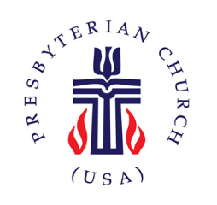
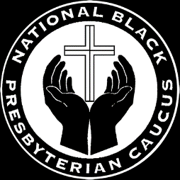
NATIONAL BLACK PRESBYTERIAN CAUCUS
PITTSBURGH CHAPTER

Announcing the 2021 Coleman-Patrick Scholarship Recipient

The recipient of this year’s Coleman-Patrick Scholarship is Ms. Kiara Rockymore of East Liberty Presbyterian Church. The funds will be used towards her post-secondary education. This award was funded through the generous ongoing contributions of various churches, members and friends of the Pittsburgh Presbytery and the Pittsburgh Chapter of the National Black Presbyterian Caucus.
Members of the Pittsburgh NBPC wish to express our sincere THANK YOU to all who contributed to the Scholarship Fund. This ministry emphasizes the importance of post-secondary education and encourages the youth in our communities.
Please continue to pray for our students as they work toward scholastic achievement this year and going forward in our communities and Presbytery.

Giving God the Glory,
Ruling Elder, Lenore Willams, moderator
NBPC, Pittsburgh Chapter, NBPC

Coleman-Patrick Scholarship Fund Committee:
Elder Alan D. Perry, chair,
Elder, Blanche Bennett,
Elder, Judith Jerry,
Elder Mary Evans,
Elder, Harriette McCray

