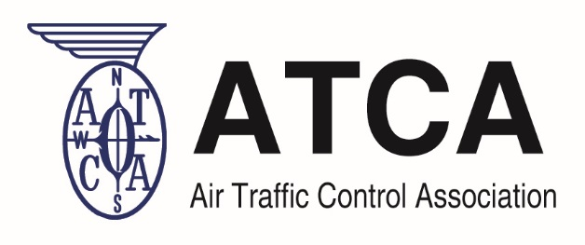
Air Traffic Control Association | 1101 King Street, Suite 300, Alexandria, VA 22314 | T: 703.299.2430 | F: 703.299.2437 www.atca.org

To better assist us in gathering the information, please complete the form:

Company: ______________________________________

Name of person completing the form: ______________________________________

Email address: _______________________________________

Phone Number: ________________________________________

Please check ALL that apply: Contract Renewal/End Date:

□ STARS (□Primary □Subcontractor) Month___ Year ____
□ TAMR (□Primary □Subcontractor) Month___ Year ____
□ ADS-B (□Primary □Subcontractor) Month___ Year ____
□ DCIS (□Primary □Subcontractor) Month___ Year ____
□ AIM (□Primary □Subcontractor) Month___ Year ____
□ MAAP (□Primary □Subcontractor) Month___ Year ____
□ SOS (□Primary □Subcontractor) Month___ Year ____
□ SE2025 (□Primary □Subcontractor) Month___ Year ____
□ SE2020 (□Primary □Subcontractor) Month___ Year ____
□ LSS (□Primary □Subcontractor) Month___ Year ____
□ SEAPORT-E (□Primary □Subcontractor) Month___ Year ____
□ eFAST (□Primary □Subcontractor) Month___ Year ____
□ eTASS (□Primary □Subcontractor) Month___ Year ____

Please add any additional contracts (primary or subcontractor) that your company is associated with not listed above:

Return the Completed Form to: mindy.soranno@atca.org by Wednesday September 18, 2019

