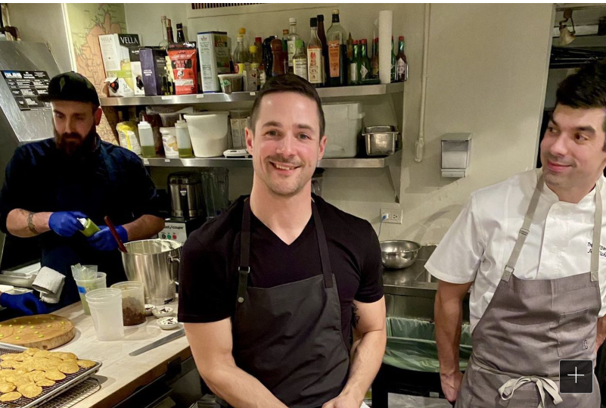
NEW YORK — Over bay scallop with truffle and pickled roses, Dungeness crab over bolted wheat pastina, and smoked maitake mushrooms with malted grains, plum pipian, and black truffle, Philadelphia’s love-in with the James Beard Foundation continues.
This week, Philadelphia chefs took over the landmark James Beard House, a brownstone in Greenwich Village, for the first two of four takeover dinners this year attended by influencers.

It is part of a new partnership between Visit Philadelphia, the city’s tourism-marketing agency, and the nonprofit organization of food professionals.

The goal: Talking up Philadelphia as a culinary-travel destination.
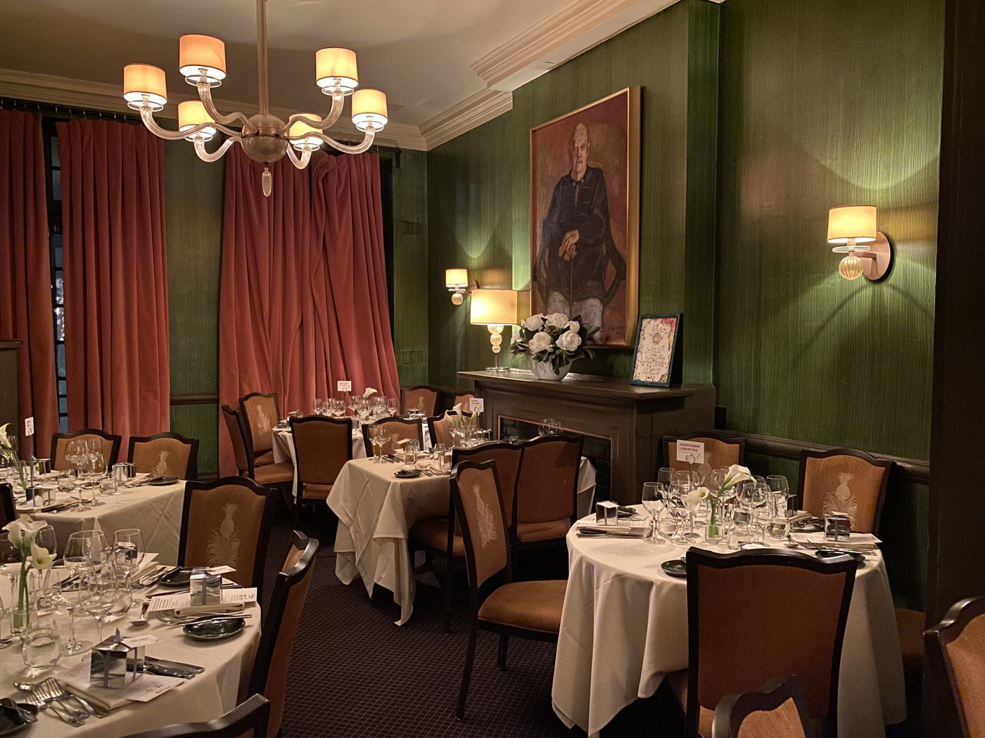
MICHAEL KLEIN / STAFF
The main dining room at the James Beard House in New York City, which sits beneath a portrait of the food writer.
Philadelphians have been hitting the world food radar in the last several years, particularly among the Beard organization. The city made a solid showing in the 2017 Beard Awards, in which winners included Stephen Starr, Michael Solomonov, and Greg Vernick.

In addition to the four Beard House dinners, Philadelphia will host the 2020 Beard Awards nomination announcement on March 25 (at the Barnes Foundation) as well as a Taste America dinner (at Spice Finch) that will feature chef-owners Jennifer Carroll and Billy Riddle with chef Vishwesh Bhatt of Snackbar in Oxford, Miss.
ADVERTISEMENT
In addition, a new series called the James Beard Restaurant Collective will be held in the Philadelphia area in August. It is a partnership between the Center City District and the foundation.
Visit Philly’s total financial commitment has not been calculated, a representative said.
As part of the Visit Philly-Beard partnership, last year a gaggle of Philadelphia chefs were shipped to Pier 60 in New York City to cook for the foundation’s annual media awards, putting Philadelphia in front of hundreds of journalists and food and travel influencers from around the country. Visit Philly had, in effect, bought itself a place at the PR table in a first for a city tourism agency.
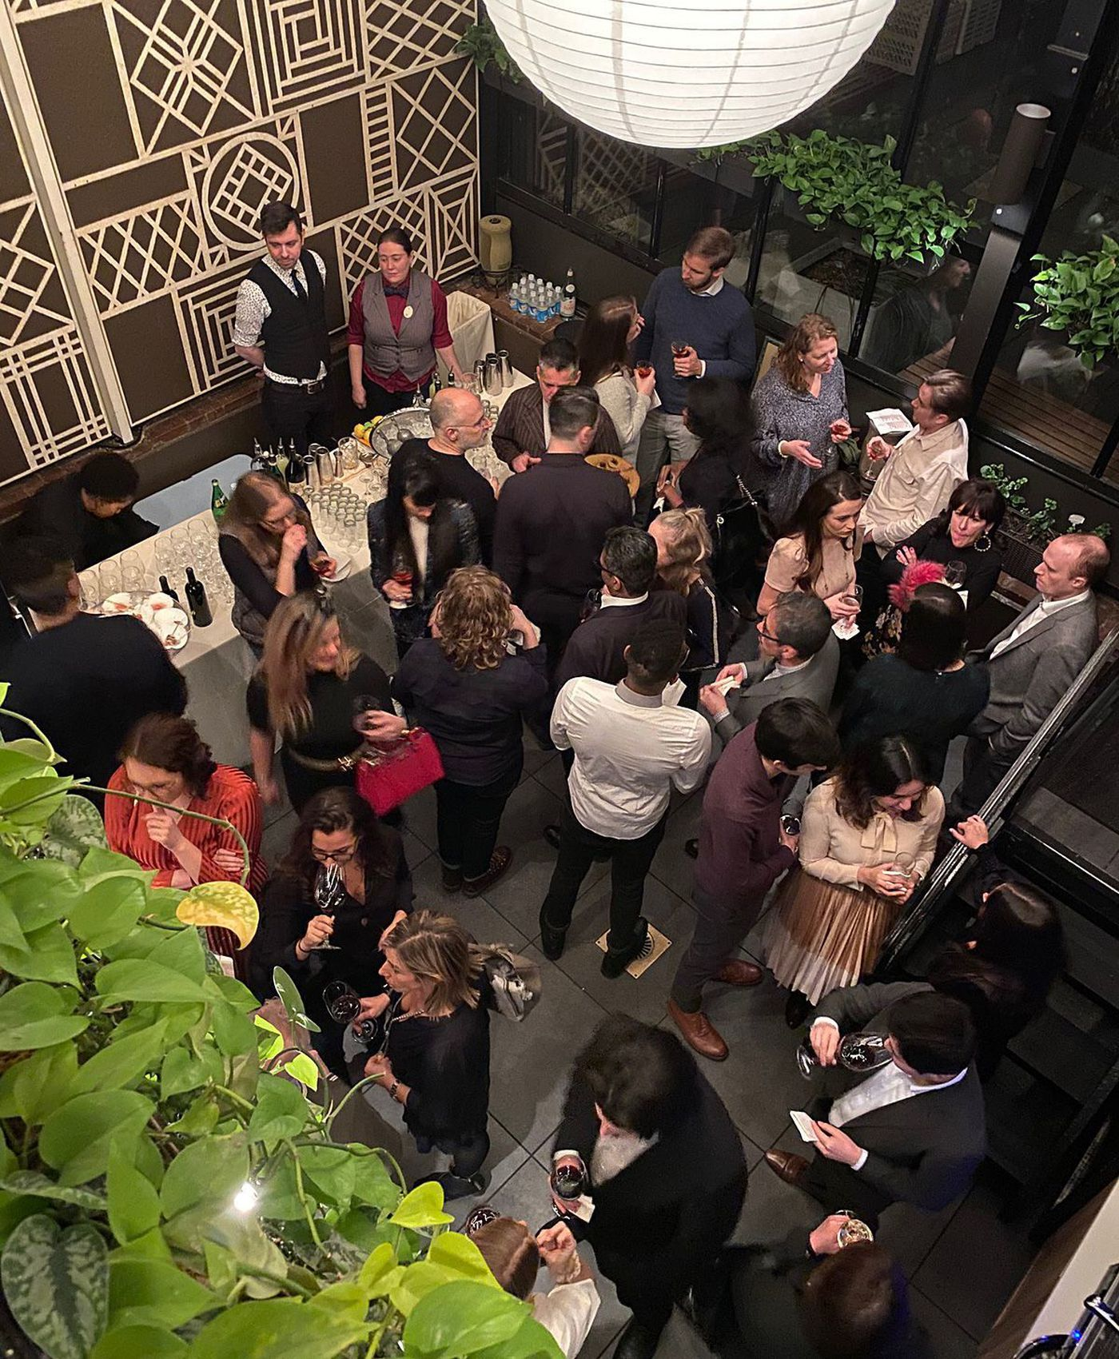
MICHAEL KLEIN / STAFF
Guests gather for cocktail hour at the James Beard House in New York City for an event on Jan. 29, 2020, sponsored by VisitPhilly.
This year’s four-dinner series will bring the partnership closer to home, as it were. Beard, the prolific cookbook author and teacher, lived in the house on West 12th Street for 12 years before his death in 1985.
It’s a food lover’s dream setting. You walk through the front door directly into the kitchen and proceed to a two-story atrium for cocktails. Upstairs in his former apartment are two dining rooms, plus a nook with a single table in his former bedchamber. Look up. The mirrored ceiling, pointed out during the opening remarks at the Jan. 29 dinner, drew titters from the 55 attendees.
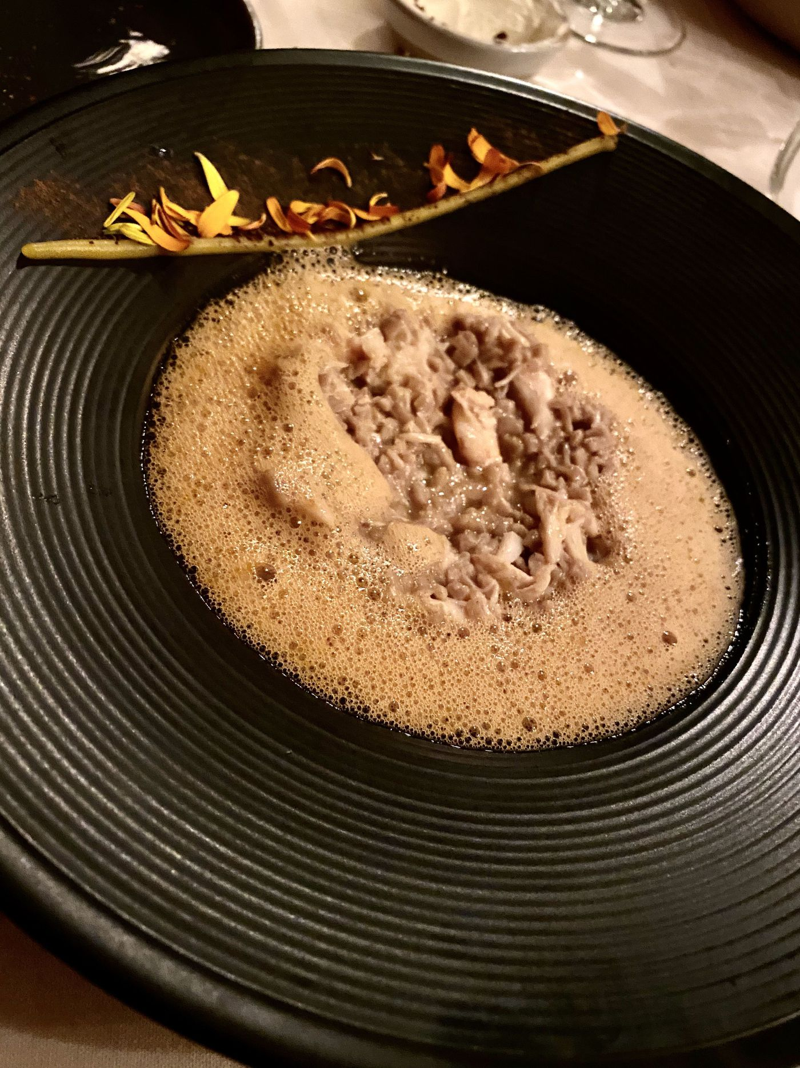
MICHAEL KLEIN / STAFF
Dungeness crab with bolted wheat pastina, as prepared by Nicholas Elmi at the James Beard House on Jan. 29, 2020.
Jan. 29′s headliners were Nicholas Elmi (Laurel, In the Valley, Royal Boucherie), Jon Cichon (Lacroix at the Rittenhouse), and Jon Nodler and Samantha Kincaid (Cadence). On Jan. 30, the guest chefs were Ed Crochet and Justine MacNeil (Fiore), Anthony Andiario (Andiario), and bartender Michelle Cudia (Tria).
At Jan. 29′s dinner, hors d’oeuvres included foie gras and potato snacks with cocoa nib and Concord grape; bay scallop with truffle and pickled roses; and duck and foie gras pates en croute. Each chef had a course, with Elmi preparing the Dungeness crab dish, Nodler the mushroom, Cichon doing lamb two ways, and Kincaid wrapping with ricotta mousse cake. Rival Bros. sent the coffee, and restaurateurs Valerie Safran and Marcie Turney, whose culinary empire includes Marcie Blaine chocolates, provided boxes of Philly-themed chocolates.

Jan. 30′s dinner included vitello crudo, with blue cheese, Tardivo radicchio, and Jewel raisins (from Andiario); Swiss chard pansotti (Fiore); caombas (dove-shape pasta, by Andiario); peposo (a Tuscan stew, Crochet), and dolce di riso with citrus, yogurt, and orange-swirled gelato (MacNeil).

The third dinner, April 21, will be vegan-themed including Rich Landau and Kate Jacoby (Vedge, V Street, Fancy Radish), Aimee Olexy (Talula’s Table, The Love, et al.), Rachel Klein (Miss Rachel’s Pantry, my daughter), and bartender Richie Tray.
June 11′s will include Kiki Aranita (Poi Dog Philly), Judy Ni (Baology), Ange Branca (Sate Kampar), and bartender Resa Mueller.

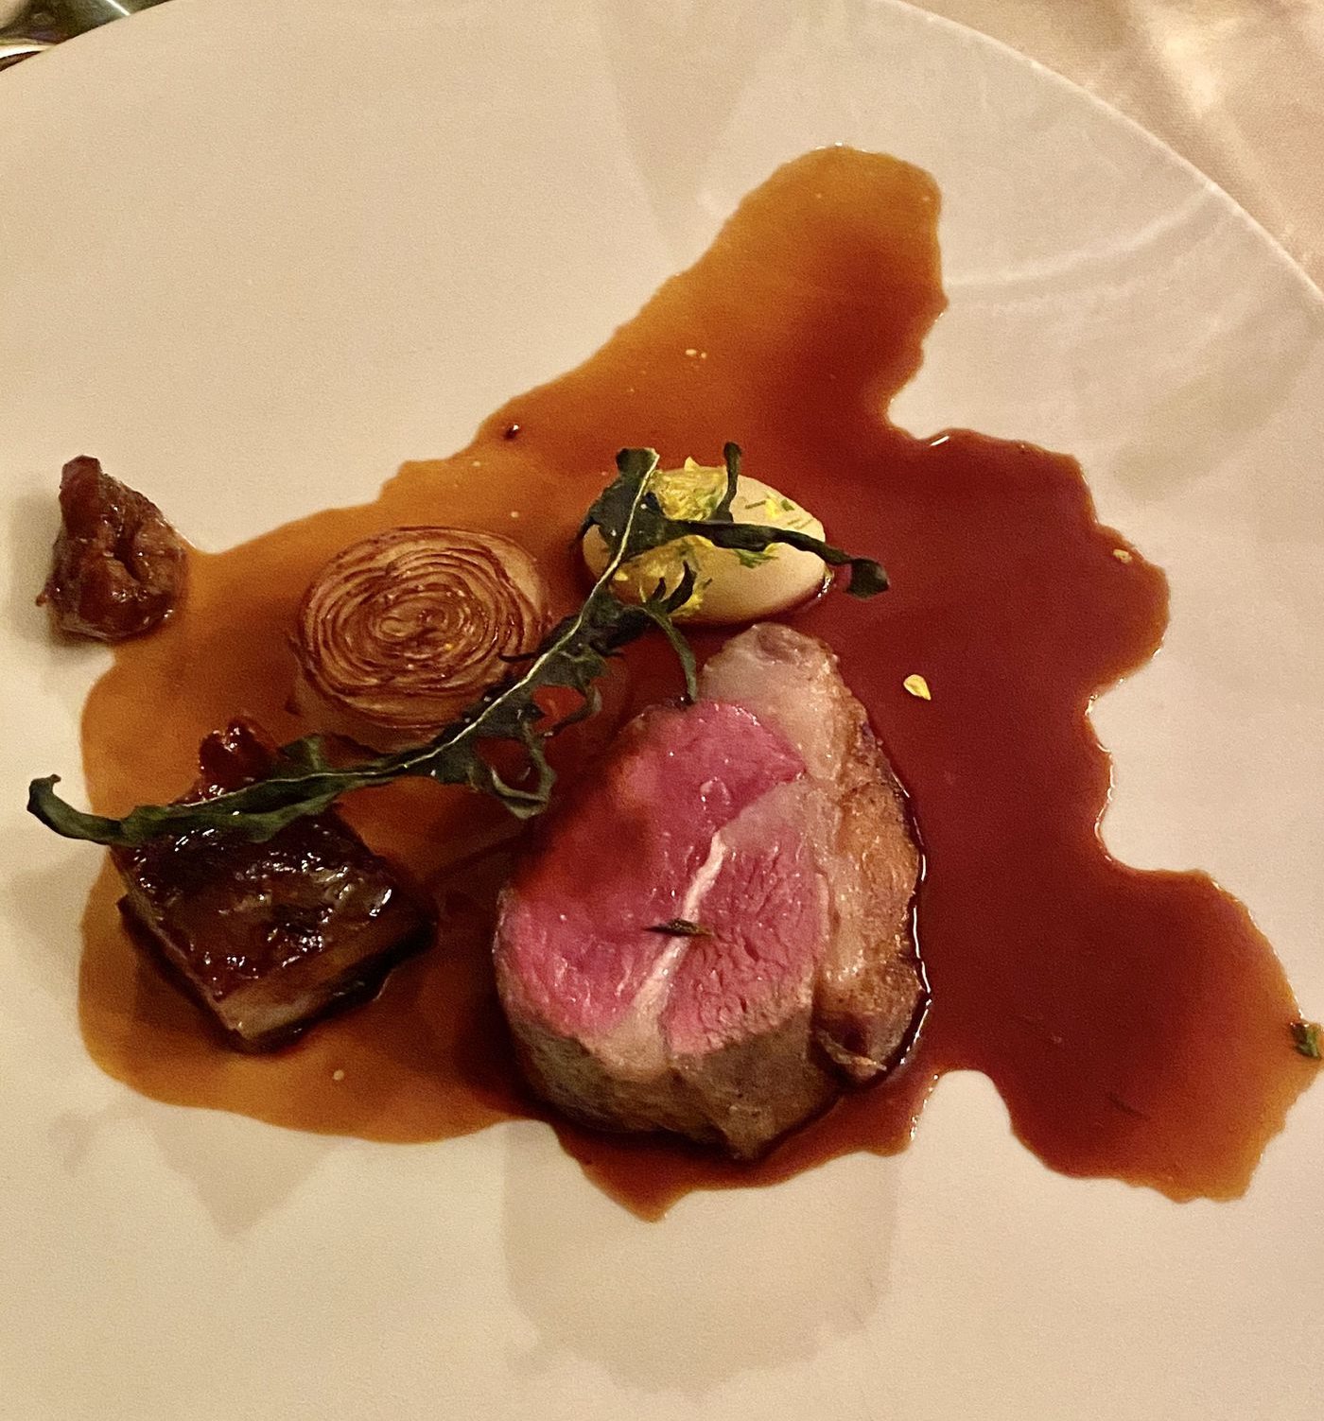
MICHAEL KLEIN / STAFF
Lamb prepared two ways by chef Jonathan Cichon of Lacroix at the Rittenhouse, as served at the James Beard House on Jan. 29, 2020.
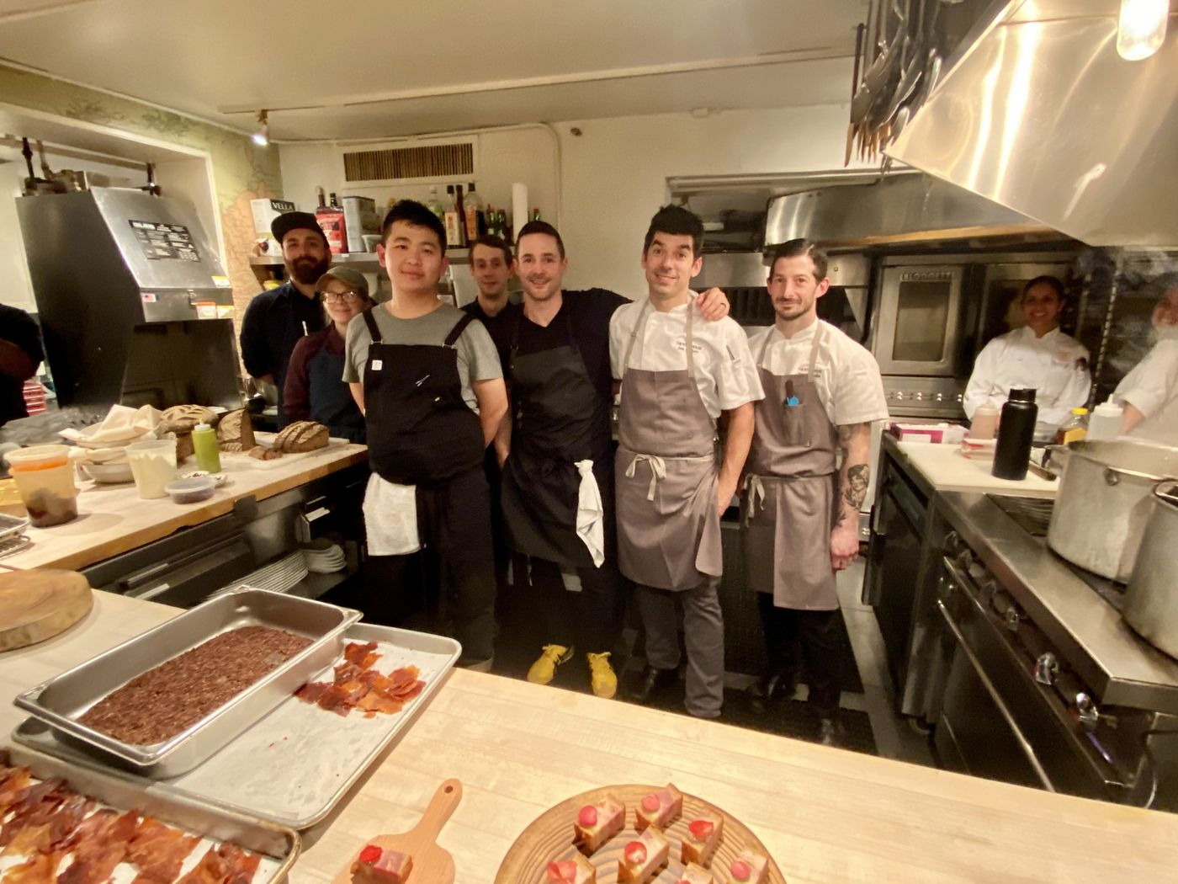
MICHAEL KLEIN / STAFF
Philadelphia chefs in the kitchen at the James Beard House in New York City (from left): Dylan Sweeney, Samantha Kincaid, Peter Lin, Jon Nodler, Nicholas Elmi, Jonathan Cichon, and Eric Leveillee.
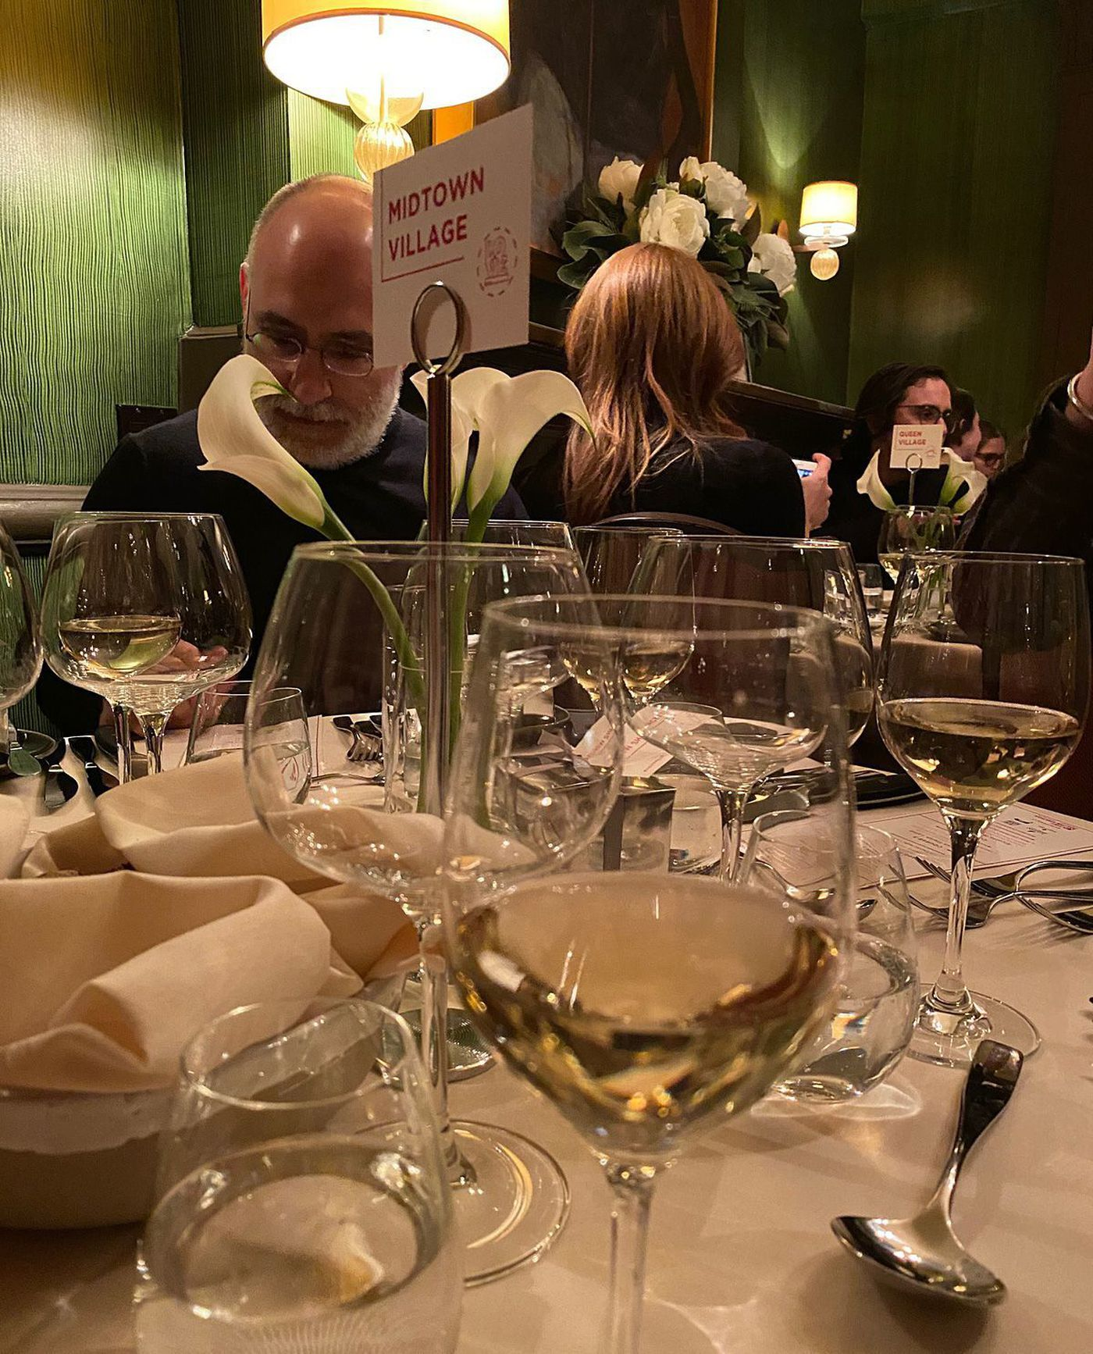
MICHAEL KLEIN / STAFF
Tables were named with Philadelphia neighborhoods, rather than numbers, at the James Beard Foundation event on Jan. 29, 2020, sponsored by VisitPhilly.

Outlet: Philadelphia Inquirer
UVM: 1,318,684
Link: https://www.inquirer.com/food/james-beard-foundation-visit-philly-chefs-tourism-partnership-20200131.html

