Gene Weiner
Gene Weiner is a business and technical consultant. Weiner International Associates serves the specialty chemical and electronics industries, with clients including several Fortune 100 companies. Mr. Weiner’s executive experience includes: that of Director and President of a leading supplier of copper clad laminates to the electronics industry; vice president of sales and marketing of one of the world's leading suppliers of photopolymers and specialty chemicals to the electronics industry; and vice president of business development of Oxy Metal Finishing, a subsidiary of Occidental Petroleum, a major specialty chemical firm.

Weiner pioneered additive circuitry with fine lines, producing a print wired memory plane in the 1950s.
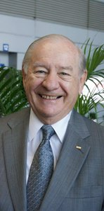

He served as a member of the Board of Directors of Wong’s Kong King International (Holdings), Ltd. Headquartered in Hong Kong, for 25 years. Mr. Weiner also served as the Chairman of the Advisory Board of Directors of PhiChem Corporation, a public specialty chemical company listed on the Shenzhen stock exchange.

Weiner was the founding publisher/editor of PAC/ASIA CIRCUIT NEWS and has authored and presented over 100 papers. He served for more than 10 years as a member of the Advisory Board of the MBA program of the Malcolm Baldridge School of Business at Post University. Mr. Weiner is a recipient of many industry awards, including the IPC President’s Award. He has been inducted into the IPC Raymond E. Pritchard Hall of Fame, the printed circuit industry's highest award and recognition.

