FOR IMMEDIATE RELEASE

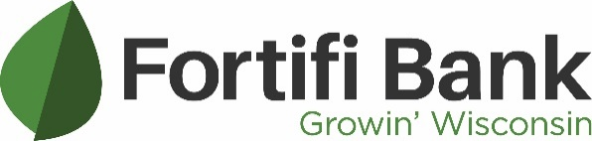
Contact:
Daniel Aronson
Marketing Manager, Fortifi Bank
daronson@fortifibank.com
920.354.4141

Fortifi Bank Announces Steve Arps as Chief Operating Officer

January 9, 2023 – Berlin, Wis. – Fortifi Bank announced today that Steve Arps joined the company as Executive Vice President Chief Operating Officer. In this role, Arps will provide strategic leadership to teams responsible for customer-facing and back-office processes, technology applications, systems, and operations, and will report directly to the President and Chief Executive Officer, Greg Lundberg.
Steve will oversee the functional activities in support of the Bank’s strategic objectives, ensuring the proper operational controls, administrative practices, and people systems are in place to effectively grow the organization and maximize operating efficiency. He also serves as a member of the Senior Management Team.
Arps has spent his 31-year professional career in the banking and finance industry, most recently served as Chief Operations Officer at Denmark State Bank where he led the development and execution of its key strategic objectives across multiple areas of the Bank. Throughout his career, Arps has demonstrated a commitment to achieving efficiencies and to mitigate risks while doing so.
“With a strong team surrounding him, Steve will empower them to deliver a superior caliber of service to our clients,” stated Fortifi Bank President and CEO, Greg Lundberg. “I am eager to see what we can accomplish with Steve on the Fortifi Bank team. His experience and leadership will help us deliver an unmatched community banking experience in Wisconsin.”
Within the past year, Fortifi Bank has made great strides to accommodate increased growth and longevity within its markets. In doing so, Fortifi Bank is better aligned with communities, has additional resources to focus on client service, and can further its mission of Growin’ Wisconsin.

About Fortifi Bank
First Berlin Bancorp, Inc is the Bank Holding Company of Fortifi Bank. Fortifi Bank has been Growin’ Wisconsin for more than 145 years – one person, one business, one relationship at a time. Financial centers can be found in Berlin, Green Lake, Green Bay, Montello, Ripon, Omro, Oshkosh, Waunakee, and Winneconne. Their full-service financial centers have been offering both personal and business clients with a portfolio of products and services that are designed with the client in mind. Local decision-making, community involvement, community ownership, and a Board of Directors comprised of local citizens have been the driving successes of Fortifi Bank since inception. For more information, visit www.fortifibank.com or call 855-876-1500.

###

