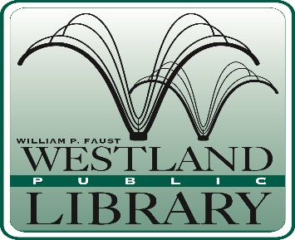

AGENDA
Board of Trustees Meeting
Wednesday, July 17, 2019
Administration Conference Room
7:00 P.M.

- Call to Order and Attendance
- Action on Agenda
- Citizens Comments on Agenda Items
- Business
- Approval of minutes from June 19, 2019 regular scheduled meeting
- Approval of minutes from June 19, 2019 Study Session
- Approval of bills for June 2019
- Friends of the Library
- Election of officers
- All staff day August 6, 2019
- Director’s Performance Evaluation (Closed session)

- New Business

- Director’s Report

- Citizens Comments

- Board Member Comments

- Next meeting topics

- Adjournment

