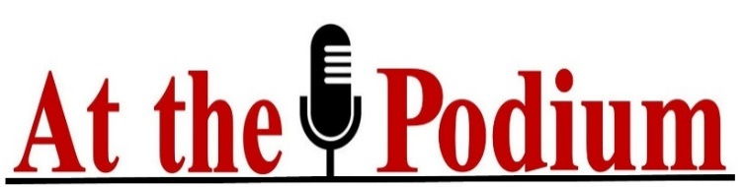

If you have official stationery with your logo on it and are making a more formal attempt to connect with an EP, you can use it. Obviously, it’s different with emails, texts, phone calls, etc.

Your Greeting: If a more formal approach is called for, you might begin with: “Dear Mr., Mrs., or Ms.” If it doesn’t need to be so formal, you could start with: “Hello Mary/Mario.”

If you have a referral, use it: “Our mutual friend XXX suggested I reach out to you.”

Your introduction: You could start with something basic like: “I’m XXX, a speaker, an XXX, etc.” Or with something different like: “I’ve attended several of the events you’ve organized over the past few years and they’ve all been great. So, I was really excited when I read you have an event coming up in XXX. This is a topic I’m very familiar with.”

Be upfront about why you’re reaching out: “I understand that you’re the person who books speakers for XXX and would like to know if I could send you information about myself and my signature presentation.” Or maybe, “I wanted to reach out to let you know I filled out the online application to be a speaker at your XXX event, and would be happy to have a conversation to provide you with any additional information….”

Give them an idea of what you can do for them: “I’ve been speaking to XXX audiences about YYY for Z years now, and I’d welcome the opportunity to share my problem-solving solutions with your audience….”

Give them an opportunity to learn more about you: “I’ve attached my Speaker One-Sheet so you can read more about my speaking experience.” You aren’t required to attach your Speaker One-Sheet though. You can share a link to your website speaker page, a digital profile page, video etc.—just choose the one that best represents why you’re a good match for the EP’s audience.

Your closing: Use this to make your intention with your communication clear. “I’m looking forward to hearing from you, (or) learning more about speaking at your event.” Or maybe: “Thank you for taking the time to read this. Please know that I’m happy to answer any questions or to provide you with more information.”

Sincerely,
XXXX
Title

Contact Information

Links to your contact information showing credibility:
Company
Email link
Website link
Other link
Social media link

