**HOW TO DELETE YOUR SIGN UP GENIUS RESERVATION**

If you created an account/login for sign up genius you can delete your own reservation.

Otherwise please call 860-429-3015 ext. 0 we will make the changes as soon as possible for you.

To change yourself, log in, click the appropriate tab, enter your access code.

Scroll down to the date you need to change and instead of a green “Sign Up” button it will read “Edit”

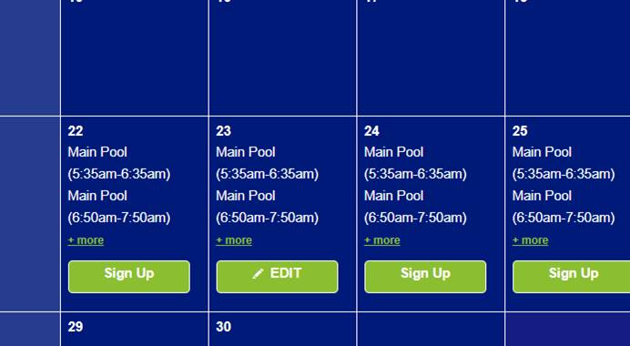

Click this button and again scroll to your current reservation time. You will then click the “x” to delete that reservation.

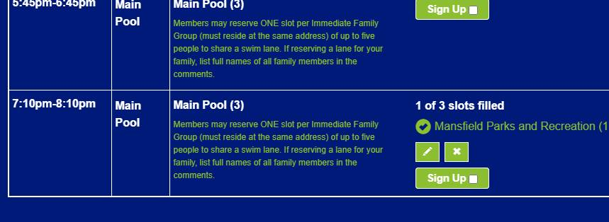

The system will ask you to confirm that you want to delete the reservation. Select “Yes-Delete”.

The calendar will then reload for you to select new times if you choose.