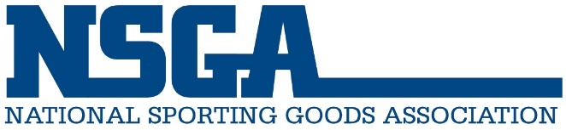
National Sporting Goods Association
3041 Woodcreek Drive
Suite 210
Downers Grove, IL 60515
(847) 296-6742
nsga.org

October 24, 2025

NSGA Comment: FTC Request for Information on Employee Noncompete Agreements

The National Sporting Goods Association (NSGA), the trade association representing companies operating over 21,000 sporting goods stores nationwide, helps its retailer and dealer members grow their business and advocates on their behalf.

At the direction of its board of directors in 2023, NSGA staff polled its members regarding whether they wanted the organization to comment on the Federal Trade Commission (FTC) proposal to ban noncompete clauses. Although the membership was divided on its opinion, a majority of respondents expressed support for the proposal. As such, NSGA supported the Federal Trade Commission’s proposed ban on noncompete clauses. NSGA also shared the opportunity for members to share their concerns directly with the FTC. One such example was posted on March 9, 2023 (ID FTC-2023-0007-1605).

Since the 2023 Request for Information, nothing has changed. In the sporting goods industry, noncompetes can be anticompetitive and result in barriers for small sporting goods retailers and dealers, which make it difficult for them to be profitable and continue in business. Loopholes and workarounds have rendered many noncompetes ineffective and are likely to result in expensive, prolonged legal matters with individuals bearing the cost of challenging a former employer. Furthermore, noncompetes have forced qualified persons out of the sporting goods industry due to their inability to earn a living in the industry.

The protection of confidential company information, intellectual property, and franchise rights are legitimate and significant concerns for employers. Subsequently, stronger enforcement of these measures should be addressed outside of noncompete clauses.

Noncompetes prevent workers from moving to better jobs, obstruct new business formation, stifle labor growth, and harm rival employers’ ability to compete. They are used as a punitive tool to restrict competition and keep employees from economic success. Should the FTC want to explore this further, please contact the National Sporting Goods Association at advocacy@nsga.org.

