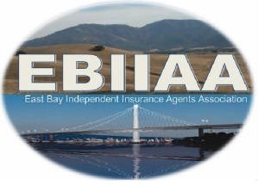
Independent Insurance Agents Association of Contra Costa County
DBA: East Bay Independent Insurance Agents Association
25A Crescent Drive #196, Pleasant Hill, CA 94523
Phone: 925-890-5781 Email: ebiiaa.dawnL@gmail.com

Holiday Gala 2025
Request for Raffle Donations
Dear Friends,

We thank you for your past support and we are hoping that we can count on your support and generosity again this year. EBIIAA will be holding their annual Holiday Gala on Tuesday, December 16, 2025 at Zio Fraedo’s Restaurant located at 611 Gregory Lane in Pleasant Hill.

We will once again be holding a benefit raffle. This year’s recipient of the raffle proceeds is

https://www.crisis-center.org/

We are in need of raffle prizes, gift cards and monetary donations for the charity raffle. If you are able to contribute, please complete the following:

☐ YES! We will provide a RAFFLE PRIZE

Please list/describe raffle donation (if known):

Company Name:

Contact Information:

We ask that you contact us regarding your donation by December 9, 2025 so that we can properly acknowledge your generosity at the Holiday Gala.

Please contact one of the following with your donation information and/or if you have any questions:
Jackie Tufo 510-396-8703 Jackie.Tufo@iwins.com
Or
Brianne Henderson 415-421-8332 ext. 303 brianne@deanshomer.com

On behalf of the Holiday Gala Committee and EBIIAA we thank you for your consideration and support!

