

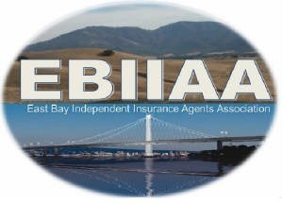

49th ANNUAL GOLF TOURNAMENT – Friday APRIL 10, 2026

GOLFER & SPONSOR REGISTRATION

name of each golfer | email or phone # | company name
SELECTION  $ TOTAL | AMOUNT | GOLFER FEES & SPONSORSHIP OPPORTUNITIES
 | $175 | SINGLE GOLFER
 | $700 | FOURSOME
 | $800 | FOURSOME WITH HOLE SPONSOR SIGNAGE ON COURSE
 | $1100 | FOURSOME WITH HOLE SPONSOR SIGNAGE & TABLING ON COURSE
 | $150 | HOLE SPONSOR - SIGNAGE ON COURSE
 | $350 | TABLING ON COURSE  INCLUDES 3 LUNCHES, COURSE PROVIDES A TABLE & 2 CHAIRS *DINNER IS NOT INCLUDED*
 | $50 | DINNER ONLY
 | GRAND TOTAL

Tournament proceeds benefit Monument Crisis Center

SPONSORS: list name as it should appear on signage

Company Name:
cONTACT nAME:
eMAIL & pHONE #:

____YES, WE WILL PROVIDE A RAFFLE PRIZE (S) PLEASE SPECIFY WHAT IS BEING DONATED IF POSSIBLE
____________________________________________________________________________________

___Invoice me to pay by check (Make Payable to EBIIAA & Mail to 25 A Crescent Dr. #196 Pleasant Hill, CA 94523)

___Pay via Credit Card Online at Zeffy: https://www.zeffy.com/en-US/ticketing/49th-annual-ebiiaa-golf-tournament

Please email the completed registration/sponsorship and golfer registration form to: DawnL Jones ebiiaa.dawnL@gmail.com or Sean Nixon at snixon@nixoninsuranceagency.com

