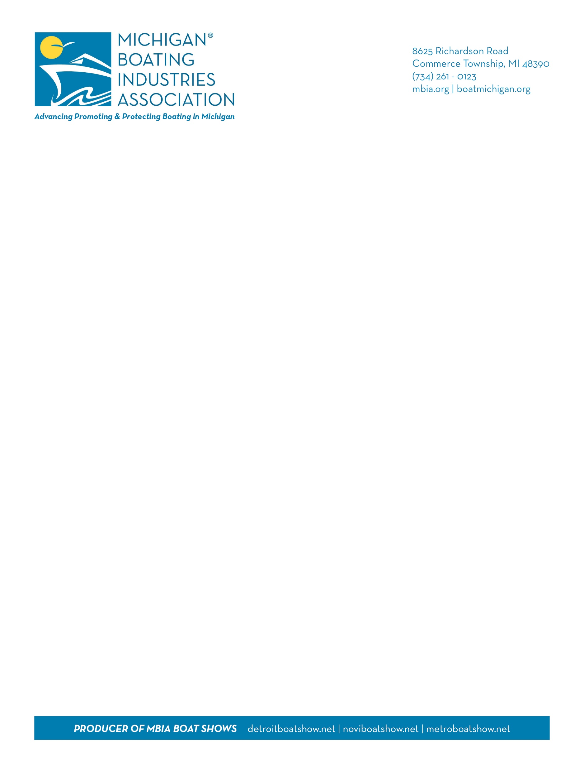
February 2, 2021
Dear Progressive Novi Boat Show Exhibitor,
Most of the respondents to our last Progressive Novi Boat Show (NBS) survey indicated they would need five weeks to prepare for the upcoming NBS scheduled for March 11 – 14, 2021. Our Boat Show Advisory Committee and MBIA Board met today to discuss the current situation and our show production.
We regret to inform you that due to the ongoing pandemic, and no response to our request to open shows at Suburban Collection Showplace under the “retail category” we are postponing the 2021 event and will begin to focus on our 2021 Progressive Metro Boat Show, September 16-19.
MBIA staff recently launched a brand new consumer website - Boatmichigan.org, with an easy-to-navigate directory of MBIA members, an event listing to promote in-house events during the typical boat show season, and more. Through this site, our social media and PR efforts, we will continue to work as an association to promote boating and your business to long-time boaters, as well as the thousands of new boaters in the state.
Our recent ad campaign produced more than 18,000 unique visits to this site in one week. As a member you receive a free listing in the directory and an opportunity to list all your promotions and events. If you would like to advertise on this site, please contact Bethany Sly at 734.261.0123, ext. 2 or bsly@mbia.org.
On behalf of the Michigan Boating Industries Association, we thank you for your patience and continued support. When it is safe to do so our indoor consumer boat shows will be back, and better than ever.
We extend our thanks and gratitude to our exhibitors, sponsors, members, and partners who have made the Progressive® Novi Boat Show a success for more than 29 years. On behalf of the MBIA Board of Directors and staff - we wish you all our best, and positive thoughts to you, your staff, and families.
Sincerely,
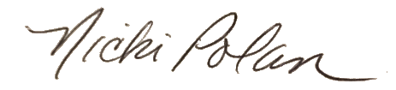
Nicki Polan
Show Manager and Executive Director

