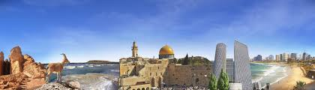
Covenant Land & Sea Bible Pilgrimage

hosted by Dr. Jim Garlow & Rosemary Schindler Garlow, Well Versed, Inc.
14 Days ~Saturday, October 14 to Friday, October 27, 2023
Approx. $3,700.00 per person, double occupancy Land Only. Includes: Deluxe lodging, two Israeli buffet meals a day, ground transportation, entrance fees, licensed tour guide, tips & much more. Add $1,000 for a single room.
DAY | Tour Details
Day 1  SAT.,  Oct 14  Depart  USA | Depart from your airline’s gateways to begin our Pilgrimage to Israel. Arrive at your USA international gateway at least three hours before departure time for the overseas flights overnight to Israel. Dinner and breakfast served onboard. Contact us for assistance in arranging your airline reservations and so we can help confirm your best arrival and departure times. We can recommend airlines and flight itineraries to coordinate with our group, even if you’d like to arrive a day or so early or stay longer than the group tour | 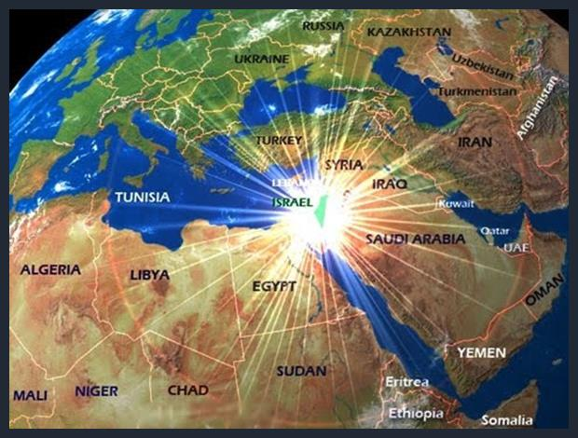  Born Again Nation
Day 2  SUN.  Oct 15  Netanya | Arrive at the Ben Gurion International Airport (TLV) in Tel Aviv. Our group will be welcomed by our agent at baggage claim and then board our bus to our hotel.  Dinner and overnight at our resort hotel on the Mediterranean Coast. | 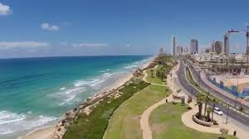
Day 3  MON.  Oct 16  Caesarea  Mt. Carmel  Nazareth | Israeli breakfast, check out of our hotel and depart for day’s tour.  - Caesarea Maritima and Aqueduct: Herod’s port city where Peter visited Cornelius, the Gospel was given to the Gentiles and Festus jailed Paul.  - Mt. Carmel: Mountain where Elijah called down fire on the altar and slew the Prophets of Baal; view the Valley of Armageddon from the overlook of the Jezreel Valley to Nazareth and the western Galilee.  - Mt. Carmel Assembly: Hebrew roots congregation and ministry center.  - Nazareth Village: Experience daily life in the time of Jesus at his boyhood home overlooking the Valley of Armageddon. This Jewish town is an authentic recreation to bring insight to the scriptures and teachings of Jesus.  Dinner and overnight at our Kibbutz Holiday Resort near the Sea of Galilee. | 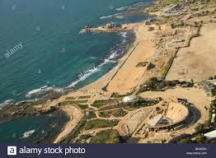  Caesarea  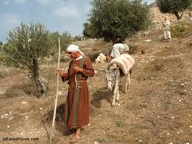  Nazareth Village
Day 4  TUES.,  Oct 17  Sea of Galilee | Israeli breakfast in our kibbutz hotel and depart for day’s tour.  - Boat Ride on Sea of Galilee: Sail in a replica of an ancient fishing vessel like those used in the time of Jesus as we worship on the water.  - Nof Ginnosar: See and learn about the discovery of the 2,000-year-old “Jesus Boat”, found by fishermen at the shore in 1986.  - St. Peter’s Fish lunch: Enjoy the traditional fish lunch of the Galilee.  - Capernaum: View Peter’s home, the first house church, and on-going excavations where Jesus taught healed, delivered all near the synagogue.  - Yardenit: Renew your baptism in the Jordan River at this traditional site.  Dinner and overnight at our Kibbutz Holiday Resort near the Sea of Galilee. | 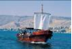  Sea of Galilee Boat  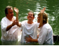
Day 5  WED.,  Oct 18 | Israeli breakfast in our kibbutz hotel and depart for day’s tour.  - Magdala: The town of Mary Magdalene and recently discovered archeological treasure of this 1st century commerce center. Visit the synagogue where Jesus preached at the Sea of Galilee and learn of the women who ministered to Him.  - Katzrin: Superb multi-media presentation of the Bashan, the Golan and Upper Galilee history up to the Yom Kippur War and its present-day restoration.  - Olive Oil Factory: Learn how olive oil is used for health and in the restoration of the Olive Trees and its biblical meaning and uses now restored to Israel.  - Golan Heights: View from the mountain of Israel’s northeastern Bashan.  - Mount Ben Tal: Mountain peak with great panoramic views of the Golan, Mount Hermon, Syria, and Lebanon. It was the site of a courageous battle fought during Israel 1973 Yom Kippur war. Explore the old bunkers and history.  Dinner and overnight at our Kibbutz Holiday Resort near the Sea of Galilee. | 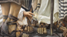  Magdala  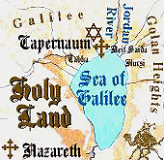
Day 6  THURS., Oct 19  Dead Sea | Israeli breakfast and check out of our hotel for day’s tour.  - Jordan River Valley: Drive down to the Galilee along the Jordan River Valley.  - Beit Hogla: House of Doves near Jericho and where Elijah established the school of the prophets, and rose in the chariot of fire, where Joshua crossed the Jordan, Jesus was baptized. Meet Robert Weinger, www.shofarsogreat.com  - Qumran: View the caves where the Dead Sea Scrolls were discovered 70 years ago. God’s Word restored to Israel ~ His promises fulfilled with the rebirth of Israel as prophesized in the scriptures  - Masada: Stand high above the Dead Sea at the 2,000-year-old fortress. A cable car takes you up to the cliff, to an unforgettable tour of the warehouses and fascinating views of the Judean Desert, Jordan, and the Dead Sea area.  - Dead Sea: Float in the sea - a unique experience, in the mineral rich water at the lowest spot on earth. Enjoy the unique atmosphere of a night in the desert.  Dinner and overnight at our spa hotel on shores of the Dead Sea. | 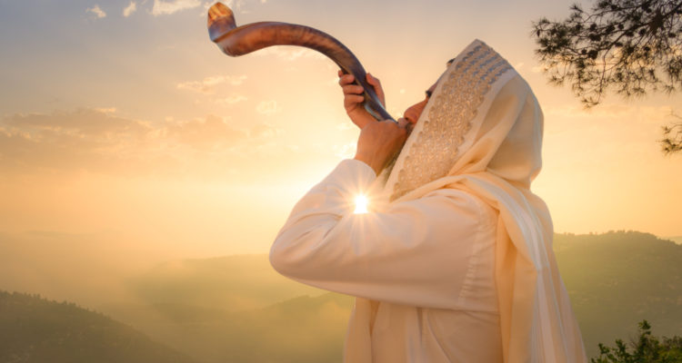  Shofar near Jericho  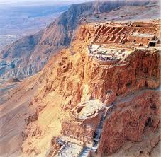  Masada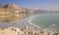  Dead Sea
Day 7  FRI.,  Oct 20  Negev Desert  Aravah  Red Sea | Israeli Buffet Breakfast in your hotel. Check out of hotel for day’s tour.  - Aravah Valley: Travel through the Aravah desert of the Great Rift Valley, a geographic name for the area south of the Dead Sea basin, which forms part of the border between Israel to the west and Jordan to the east. Its fascinating beauty rich in biblical history. Ezekiel 47 declares that a stream will flow from the temple East and South and will make the Dead Sea and Aravah bloom.  - Timna Park: See the model of Moses Tabernacle in the Wilderness at one of its original resting sites. A life-size replica includes the Laver and Altar in the outer court, the Menorah, the Incense Altar and the Table of Shew Bread. Inside the tabernacle is an Ark of the Covenant containing models of the Ten Commandments, the Rod of Aaron that budded, and the Pot of Manna. View the copper mines of King Solomon and the impressive landscape formations.  Shabbat Dinner and overnight at our lovely resort hotel in Eilat at the Red Sea. | 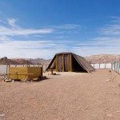  Moses Tabernacle  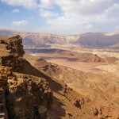  Timna Park
Day 8  SAT.,  Oct 21  Shabbat  Eilat | Israeli Buffet Breakfast in your hotel. Depart for day’s tour.  - Eilat Aquarium Underwater Observatory Coral and Marine Park. Walk through the underwater, glass tunnels allow you to view tropical fish and the colorful coral reefs with its marine life.  - Free time to enjoy this resort’s many shops, fabulous beaches, pools. Prepare to enter Shabbat and celebrate with a festive dinner and rest at our spa hotel.  - Petra: Possible option for a day tour of Petra in Jordan. (Additional charge)  Dinner and overnight at our resort hotel in Eilat at the Red Sea. | 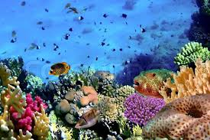  Eilat Aquarium  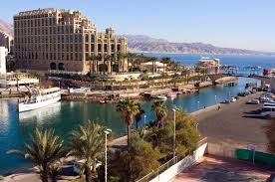Eilat Red Sea
Day 9  SUN.  Oct 22  Negev Desert | Israeli Buffet Breakfast in your hotel in Eilat. Check out of hotel for day’s tour into Israel’s spectacular Negev Desert.  - Ovda Wilderness: Despite its seeming bleakness, its soil is surprisingly rich. That is what made it prime land for settlement where the desert blooms.  - Mitzpe Ramon: View the 2,000-year “Grand Canyon” of Israel. Observe the vast Negev Desert, wilderness area of the biblical patriarchs and spice routes.  - Avdat: An ancient Nabatean city on the trade route from Arabia to the Mediterranean ports. Merchants carrying incense, perfume, and spices, along the route to Petra, crossed this road, called “The Incense Route”.  - Kibbutz Sde Boker: Pass by David Ben Gurion’s home in the Negev.  - Beersheba: Visit Abraham’s Well at the gateway to the Negev Desert. View the altar where God made covenant with Abraham, Isaac, and Jacob.  Dinner and overnight at our hotel in Jerusalem | 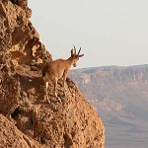  Mitzpe Ramon  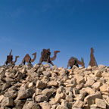  Avdat Incense Route  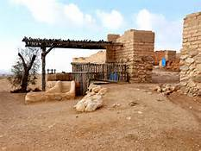  Abraham’s well
Day 10  MON.,  Oct 23  Old City Jerusalem | Israeli Buffet Breakfast in your hotel. Depart the hotel for day’s tour.  - City of David: The foundation of Jerusalem where King David had his palace and Israel’s kings were anointed. Shaped in a footprint, see Nehemiah’s walls.  - Pilgrimage Road: Newly excavated path from Pool of Siloam to the Temple.  - Davidson Center: Learn of Temple times and how pilgrims came to worship 2,000 years ago when King Herod rebuilt the temple.  - Southern Steps of the Second Temple: Come up to pray and stand on the very steps where Jesus taught and His Holy Spirit baptized 3,000 Jewish pilgrims observing Shavuot, the Feast of Pentecost, 50 days after His Resurrection. See the Pinnacle of the Temple and the Shofar Sounder site and the many mikvahs that prepared those who ascended with sacrifices.  - Western Wall: Place your written prayers written in the Western Wall of the Second Temple, one of the holiest sites in Judaism.  - Temple Institute: View the temple vessels, furniture, garments & history and learn how preparations have been made for Messiah’s soon coming.  - Jewish Quarter and Roman Cardo: Shopping in the heart of Jerusalem, see the restored synagogue, Golden Menorah, as we walk through the ancient streets of biblical history and modern-day restoration of Zion.  Dinner and overnight at our hotel in Jerusalem.  - “Night Spectacular” sound and light show. The walls David’s Citadel become the stage for a nighttime show celebrating Jerusalem’s 4,000-year-old history through virtual reality images telling the stories of King David, the Roman conquest, Muhammad, the Crusaders, and Suleiman the Magnificent, among other people and periods. Unbelievable, inspiring feast for the senses! | 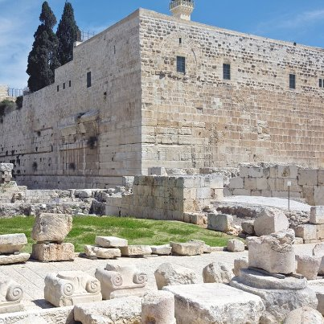  Southern Steps  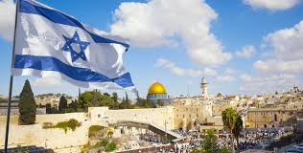  Western Wall Moriah  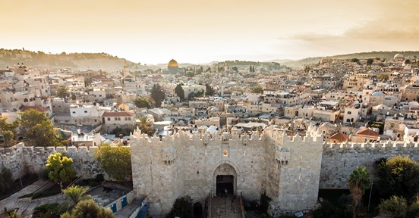  Jerusalem City Gate  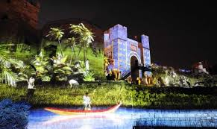  “Night Spectacular”
Day 11  TUES.  Oct. 24  Samaria  Covenant Heartland | Israeli Buffet Breakfast. Depart for day’s tour on the Road of the Patriarchs: Abraham, Isaac and Jacob, in Israel’s Covenant Heartland along the Mountains of Israel.  - Shiloh: Visit Israel’s first capital where Hannah prayed for a child, Samuel the Prophet. See the ancient tabernacle site, visitor center and the new community. Experience Israel’s 1st capitol for 369 years where life in Biblical times is recreated and the Lord’s Feasts celebrated where Joshua settled the Land.  - Bethel: Visit this holy covenant site on the Road of the Patriarchs where Jacob met with God and a ladder opened for angels to ascend and descend heaven. Genesis 28 tells how God told Jacob He was giving him the Land and that he would be a blessing to all nations. Jacob replied, “Surely God is in this place!”  Dinner and overnight at our hotel in Jerusalem.  Guest: Holocaust testimonies of Schindler Survivors Joseph & Rebecca Bau’s daughters | 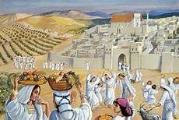  Ancient Shiloh  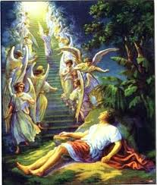  Jacob’s Staircase, Bethel
Day 12  WED.  Oct 25  Jerusalem | Israeli Buffet Breakfast in your hotel and depart for the day’s tour.  - Yad Vashem: Holocaust Memorial Museum to the Six Million Jewish people murdered in the Holocaust during World War 11, containing the world’s largest repository of information on the Holocaust. Walk through the time tunnel to learn how anti-Semitism progressed under Nazi Socialism resulting in the destruction of millions of innocent people. Discover danger signs so you will not be silent and prevent a reoccurrence of this tragedy – “Never Again”.  - Mt. Zion: Visit King David’s Tomb and the Upper Room, site of the Last Supper, a Passover Seder, and location of the Early Church.  - Grave of Oskar Schindler: Oskar is buried in the Christian Cemetery on Mount Zion in honor of saving over 1,200 Jews in the Holocaust.  - House of Caiaphas, St. Peter Galicantu: House of Jerusalem’s High Priest where Jesus stood trial and was denied three times by Peter before His death.  Visit the dungeon where He was lowered into the pit and jail cells where Peter and John were imprisoned for preaching the Gospel.  Dinner and overnight at our hotel in Jerusalem. | 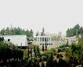  Yad Vashem  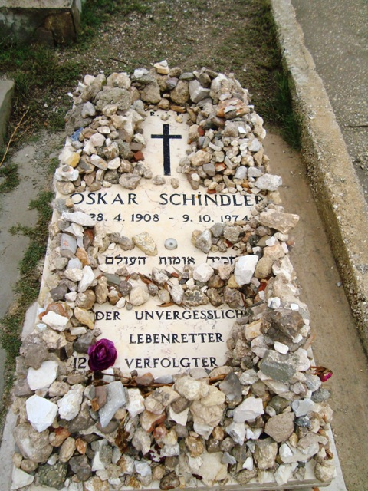  Oskar Schindler Grave  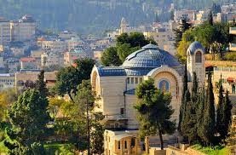
Day 13  THU.,  Oct 26  Mount of Olives  Jaffa | Israeli Buffet Breakfast in your hotel and check out of our hotel for the day’s tour.  - Mount of Olives: View the Golden City and enjoy the panoramic view of Jerusalem and it’s surrounding area, including the Kidron Valley and the Eastern Gate. This is the site of Messiah’s ascension and return.  - Garden of Gethsemane: Enter this lovely prayer garden with its ancient olive trees, some believed to date back to the times of Jesus and where He prayed the night of His betrayal by Judas and arrest.  - Church of All Nations: Overlooking the Valley of Jehoshaphat, location of the judgment of nations concerning their treatment of Israel. Joel 3:2, 12.  - Garden Tomb: See Golgotha and enter the tomb where Jesus rose from the grave in Jerusalem. Celebrate Messiah’s resurrection with a communion service.  - Friends of Zion Heritage Center: History of Christian support and participation in the return and restoration of the Jewish people back to their Promised Land and Zion; honors the Righteous Among the Gentiles.  - Jaffa –Ancient port of Jonah, where Peter healed Tabitha, and home of Simon the Tanner where Peter was called to the Gentiles, Acts 9-10.  - Farewell Dinner: Celebrate our wonderful journey in the Holy Land at a beautiful restaurant overlooking the Mediterranean Sea. Enjoy a fabulous feast of Middle Eastern dishes, a bountiful assortment of delicious food.  Transfer to the Ben Gurion International Airport to check-in for our flights back to USA. | 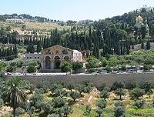  Mount of Olives  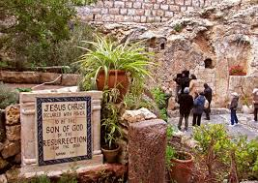  Garden Tomb  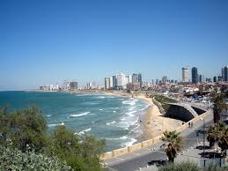  Jaffa/Tel Aviv
Day 14  FRI.  Oct 27  Return to  U.S.A. | Overseas and overnight flight with dinner and breakfast onboard. Pass through U.S.A. Customs and transfer to your domestic flights back to home.  End of Israel Tour – Itinerary subject adjustments and pleasant surprises! | 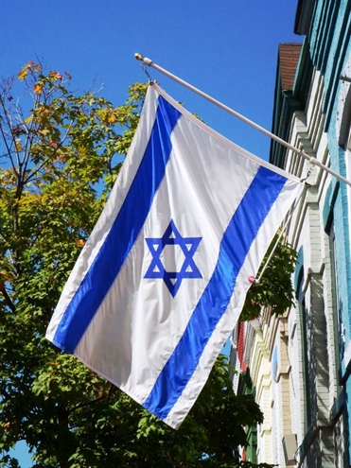

Israel Tour Includes:
- Greeting and assistance at Ben-Gurion Airport by our tour representatives and staff.
- Luggage porterage for your suitcases at the Ben Gurion Airport and at our hotels.
- 11 overnights in 4 star-Deluxe hotels: 1 night along the Mediterranean Shore, 3 nights near the Sea of Galilee at a Holiday Resort, 1 night at a Dead Sea and 2 nights in Eilat at Spa Resorts, and 4 nights in Jerusalem.
- 11 days sightseeing, special evening activities and guest ministries.
- English speaking, Bible-Believing, master Jewish tour guide throughout the entire tour.
- Individual headsets to adequately hear our guide onsite.
- Luxury air-conditioned coach and entrance fees to each location as noted on the itinerary.
- Meals: Israeli buffet breakfasts and dinners at hotels, a St. Peter’s Fish lunch and a Farewell Dinner.
- Official Israel Ministry of Tourism Ambassador for Israel Certificate and Travel Kit.
- Tips to our bus driver, tour guide, and the staff of our hotels and restaurants.
- Not included: Airline flights, expenses of a personal nature, such as souvenirs, bottled water, phone calls or travel insurance
For further information contact, Rosemary Schindler Garlow at schindlertours@yahoo.com, 1-510-677-4215 with www.lipkintours.com Aaron & Eti Lipkin, office@lipkintours.com Upcoming Tours 2023 Group Tours
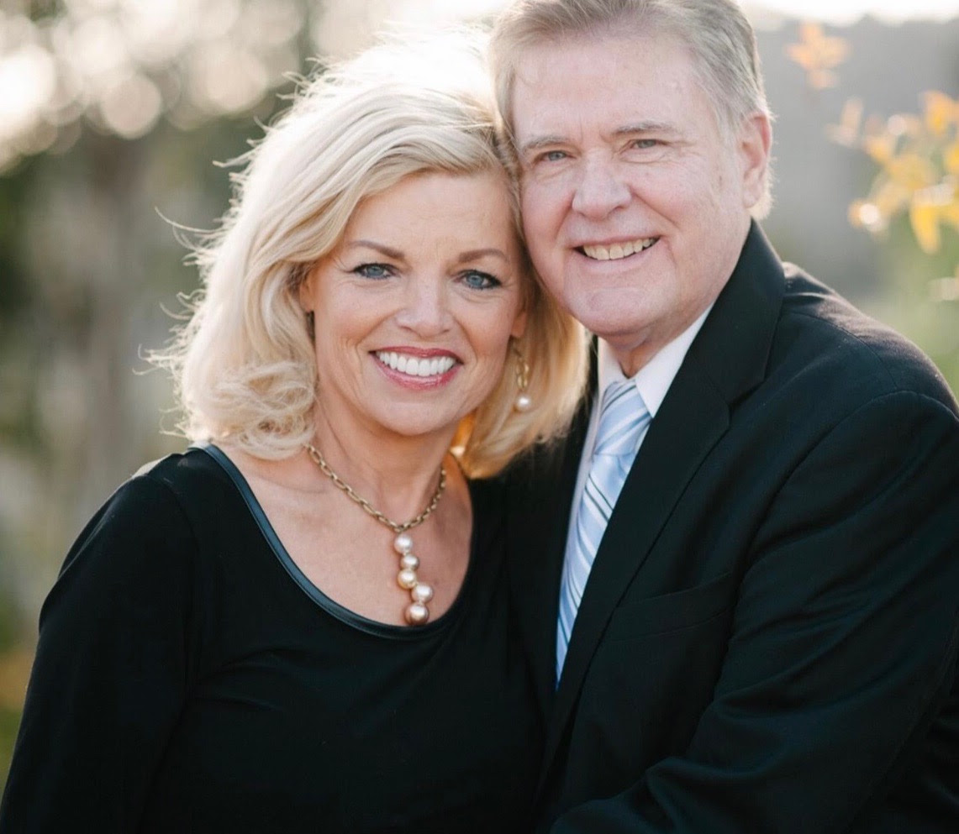 YOUR HOSTS – Well Versed and Schindler’s Ark
Dr. Jim Garlow has led trips to Israel, plus many USA Spiritual Heritage & European church history tours. He authored 21 books and is regularly on the Internet, Radio and TV.
Rosemary Schindler Garlow: Israel specialist with over 70 trips to the Holy Land hosting, coordinating, and speaking in connection with her family heritage seen in “Schindler’s List”.
Together they direct Well Versed, their ministry bringing Biblical governance to nations and based in Washington DC, at the UN and Jerusalem. www.wellversedworld.org They co-host WPN, the World Prayer Network, online Sunday, and Wednesday evenings at www.worldprayernetwork.org

REGISTRATION FORM ~ Covenant Land & Sea Bible Pilgrimage
hosted by Pastors. Jim Garlow and Rosemary Schindler Garlow, Well Versed.
14 Days ~Saturday, October 14 to Friday, Oct 27, 2023
Land Only: $3,700 per person, double occupancy. Includes: Israeli buffet breakfasts and dinners, deluxe lodging and bus transportation, site entrance fees, licensed tour guide, tips and much more. Single room, no roommate: + $1,000.00

PASSENGER NAME: Passengers are responsible to ensure that the names printed on this registration form EXACTLY match the first, middle and last name written in their passport. PLEASE ENTER DETAILS IN CAPITAL LETTERS. Name must be spelled exactly as it appears on your passport

LEGAL NAME: First: ____________________________________________Middle: __________________________________________Last:___________________________________________________

ADDRESS: ___________________________________________________________________________________________________________________________________________________________________

CITY: ________________________________________________ STATE: _______________ ZIP_________________________ CELL PHONE: __________________________________________________

EMAIL_______________________________________________________________________________________________

I’d like my nametag to read (If different from your passport name) _________________________________________ I am a citizen of _________________________

My Roommate is _____________________________________ I would like a Single Room: no roommate, add $1,000. ____________
I am registering for Land Only $3,700.00 __________ I want to add the Petra Day Tour, Sat., Oct. 21 for $400. ______

My Airline is _________________ My Flight Confirmation Code is: _________________________Group flights may be available on United Airlines.
My frequent flyer membership number is__________________. Please contact me with flight recommendations_____________________

Date of Birth______________________ Passport Number______________________________ Expiration Date_________________
Please include a copy of your passport photo page along with this signed Registration Form.
The Registration Deposit is $300.00 per passenger. Make checks out to Lipkin Tours, LTD
A 3RD person sharing a room, triple accommodations, or children to 12 years of age are $150.00 less each.

Medical Issues or Disabilities: ___________________________________________________________________________________
_________________________________________________________________________________________________________________________
Emergency Contact Info: Name: _________________________________________________________________________________
Relationship: _________________________________________ Phone: ____________________________________________________
Email address: ____________________________________________________________ City & State____________________________

PAYMENT Deposit- $300.00 per person due with this completed and signed Registration Form.
Your second payment of $1,500 pp is due by Thursday, June 15, 2023, 120 days prior to departure.
Your final balance is due by Monday, August 14, 2023, 60 days prior to departure.

Methods: CHECK: payable to LIPKIN TOURS, LTD or by CREDIT CARD. Tour Deposit: $300.00___________

Credit Card Number_________________________________________________ Expiration _____________________ 3 Digit Code__ __ __

2nd Payment $1,500.00 ____________ Date_________; Final Payment Amount_______________ /Date______________

Send this completed Registration Form with a copy of your passport photo page
and a $300 Deposit made out to LIPKIN TOURS, LTD to: Rosemary Schindler Garlow,
2514 Jamacha Road, Suite 502-120, El Cajon, CA 92019. Phone: 1-510-677-4215 schindlertours@yahoo.com Contact: Rosemary for online Payment and Registration options.

You may scan and e-mail copies of your registration documents to: schindlertours@yahoo.com. Per US policy, you cannot travel internationally if your passport is due to expire within six months of our travel dates. Please check the expiration date on your passport. For passport assistance: http://travel.state.gov/content/passports/english.html

I HEREBY AGREE TO THE FOLLOWING TERMS.

SIGNATURE: ____________________________________________DATE: ____________________

Covenant Land & Sea Bible Pilgrimage ~ 14 Days: Saturday, October 14 to Friday, October 27, 2023
Registration Terms and Conditions
DEPOSIT: $300.00 per person due with this completed and signed Registration Form. Your second payment of $1,500 is due by Thursday, June 15, 2023, 120 days prior to departure. Your final balance is due by Monday, August 14, 2023, 60 days prior to departure.
CANCELLATION FEES: CANCELLATION FEES: Up to 100 days prior to departure date, 7/6/23, a $150.00 cancellation fee. From 99 to 61 days prior, 8/14/23, to departure date, a $400.00 cancellation fee. From 60 days to 45 days prior, 8/30/23, to departure date, a $1,000.00 cancellation fee. From 45 days prior to departure date, and on – full cancellation fee (100%). We will make every effort to you as our passenger and will personally assist you in preparing your wonderful journey.
GROUP AIR PACKAGE OPTION INCLUDES: If available we will offer round trip airfare from West and East Coast Gateways. All air rates and schedules are subject to change prior to ticketing. Additional airport gateways will be available on and individual basis. Call for individual prices and air itineraries. We will travel as a group as much as possible, especially into and from Israel.
AIRLINES AND GROUP AIRFARE, if applicable: Once issued after final payment, tickets are non-refundable. Airline schedules and flights are subject to change without notice. Lipkin Tours, LTD and Schindler Tours are not responsible for penalties incurred for tickets, international or domestic, not issued by Lipkin Tours, LTD due to schedule and/or flight changes. Airline fuel charges are included in our group airfare if available. We reserve the right to amend your airfare due to increases in fuel surcharges imposed by your airline. Once issued, tickets are no longer subject to potential increases and are non-refundable but transferable. Due to COVID crisis airlines will refund individual fares.
Please note that we cannot guarantee and arrange specific seat requests on group seating, but this can be done at check-in. Passengers are responsible to reconfirm their flights 72 hours prior to departure for all flights. If you are an airline frequent flyer member, you can adjust and select your seats online by logging into your account. It is the passengers’ responsibility to know whether the airline reserved on their behalf participates in the passenger’s frequent flyer program, and to provide the information to their airline.
LUGGAGE: All tour packages allow one piece of luggage per person for check-in up to 50 lbs. and a carry-on bag, plus a personal item such as a purse or backpack. Excess luggage will be subject to a charge of up to $100 per piece. Lipkin Tours LTD and Schindler Tours are not responsible for excess luggage or weight charges levied by the airline.
DEVIATIONS from Group Flights if provided Any passenger deviating from the group flights will be subject to the airline charges for the actual itinerary of the deviating passenger, taxes, stopover fees, weekend surcharges, etc. Passengers can arrive or depart later than the main group dates, pre or post tour and book separate or their own flights to coordinate with our group arrival and departure schedule.
HOTEL ACCOMODATIONS: Will be provided in accordance with the itinerary or similar. All rooms are standard, king or twin-bedded rooms with private facilities, unless you have specifically requested and paid for an upgrade room category. Special requests such as connecting rooms are subject to availability. Lipkin Tours and Schindler Tours are not held responsible for damaged or lost luggage/personal items. All damages/loss must be reported at time of incident and documented in writing by local authorities to your insurance company.
TRANSPORTATION AND SIGHTSEEING: Enjoy our deluxe air-conditioned motor coach with licensed English speaking Jewish Bus Drivers and Tour Guides. We include individual headsets for each passenger to adequately hear our master guide at our sightseeing locations.
NOT INCLUDED IN PACKAGE: Travel Insurance (we recommend you purchase travel insurance coverage policies that would benefit you in case you had to cancel the trip due to a health or family emergency before and during the trip), COVID related medical coverage is available if needed upon entry or exit of Israel. Passport fees, border taxes when applicable, items not listed on standard group menus, mineral or bottled water, specialty coffee beverages, after meal beverages, personal expenses not indicated above or specifically mentioned in the itinerary (i.e. laundry, valet service, cables, telephone calls, postage, souvenir money, etc.)

Lipkin Tours LTD and Schindler Tours assumes no responsibility for any injuries, damages, losses, accidents, delays, schedule changes, or irregularity resulting from circumstances beyond the control of Lipkin Tours LTD and Schindler Tours to any person or reason including but not limited to default or omission of any private or commercial carrier or third-party providing services or facilities connected with this tour or any part thereof. Lipkin Tours LTD and Schindler Tours reserve the right to dismiss persons who disrupt the tour operation, our passengers or behave in a manner unacceptable to group travel and courtesy. The tour directors and hosts retain the right to terminate participation of any passenger displaying disruptive behavior, endangering fellow passengers, or interfering with the operations of the tour. Such a passenger will be responsible for his or her own additional expenses apart from the group.

Note: Short walks to and from site locations, getting on and off the bus, climbing stairs, walking on uneven cobblestone are part of the physical requirements of this trip. If you have any physical challenges that make it difficult to walk distances, up inclines, climb stairs, carry luggage, ride escalators, or ride in a wheelchair, etc., you will need to travel with a companion who can assist you. Also please notify us of any physical conditions that might affect you while traveling.

Not Included: Personal travel insurance: We recommend contacting Rich Huston directly for options at his Kansas City U.S. Office phone through Vonage at 913-244-3711 (8:00-5:30 CST) on your mobile phone, or the Signal App, or if using WhatsApp call +49-1765-770-9256. (Germany). Email: rich.huston@gmail.com. Travelex Insurance https://www.travelexinsurance.com/index.aspx?location=16-0067 or 1-800-228-9792 with reference Location Number 16-0067. COVID related coverage available if needed.

For further information contact, Rosemary Schindler Garlow, schindlertours@yahoo.com, 1-510-677-4215
Send this completed Registration Form, a copy of your passport photo page and your payment made out to LIPKIN TOURS, LTD. Info@lipkintours.com

We accept Credit Card Payments (only American Express charges an additional fee); call Rosemary with your information or pay online at www.lipkintours.com under “Upcoming Tours, 2022 Group Tours”
Email or mail to Rosemary Schindler Garlow, 2514 Jamacha Road, Suite 502-120, El Cajon, CA 92019

