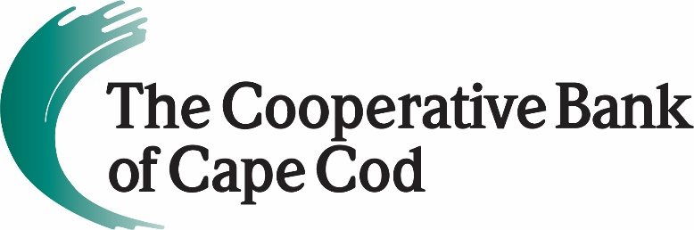

The Cooperative Bank of Cape Cod
Poised to Take Small Businesses to Next Level
October 4, 2021 (Hyannis, MA) – Building on its pandemic experience supporting business owners – no matter the business size or need – The Cooperative Bank of Cape Cod has expanded its expert team, streamlined loan products, and enhanced personal service.
“Our team was able to pivot to guide small business owners through an extraordinary time, securing much-needed funding and helping keep more than 15,000 people employed,” said Lisa Oliver, Chair, President and CEO of The Cooperative Bank of Cape Cod. The Bank helped over 1,000 small businesses obtain SBA Paycheck Protection Program loans, totaling over $116 million. “Now, with our ‘Big on Small Business’ initiative, our team will help take small business clients to the next level.”
In 2020, the Bank introduced the role of Small Business Specialist at each of its nine branches. That move was crucial in helping clients navigate PPP and withstand the economic impact of the pandemic. The specialists, supported by a full credit and lending team behind the scenes, created customized solutions for clients.
“These Small Business Specialists know the client, know their business, and are empowered to deliver tailored solutions,” said Sheryl Walsh, Senior Vice President, Chief Consumer & Small Business Banking Officer. “It’s about streamlining the process, while offering a more personal experience.”

The “Big on Small Business” program includes several new features for the small business owner. Most notably, The Coop is offering quick decisions on completed small business loan applications. The loan application process is streamlined and can be completed online, coupled with expedited funding following approval. The online application process has been significantly streamlined from traditional paper applications, making it easier and faster for business owners to seek capital.

“This is really the cornerstone of the program,” said Richard Zilewicz, Senior Vice President and Chief Commercial Banking Officer. “It’s about giving business owners easier access to capital and removing unnecessary barriers. Our team is committed to turning applications around.”

The Coop has dedicated resources to help business owners, too, and has bolstered its small business banking relationship team by creating a new position, Small Business Relationship Manager. Additionally, each of The Coop’s nine branches has a designated Small Business Specialist, who are dedicated to helping clients craft a financial plan that meets their goals – from payroll to merchant services, loans to online banking, and more.

Other elements of the program include competitive business credit cards; checking and savings accounts with compelling incentives; investment services; merchant card transaction processing; and payroll services, among others.
Learn more about the Small Business program at mycapecodbank.com.
About The Cooperative Bank of Cape Cod
The Cooperative Bank of Cape Cod is an independent, local, mutual community bank with over $1.3 billion in assets and 170 employees. Established in 1921, the bank is committed to investing in the Cape Cod community where we live and work. Throughout 2021, the bank will be commemorating the centennial of its founding with special events and programs, along with the “100 Reasons to Love the Coop” campaign to highlight what it has meant to generations of Cape residents, businesses and employees.
The bank is headquartered in Hyannis with branches on Route 6A in Yarmouth Port, East Dennis and West Barnstable; in Sandwich at 275 Cotuit Road; in Hyannis at 695 Attucks Lane in Independence Park; in East Harwich at 1470 Orleans Road/Route 39; in North Falmouth at 660 North Falmouth Highway; in Falmouth at 238 Worcester Court; and in Marstons Mills at 3878 Falmouth Road. For more information, please visit www.mycapecodbank.com, www.facebook.com/mycapecodbank, or call 508.568.3400.
###

