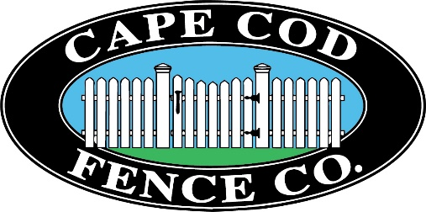

FOR IMMEDIATE RELEASE

Date: 4/17/20

Media Contact: Matt Pitta, Director of Communications

The Davenport Companies

(508) 760-9293/ (508) 962-6747

mpitta@thedavenportcompanies.com

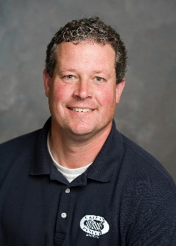
Cape Cod Fence Co. Names New General Manager
(SOUTH YARMOUTH, MA) – Cape Cod Fence Co. in South Yarmouth has named Mark Walsh, a more than 30-year employee of the company, as its new General Manager.
Walsh joined Cape Cod Fence Co. in 1988 while he was on summer break from Merrimack College in North Andover, MA and has been with the company ever since.
His first role was digging holes on fence jobs. After graduating from college, Walsh stayed with Cape Cod Fence Co. and worked his way up to foreman, ultimately taking a sales position in 1998, where he sold and oversaw the production and installation of fencing jobs across Cape Cod and the Islands.
In his new role as General Manager, Walsh will oversee the daily operations at Cape Cod Fence Co., working in conjunction with sales and installation team members.
“Mark has been an invaluable asset for more than 30 years and has the skills and attention to detail that will continue to make Cape Cod Fence Co. the region’s top installer of a variety of fencing and fencing-related products,” said Paul Rumul, president of The Davenport Companies, which is the parent company of Cape Cod Fence Co.”
“For Mark, it’s not just about installing a fence and moving on to the next job. He builds a relationship and trust with our customers and ensures every project is completed to superior standards,” said Rumul.
Since 1956, Cape Cod Fence has been one of the leading suppliers and installers of wood, metal, and vinyl fence products.
In additional to fencing, we offer expert professional year-round installations, sales and design of tennis court, pool, shower enclosures, gates, dog and horse fencing and accessories such as cupolas and flagpoles.

