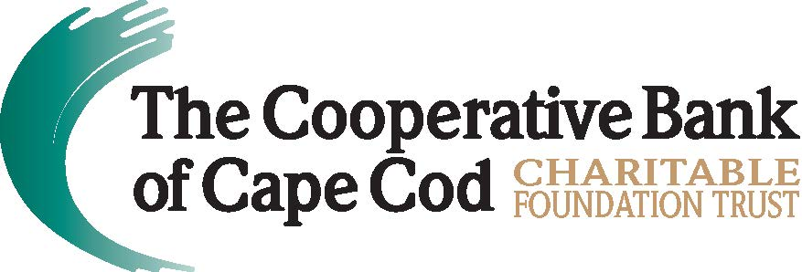

The Cooperative Bank of Cape Cod Charitable Foundation Trust
Awards $40,000 in Grants to Local Nonprofits
Cape Symphony, Champ Homes and Health Imperatives Named Beneficiaries for Third Quarter of FY2023; Bank Also Contributes to Cape & Islands Council of Boy Scouts of America, Cotuit Center for the Arts and Outer Cape Health Services
Hyannis, Mass. (January 4, 2023) -- The Cooperative Bank of Cape Cod Charitable Foundation Trust (The Coop Foundation) has awarded $40,000 in grants to six local nonprofit organizations dedicated to enhancing the quality of life in the region.
The new grants awarded mirror the bank’s corporate giving focus areas for fiscal year 2023 – Housing Initiatives and Solutions, and Social Justice and Racial Equity.
“I congratulate the extraordinary nonprofit organizations awarded Foundation grants this quarter – their dedication to making our communities better and more equitable places to live deserves recognition and support,” said Lisa Oliver, Chair, President and CEO, The Cooperative Bank of Cape Cod. “The challenges facing Cape Cod, especially the severe housing crisis, homelessness and poverty are significant and require all of us to participate in developing and implementing solutions, whether it be a financial commitment or through volunteerism.”
During the recent quarterly meeting of the Board of Trustees, the following grants were awarded:
- $10,000 to Champ Homes for its Transitional Housing Assistance Program, an intermediate step between emergency shelters and permanent housing that serves approximately 75 individuals annually who are on the brink of homelessness. The program addresses immediate concerns such as hot showers, clean towels, clothing and toiletries, an address for mail services, and food. Additionally, participants work closely with a team of care coordinators to navigate continuing education, access healthcare, complete housing applications, obtain employment, and learn to advocate for themselves.3

- $5,000 to Cape Symphony to support its ongoing initiatives to provide need-based financial assistance and scholarships for its arts education programs, which annually serve more than 20,000 school children throughout Barnstable County. Historically these scholarship awards range between 10% and 75% of the total tuition cost. In cases of extreme financial need, full scholarships will be ordered.

- $5,000 to Health Imperatives, Inc. to support its Partnering for Progress initiative for improving the coordination of immigrant services in Barnstable County. The initiative will spearhead outreach into immigrant communities, deliver training to nonprofit organizations to better assist immigrants, conduct resource fairs for immigrants to obtain information and services and launch a working group of nonprofits to streamline, coordinate and remove barriers to immigrant services. Health Imperatives’ Hyannis location serves nearly 6,000 people annually, of which approximately 40% are immigrants.
In addition, The Coop also distributed the next round of multi-year grants to three nonprofit organizations, including:
- $5,000 to Cape & Islands Council, Boy Scouts of America for a new Welcome and Education Center at Camp Greenough in Yarmouth.

- $10,000 to Cotuit Center for the Arts for its recently finished ceramics studio.

- $5,000 to Outer Cape Health Services for its new health center in Harwich.
About The Cooperative Bank of Cape Cod Charitable Foundation Trust
The Cooperative Bank of Cape Cod Charitable Foundation Trust is a 501(c)3 registered nonprofit in the state of Massachusetts with a mission to cultivate vibrant and thriving communities. Established in 2018, The Coop Foundation solidifies and formalizes The Coop’s commitment as a mutual bank to give back to the community, earmarking funds for philanthropy that won’t decrease according to the bottom line, but increase as the assets of the Trust grows. The Coop Foundation serves as an extension of the Bank’s current community giving program by enhancing and expanding it. For more information, please visit mycapecodbank.com/charitable-giving.
###

