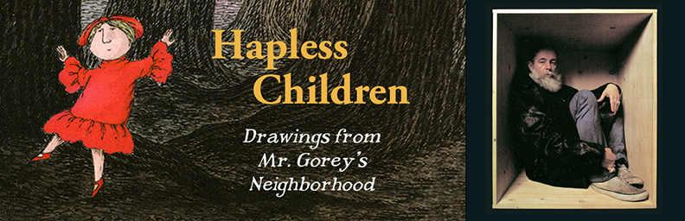

FOR IMMEDIATE RELEASE: MARCH 8, 2021
The Edward Gorey House opens its 2021 Season on Thursday, April 8, with:
Hapless Children
Drawings from Mr. Gorey’s Neighborhood

The Edward Gorey House • 8 Strawberry Lane, Yarmouth Port, MA 02675
508-362-3909 • edwardgoreyhouse@verizon.net • www.edwardgoreyhouse.org
Contact: Gregory Hischak, Director/Curator

As if the world of late wasn't unsettling enough without having a warning label slapped on our 2021 Exhibit—but here it is:

Hapless Children, the new exhibit at the Edward Gorey House in Yarmouth Port, is populated with a menagerie of children who all come to bad ends, and we urge that no emotional attachments be made to these children.

Most return visitors to the House already know this, but it’s worth bringing up again this year. In the surreal universe assembled from Gorey’s 116 books and various other works, published between 1953 and his death in 2000, children rarely fare well. Gorey's depiction of childhood is a harsh and wintery neighborhood where dark sedans glide out of frame; an unsavory world of abductions, consumptions, hailstorms, axes from heaven, and even meaner tricks of fate waiting in the shadows. In this neighborhood children themselves are either ignored, barely tolerated, dispensed with, forgotten about, or abandoned. Why display such carnage you ask? Because Gorey poses some very interesting questions about childhood and about the literature children feed on. Plus, Gorey’s drawings are sublimely crafted and often very, very funny.

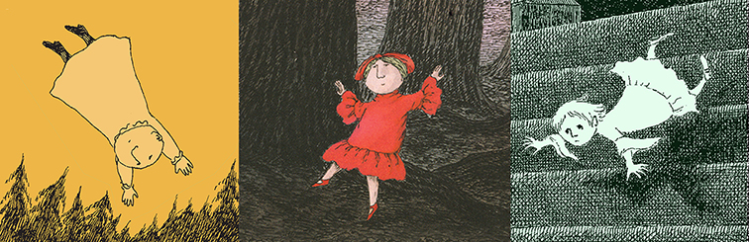
“I’ve been murdering children in my books for years.”
Edward Gorey (Conversations with Writers, Robert Dahlin, 1977)

In spite of Gorey’s somewhat murderous babysitting reputation, Hapless Children also demonstrates that Gorey was a prolific and sought-after illustrator for other children’s book authors like Peter Neumeyer, John Bellairs, Florence Parry Heide, and John Ciardi among others. Gorey’s reputation as a children’s book illustrator was such that he even taught classes in children’s book design in New York in the late 60s. While Gorey’s own books were almost always marketed away from children, he considered them to be Children’s Literature. Few publishers agreed with him, but both contemporaries of his, like Maurice Sendak, and later writers, like Lemony Snicker (Daniel Handler), found great success in mining those darker recesses of childhood.

Asked what he was like as a child, Edward Gorey frequently answered “Small.” It’s a brusque comedic quip that subtly hints at—and bluntly states–the vulnerability and powerlessness beneath childhood’s rosy veneer. Gorey isn’t interested in happy endings, he likes victims, and nothing dispenses with decorum faster than the involvement of a child. Dickens certainly played this card and he wasn’t alone in doing so. Borrowing from a broad and well-worn tradition of 19th Century penny-dreadful publications and children’s cautionary tales, Gorey rarely hesitates to use children to bring a poignant message home in his taut little tales.

Hapless Children is comprised of original artwork to several of Gorey’s iconic books, like The Gashlycrumb Tinies (1963) and The Doubtful Guest (1957) as well as lesser-known works like The Tuning Fork, The Beastly Baby, and The Retrieved Locket (all generously on loan from the Edward Gorey Charitable Trust). Examples of Gorey’s commercial children’s book illustration work are also on view, in addition to examples of older 19th century cautionary tales—which tend to be a lot more gruesome than Gorey’s work. The Gorey family album, as assembled by Edward’s mother Helen, is also on display throughout the exhibit.
Is Hapless Children suitable for children? Yes, kids who have discarded most of their inborn empathy (i.e. ages 7 and up) will have an excellent time —much to their parent’s dismay. The mayhem of Gorey’s work belies the fact that it works as children’s literature—just as Gorey always intended it. Each of his seemingly simple yet-beautifully heartless little books become helpful illuminations on what lies ahead for a child, carefully explained as if by another child. Lastly, we have an alternate warning label for this year’s exhibit and it reads:

Your Child may thank you tomorrow for the useful information you divulge today.

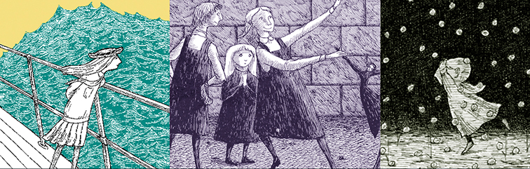

Additional Background Material about Edward Gorey
As an artist, Edward Gorey isn’t attached to a movement or a style, to a decade or even a century for that matter. Working in either New York or on Cape Cod for almost fifty years, Gorey’s work embraces a swath of Western arts & literature that includes Nonsense, Symbolism, Dada and Surrealism, while also reflecting the influence of Eastern arts, literature and philosophy. As a writer, illustrator, set and costume designer, his works are rife with the aesthetics of 19th Century engraving techniques, the cadences of an Agatha Christie novel and the visual dynamics of silent film. Twenty-one years after his death, Gorey’s work continues to remain several steps ahead of us.

2021 Hours for the Edward Gorey House are as follows: Spring Hours: April 8 to July 4:
Thu/Fri/Sat: 11am-4pm; Sun: 12-4pm. Summer Hours: July 7 to Oct 10: Wed thru Sat: 11am-4pm; Sun: 12-4pm. Fall/Winter Hours: Oct 15 to Dec 31: Fri/Sat: 11am-4pm; Sun: 12-4pm.
Due to limited capacity, reservations are highly recommended by calling 508-362-3909

House Admission: Adults: $8.00; Students, Teachers & Seniors: (65+): $5.00,
Children 6-12 years old: $2.00; Children under 6: free.

Images shown, and others, are available in high res upon request. Images used should include the credit Courtesy of the Edward Gorey Charitable Trust. For more information, please contact Gregory Hischak.
# # #

