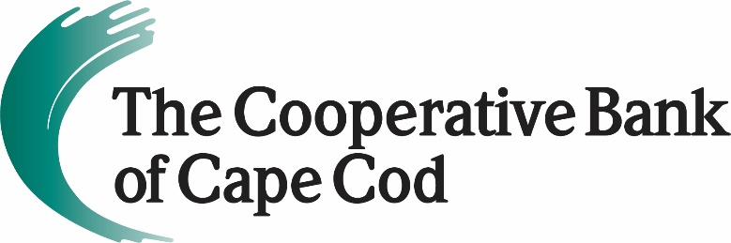

The Cooperative Bank of Cape Cod Named One of the Nation’s
Best Banks to Work For in 2022
American Banker Recognizes The Coop’s Workplace Environment for Third Consecutive Year
November 17, 2022 (Hyannis, MA) - The Cooperative Bank of Cape Cod has been named one of the “Best Banks to Work For” by American Banker magazine for the third consecutive year.
The “Best Banks to Work For” is an annual survey and awards program dedicated to identifying and recognizing the industry’s best employers and providing organizations with valuable employee feedback.
“To be recognized again for workplace excellence by American Banker is a profound and humbling honor,” said Lisa Oliver, Chair, President and CEO of The Cooperative Bank of Cape Cod. “It is particularly gratifying that this outstanding designation was significantly based upon an independent survey of all The Coop’s employees. In 2023, we look forward to evolving The Coop into an even better place to work.”
American Banker recognized 90 banks across the U.S. that have less than $3 billion in assets.
Determining the “Best Banks to Work For” involves a two-step process. The first step involves an evaluation of participating companies’ workplace policies, practices, and demographics. In the second step, employee surveys are conducted to directly assess the experiences and attitudes of individual employees with respect to their workplace. The combined scores determine the top banks and the final ranking. Full results of this year’s program are available at https://www.americanbanker.com/list/best-banks-to-work-for and in the November issue of American Banker magazine.
Empowering employees to strike an appropriate work-life balance is of utmost importance to bank leadership and played a significant role in The Coop’s award designation.
The Coop offers a “work where it works” program that provides hybrid work arrangements for many bank roles, to allow for flexibility and work/life balance. Family members are often invited to corporate events, and the bank helps to pay for childcare, offers flexible time off so employees can attend important family events and provides an extensive wellness program that supports an employee’s overall well-being.
Additionally, The Coop has multiple recognition programs that acknowledge exceptional customer service and collaboration, is committed to diversity, equity and inclusion in the workplace, and encourages volunteerism in the communities it serves.
About The Cooperative Bank of Cape Cod
The Cooperative Bank of Cape Cod is an independent mutual community bank with more than $1.3B in assets and 170 employees.
The Coop delivers a robust suite of digital and traditional banking products including mobile and online banking, person-to-person payments, business loans, mortgages, cash management, credit cards, merchant card transaction processing, payroll services and checking and savings accounts. The bank also offers dedicated staff and customized programs to support businesses of all sizes, a major driver of the regional economy, by offering products including construction loans, mortgage loans, lines of credit, term loans and time notes.
Through The Cooperative Bank of Cape Cod Charitable Foundation Trust, the bank is a prominent philanthropic partner with local nonprofits addressing needs and challenges of the community.
Headquartered in Hyannis, The Coop also operates nine full-service branch locations throughout Cape Cod and a mortgage office in Provincetown. For additional information, please visit www.thecooperativebankofcapecod.com, www.facebook.com/mycapecodbank or call 508-568-3400.
###

