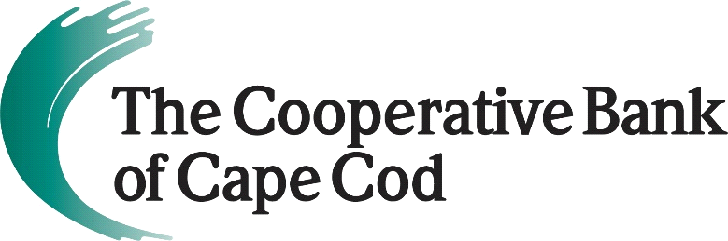

In Celebration of SBA’s National Small Business Week 2022…
The Cooperative Bank of Cape Cod Partners with Love Live Local
to Showcase Exceptional Small Businesses
May 2, 2022 (Hyannis, MA) – The Cooperative Bank of Cape Cod has partnered with Love Live Local, an advocacy organization dedicated to educating consumers on the importance of shopping local, to share stories of small businesses having a big impact on the community.
The Coop will provide financial support for the Shop Local Stories series, a year-long initiative to recognize small businesses throughout Cape Cod that contribute more to the community than simply providing goods and services.
The Shop Local Stories pay tribute to businesses in the region that give back to the community, provide exceptional customer service, support other local businesses or provide employment opportunities in a unique and interesting way.
Nominations for a business to be featured in Shop Local Stories can be submitted through a brief form at www.lovelivelocal.com/shoplocalstories. Selected businesses will be featured on the Love Live Local website, on its social media platforms and in a monthly email – a $500 value, underwritten by The Cooperative Bank of Cape Cod.
“I couldn’t think of better way to celebrate National Small Business Week than launching a partnership to honor local small businesses that are doing exemplary work in the community and providing superior service to our neighbors,” said Lisa Oliver, Chair, President and CEO of The Cooperative Bank of Cape Cod. “Every day, the Cape’s small businesses are going above and beyond simply conducting single transactions with customers and The Coop looks forward to working with Love Live Local to tell their stories.”
According to recent Love Live Local research, small businesses with 1-19 employees represent 90% of Cape Cod’s economy and keep 2-4 times as much money in the local economy as their national chain competitors. The organization’s research also shows that if just 10% of spending shifted to local retailers, an additional $112 million would be funneled into the Cape Cod economy annually.
In addition to the Shop Local Stories, The Coop is also providing $5,000 to underwrite the cost on the next iteration of the Local Matters report, a comparative survey detailing the impact of the independent and locally owned business community on Cape Cod. The first report, Measuring Impact, was released during the height of the pandemic in 2020 and focused on restaurants, hotels and retail businesses. The second report released last year, Investigating Influence, was a look into nationwide corporate concentration, consolidation and power and its impact on the local business community on Cape Cod. The goal in 2022 is to focus research efforts on business and personal services like printers, bookkeepers, and fitness centers and the impact of the shift to corporate and online commerce has had on mom-and-pop businesses in these sectors.
“We are grateful for the partnership and support of The Cooperative Bank of Cape Cod, which has long been a champion for our region’s small businesses,” said Amanda Converse, Chief Executive Officer, Love Live Local. “The Cape’s small businesses contribute more to the local economy than their corporate counterparts and deserve our support and recognition. We hope the community will find our Shop Local Stories series to be to be informational, inspiring and uplifting.”
About Love Live Local
Love Live Local is a Cape Cod organization dedicated to community advocacy and educating consumers on the importance of shopping local. Our mission is to foster an economically sustainable, creative and exciting future for the Cape and help all those who love this place participate in keeping it special.

Our aim is to work with local businesses to achieve their economic goals and communicate their importance to the sustainability of the Cape Cod community as a whole, as well as foster community connection among individuals and organizations in order to improve the overall health of our region.

About The Cooperative Bank of Cape Cod
The Cooperative Bank of Cape Cod is an independent mutual community bank with more than $1.3B in assets and 170 employees.
The Coop delivers a robust suite of digital and traditional banking products including mobile and online banking, person-to-person payments, business loans, mortgages, cash management, credit cards, merchant card transaction processing, payroll services and checking and savings accounts. The bank also offers dedicated staff and customized programs to support small businesses, a major driver of the regional economy.
Through The Cooperative Bank of Cape Cod Charitable Foundation Trust, the bank is a prominent philanthropic partner with local nonprofits addressing needs and challenges of the community.
Headquartered in Hyannis, The Coop also operates nine full-service branch locations throughout Cape Cod and a mortgage office in Provincetown. For additional information, please visit www.thecooperativebankofcapecod.com, www.facebook.com/mycapecodbank or call 508-568-3400.
###

