FOR IMMEDIATE RELEASE
July 25, 2021

Pastel Painters Society of Cape Cod Celebrates the Opening of its 25th Annual “For Pastels Only” National Exhibition, July 20 through August 14 at the Cultural Center of Cape Cod.

Award Winners Announced at Opening Reception.

For twenty-five years, “For Pastels Only on Cape Cod” has been the Pastel Painters Society of Cape Cod’s (PPSCC) premier juried show and sale, featuring paintings by internationally recognized contemporary artists with a wide range of artistic styles and subjects, including landscapes and coastal scenes, still life, and figurative work.

Local Sandwich, Mass. artist and Juror of Selection, Eileen Casey, IAPS-MC, was presented with the challenge of curating the work to include in this much anticipated annual exhibition. “My responsibility was to choose the best work to represent the Pastel Painters Society of Cape Cod.” said Casey. “It takes courage for artists to put their work and themselves out there. This as an opportunity for personal growth and improvement as an artist, an entrant and a juror.”

Artists, collectors, and visitors gathered Saturday night to celebrate the opening of the show at the Cultural Center of Cape Cod in South Yarmouth, Mass. More than $7,000 in cash and merchandise were awarded to 30 artists during the reception by Pastel Painters Society of Cape Cod President Dave Kaphammer.

Juror of Awards, Dawn Emerson, PSA , Bend OR, commented on how the artists’ unique expressions of beauty enrich our lives, “This show is a wonderful example of 100 different ways the humble pastel medium can be used to express the visual power of storytelling through imagery, and the healing power of witnessing, honoring, and experiencing nature through painting. This exhibit reassures me that humanity will survive and thrive as long as artists remind us of the beauty around us.”

Best in Show was awarded to Maryann Mullett, Fitzwilliam, NH, for her pastel, “Not Everything is Black and White.” Corey Pitkin, Broadalbin, NY, received the Award of Excellence for “Seated Nude,” and the Award of Honor went to Alex Kasyan, Montreal, QC, for “Morgan.”

The exhibition is free and open to the public. All works of art are available for viewing and purchase at the Cultural Center of Cape Cod and online at https://ppscc.org/2021-for-pastels-only-gallery/ .

The Pastel Painters Society of Cape Cod has more than 250 members in 30 states and is a member of the International Association of Pastel Societies (IAPS) which represents pastel societies from around the world. For more information visit https://ppscc.org/

Top Award Winners
Comments by Juror of Awards, Dawn Emerson

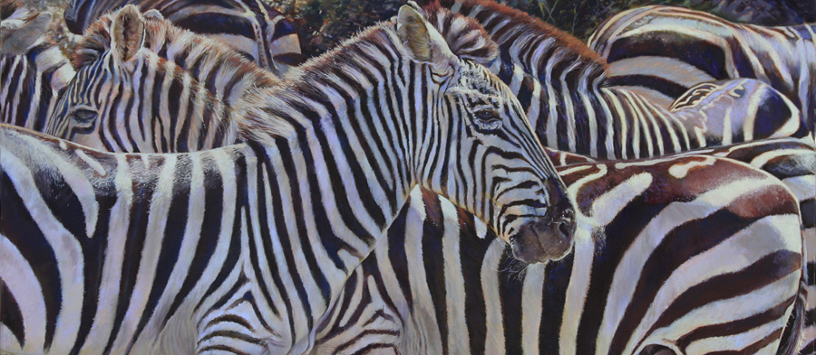

Best in Show: Maryann Mullett, “Not Everything is Black and White”

Juror’s Comments: “This striking painting of zebras is a tour de force of technique and design. The painting seems to move as we look at it, as our eyes follow the stripes that expand and contract in size like a slinky. We feel as though we are close in to the herd, yet able to see the subtlest changes of light, texture, and color on the surfaces of fur and skin. There is unity in the herd as a whole with this wide format, as well as individual nuances that let us enjoy each zebra separately. It's a fun painting to explore from nose to tail, and we as viewers can enjoy witnessing right along with the artist. A beautifully executed painting!”

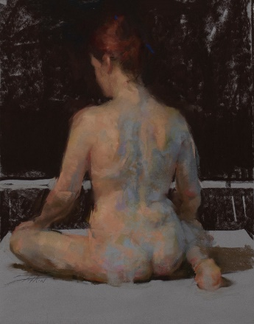

Award of Excellence: Corey Pitcan, “Seated Nude”

Juror’s Comments: “This small painting is packed with enormous mastery of the pastel medium. It appears effortlessly executed, yet demonstrates an exquisite handling of light and shadow, color, and form. The subject has such presence that we find ourselves wanting to know more about the model. The way the background is broken into simple dark and light horizontal intervals beautifully complements the description of her skin and weight. Detail is delivered with minimum description, and the design is elegant.”

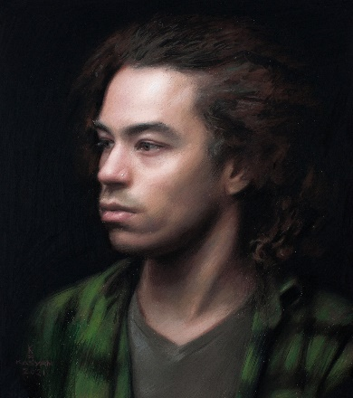

Award of Honor: Alex Kasyan, “Morgan”

Juror’s Comments: “This classical portrait is executed with such loving attention that the viewer senses the quiet presence of this young man. Every inch breathes with nuance and subtlety, and sublimely illustrates the magic of the pastel medium to capture the feeling of light and shadow on youthful skin, hair, and clothing. There is also a mystery to the portrait that beckons us to want to know more about this person.”

