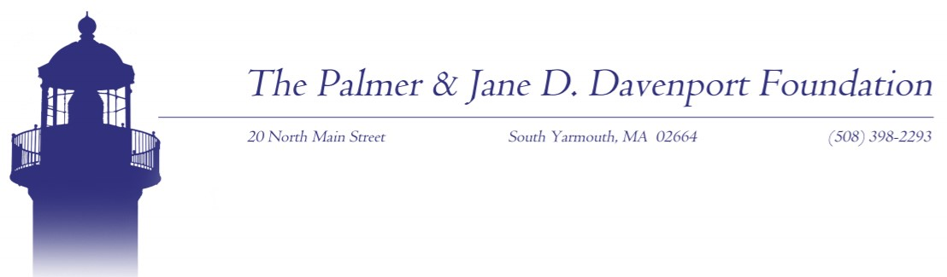

FOR IMMEDIATE RELEASE

Date: 01/11/2021
Contact: Matt Pitta, Director of Communication
The Davenport Companies
O 508.760.9293 / M 508.962.6747
mpitta@thedavenportcompanies.com

$40,000 AWARDED TO EIGHT CAPE COD NON-PROFIT ORGANIZATIONS BY THE PALMER AND JANE D. DAVENPORT FOUNDATION

(SOUTH YARMOUTH, MA) – The Palmer & Jane D. Davenport Foundation is pleased to announce that $40,000 has been awarded to eight Cape Cod non-profit organizations to fund missions ranging from Alzheimer’s assistance to housing and cancer support, among others.
The mission of The Palmer and Jane D. Davenport Foundation is to improve the health, welfare, and quality of life for people living on Cape Cod and the Islands.
The following organizations will each receive $5,000 in funding: Alzheimer’s Family Caregiver Support Center; Cape Cod Council of Churches; Cape Wellness Collaborative; Champ Homes; Community Health Center of Cape Cod; Duffy Health Center; Kennedy Donovan Center; and RFK Children’s Action Corps.
The mission of the Foundation is to broaden public access to the highest level of quality healthcare for residents and visitors and to foster opportunities for the creation and implementation of new technology acquisitions or facility expansion projects from regional health, social and human service agencies, or providers.
Organizations that receive funding are encouraged to leverage the grants to produce meaningful results and drive innovation that will complement comprehensive results.
Requests for future funding can be made by visiting www.davenportfoundation.org or emailing to request@davenportfoundation.org.
#

