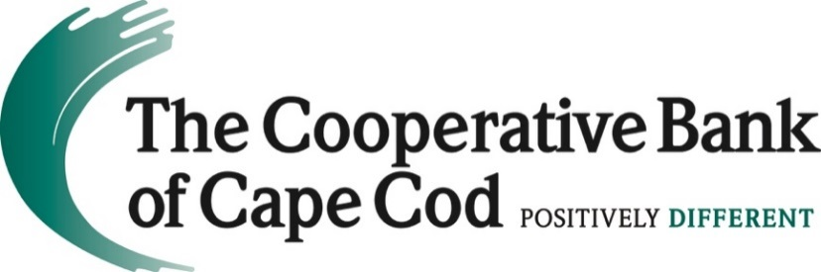

The Cooperative Bank of Cape Cod Named Among Boston Business Journal’s
Most Charitable Companies in Massachusetts
Hyannis, MA (July 22, 2022) -- The Boston Business Journal has named The Cooperative Bank of Cape Cod an honoree in its annual 2022 Corporate Citizenship Awards, a recognition of the region's top corporate charitable contributors.

The Business Journal annually publishes this list to showcase companies that promote and prioritize giving back to their communities – a feat that is even more important during times of turmoil and crisis, such as those we all collectively experienced throughout 2021.
“The past couple of years has presented companies and communities with many challenges, and the needs have continued to grow. It is with honor that we present our list of the Top Charitable Contributors in Massachusetts – companies who gave $100,000 or more to Mass.-based in charities in 2021. Collectively, they gave $322 million in cash contributions – a true example of the business community coming together to help those in need. We are proud to celebrate these organizations who give both money and time to make Boston a stronger and better place for all.” said Boston Business Journal Market President and Publisher Carolyn Jones.
This year, 95 companies have qualified for the distinction by reporting at least $100,000 in cash contributions to Massachusetts-based charities last year as noted above. The honorees this year include companies from such industry sectors as financial and professional services, health care, technology, retail, and professional sports.
“We are honored and proud to be recognized by the Boston Business Journal as one of the region’s most charitable companies,” said Lisa Oliver, Chair, President and CEO of The Cooperative Bank of Cape Cod. “Philanthropic support of local nonprofits working to keep our communities and neighbors strong, vibrant and healthy has been a hallmark of The Coop for more than a century. As Cape Cod’s needs evolve, so does our focus. That’s why we will be concentrating our charitable giving on housing solutions and racial equity and social justice issues during our fiscal year 2023.”
The Cooperative Bank of Cape Cod, whose contributions in many instances include both the corporation and its charitable foundation, will be honored at the BBJ’s 17th Annual Corporate Citizenship Awards on Thursday, September 8th at the Revere Hotel Boston Common (200 Stuart St., Boston) from 5:30pm – 8:30 pm. The evening will be filled with networking, making connections, and recognizing all the Charitable Contributors, the Alnoba Lewis Family Foundation CEO Social Leadership Awardee and our 2022 Corporate Citizenship Community Collaboration Awardees (previously our Partners of the Year).
For more information on the event and how to register to attend, click here.
The Boston Business Journal is the region's premier business media organization, one of 44 markets owned by American City Business Journals. For marketing and sponsorship opportunities, contact the Business Journal today.
About The Cooperative Bank of Cape Cod
The Cooperative Bank of Cape Cod is an independent mutual community bank with more than $1.3B in assets and 170 employees.
The Coop delivers a robust suite of digital and traditional banking products including mobile and online banking, person-to-person payments, business loans, mortgages, cash management, credit cards, merchant card transaction processing, payroll services and checking and savings accounts. The bank also offers dedicated staff and customized programs to support businesses of all sizes, a major driver of the regional economy, by offering products including construction loans, mortgage loans, lines of credit, term loans and time notes.
Through The Cooperative Bank of Cape Cod Charitable Foundation Trust, the bank is a prominent philanthropic partner with local nonprofits addressing needs and challenges of the community.
Headquartered in Hyannis, The Coop also operates nine full-service branch locations throughout Cape Cod and a mortgage office in Provincetown. For additional information, please visit www.thecooperativebankofcapecod.com, www.facebook.com/mycapecodbank or call 508-568-3400.
###

