
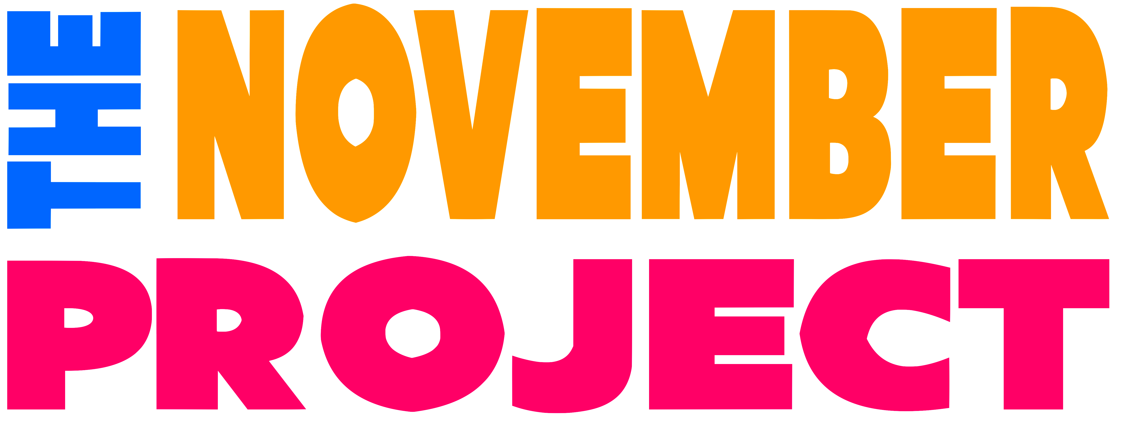
FOR IMMEDIATE RELEASE
CONTACT: Jared Hagan, 508-896-1888
publicity@caperep.org

Cape Rep Theatre presents The November Project
Over three weeks in October Cape Rep Theatre will present The November Project, a theatrical collaboration featuring over 60 singers, actors, choreographers, musicians, and Young Company members from Cape Cod. Each of three episodes will feature a different array of artists and actors our audiences have come to know and love in taped performances on Cape Rep Theatre’s campus, indoors and out. The November Project will stream free online at www.CapeRep.org and our YouTube channel.
Episode 1 airs on October 15 and will be available through November
Episode 2 airs on October 22 and will be available through November
Episode 3 airs on October 29 and will be available through November

About The November Project
The power of artistic endeavors, of theater, is to cultivate our shared humanity. The November Project recognizes the need to come together at this watershed moment in American History to search for strength, insight, common experience, authenticity, joy and purpose. Theaters cannot physically bring artists and audience together. Therefore the November Project is an effort to come as close as possible. The collective output of our work will be aired during the final three weeks leading up to the November election.

About the artists
Conceived and directed by Janine Perry and Maura Hanlon with Scenic Design by Ryan McGettigan and Lighting Design by Susan Nicholson. Performers include many of your favorite Cape Rep company members and its extended family all primarily from Cape Cod. This has been an intentional choice to bring the faces and considerable talent of our artistic and resident Cape Cod community closer together in this difficult time.

Cape Rep’s 2020 Season is made possible through the generous support of Cape Air, Zudy, Trish Metz, Cove Road Real Estate, Secure Storage, Friends Marketplace, Cape Cod Linen Rental, Specialty Builders’ Supply and Snowy Owl Coffee Roasters.

Cape Cod Repertory Theatre Company, Inc. is a 501c3 organization, founded in 1986 as a company dedicated to creativity and professionalism. On seven acres of land in Nickerson State Park in Brewster, Massachusetts, Cape Rep Theatre is the steward of the beautiful land and historic buildings that are home to the company’s three theaters, including the only outdoor theater on Cape Cod.

