Come and check out the NEW Rope’s End Restaurant in South Yarmouth
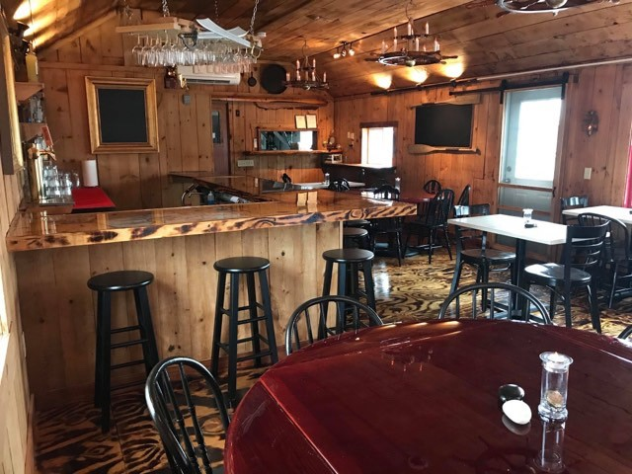
We are pleased to announce that Rope’s End Restaurant in South Yarmouth is now open! Serving dinner from 4 p.m. to 10 p.m. Friday through Tuesday. We invite you to indulge your inner pirate; our unique menu features a variety of appetizers, salads, original skewered entrees, house-made sides, and a 3 lb. smoked turkey leg. Feeling adventurous? Stop in to see our latest irresistible specials. Our bar offers a selection of local spirits and wine on tap. You’ll love our authentic pirate decor and warm, inviting atmosphere. If you’re looking for a location to host your private party or special event, see our website for contact information and to learn more about our flexible bar and catering arrangements. Outside patio available for seasonal use.
No treasure map is needed for those in search of something new — at Rope’s End, you can eat like a captain and drink with your crew!
Website: www.ropes-end.com

