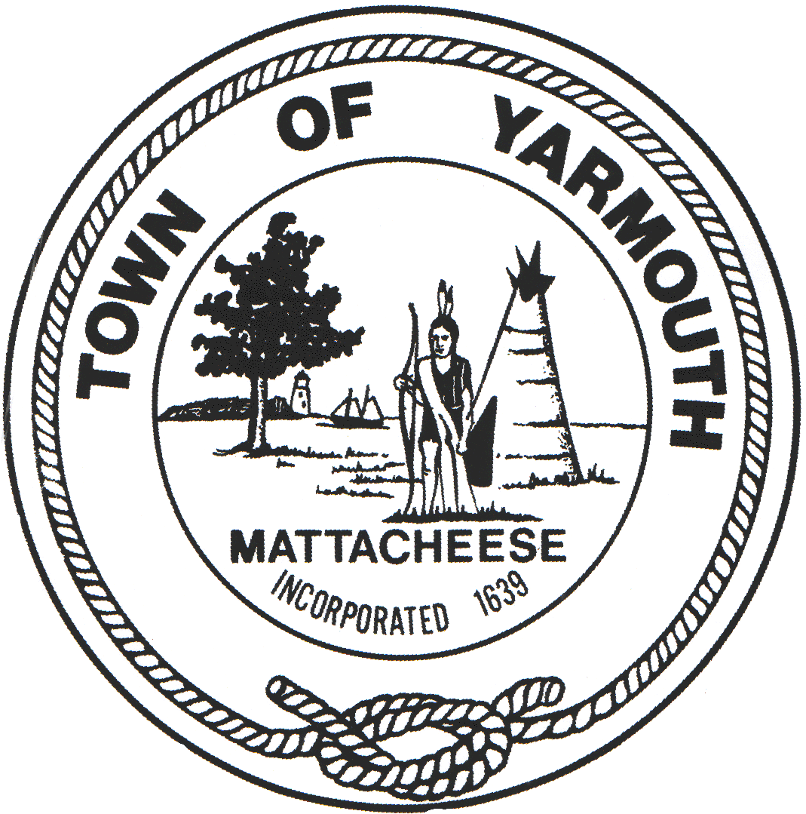 | TOWN OF YARMOUTH | Administration
 | DEPARTMENT OF PUBLIC WORKS | Engineering
 | 74 TOWN BROOK ROAD, WEST YARMOUTH, MA 02673 | Building & Grounds
 | Telephone (508) 398-2231 ext. 1250 Fax (508) 771-7998 | Highway
 |  | Waste Management
 |  | Water

For immediate release
November 2, 2022
PRESS RELEASE
Town of Yarmouth

The Town with their contractor Lawrence Lynch Corp. will be milling Highbank Road

Project Location: Highbank Road from North Main Street to Great Western Road

Date & Hours of operation: Friday November 4, 2022 from 7:00am-5:00pm

Description of Traffic Management: Traffic will be alternating lanes. Police details will be on site as well as a Town inspector. Drivers who are traveling through the affected area should expect delays, reduce speed and use caution. All work is weather dependent.

Please direct questions to the DPW Administrative office at 508-398-2231, Ext. 1250.

