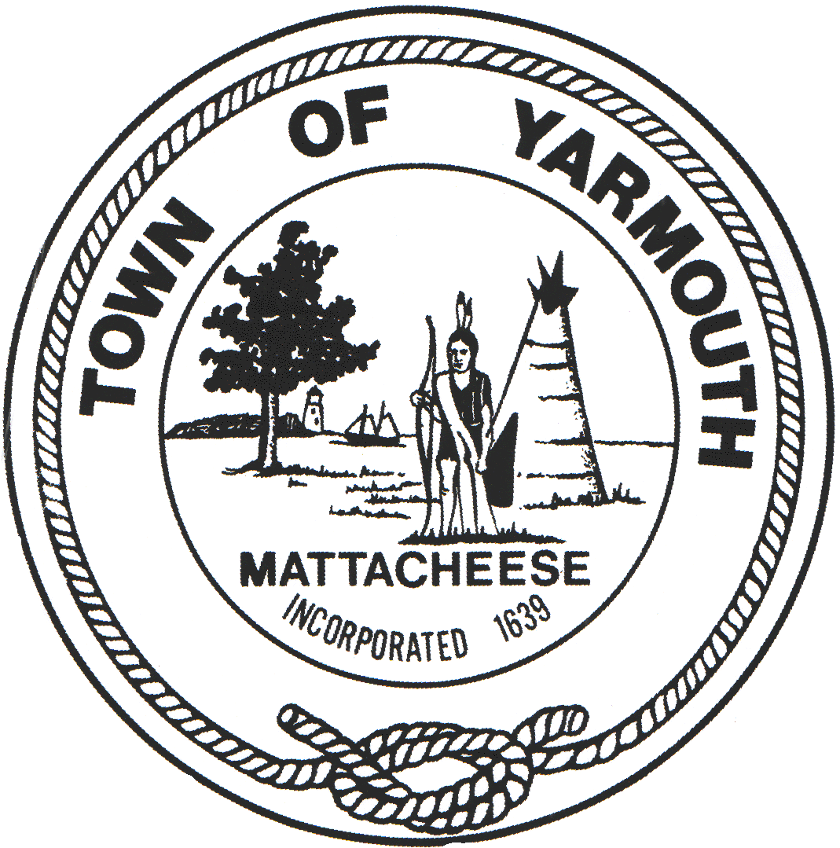 | TOWN OF YARMOUTH | Administration
 | DEPARTMENT OF PUBLIC WORKS | Engineering
 | 99 BUCK ISLAND ROAD, WEST YARMOUTH, MA 02673 | Building & Grounds
 | Telephone (508) 398-2231 ext. 1250 Fax (508) 771-7998 | Highway
 |  | Waste Management
 |  | Water

For immediate release
October 19, 2022

PRESS RELEASE
National Grid
Route 6A, Yarmouth Port
Expect Delays October 2022 through May 2023

Please expect traffic delays along Route 6A between the Barnstable Town Line to Summer Street.
National Grid with their contractor, Neuco Inc., will be replacing the existing gas main within the roadway of Route 6A between the Barnstable Town Line to Summer Street, Minden Lane and the northern portion of Willow Street.
Traffic will be alternating throughout the day from 7:00AM through 3:00PM; subject to MassDOT approval of modified hours.

Work is estimated to begin Monday, October 24, 2022 and continue through Friday, May 26, 2023.

Pedestrians and bicyclists, please use caution through the active construction zone.

Police Details will be on site at all times for traffic control & public assistance.
Please direct questions or concerns to the National Grid office at 1-800-233-5325

