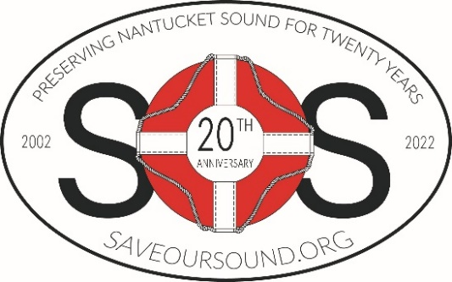
For Immediate Release

Alliance to Protect Nantucket Sound Press Contact: Peter Eramo, Jr.
4 Barnstable Road peter@saveoursound.org
Hyannis, MA 02601 540-226-7385

May 2, 2022

Alliance to Protect Nantucket Sound
Celebrates 20th Anniversary in May 2022
***** ***** ***** ***** ***** *****

The Alliance to Protect Nantucket Sound, the nonprofit environmental group dedicated to the permanent preservation of Nantucket Sound, celebrated its twentieth anniversary on May 2, 2022. The long-term mission of the Hyannis-based organization is the preservation of Nantucket Sound, the historic body of water that lies between Cape Cod and the islands of Martha’s Vineyard and Nantucket, including protecting traditional uses such as fishing and recreation, recognizing the Sound’s revered maritime and tribal history, and addressing water quality issues and other environmental threats to this special body of water.

Formed in 2002 in response to numerous growing environmental threats and the proposed Cape Wind project in Nantucket Sound, the Alliance has worked to defend the ecology and environment of the Sound, including efforts to prevent diminished water quality, coastal erosion, habitat degradation, and other effects of climate change.

Since the defeat of Cape Wind in 2017, the Alliance has focused its efforts on enactment of The Nantucket Sound National Historic Landmark Act (NSNHLA). This federal legislation would permanently protect and preserve Nantucket Sound, designate the Sound as a National Historic Landmark, and recognize its historic, environmental, tribal, and economic values. The Act would also provide significant environmental protections and prohibit the federal government from authorizing industrial projects throughout the Sound that are inconsistent with protections that exist under state law.

The Alliance has built a strong coalition in support of the NSNHLA at the local, state, and national level to include nearly 100 stakeholder groups representing tens of thousands of individuals. These include municipalities, tribal governments, environmental organizations, historic preservation groups, commercial fishermen, renewable energy developers, chambers of commerce, homeowners, and key elected officials.

-- page 1 of 2 --

“The Alliance has made significant progress towards our goal of protecting Nantucket Sound in perpetuity thanks to the continued support of our many donors and partners,” said Audra Parker, President and CEO of the Alliance to Protect Nantucket Sound. “For twenty years, the Alliance has been the only nonprofit environmental group dedicated to the protection and preservation of Nantucket Sound. This single and vital ecosystem lacks the meaningful protections that most bodies of water along the east coast enjoy. We will continue to pursue federal legislation and other actions so that Nantucket Sound is preserved for generations to come.”

The Alliance has also built successful educational programming to spread awareness of Nantucket Sound and the need to protect it. In the fall of 2020, the Alliance launched its virtual webinar series A Celebration of Nantucket Sound (ACONS). These free monthly webinars focus on important aspects of Nantucket Sound and each feature an expert guest speaker. Past episodes have covered the Sound’s contribution to the Blue Economy, its shipwrecks and historic sites, tribal history, unique wildlife, history of lighthouses, and fishing in Nantucket Sound, among others. To date, the ACONS series has been viewed by thousands of individuals locally and across the United States. The next webinar, Thursday, June 2 at 6pm (ET), will feature an overview of sea turtles, presented by the Sea Turtle Stranding Coordinator at Mass Audubon’s Wellfleet Bay Wildlife Sanctuary.

The Nantucket Sound Ambassador Program, launched by the Alliance in the fall of 2021, is a partnership between the Alliance and local schools on the Cape and Islands. This program encourages high school students to be responsible stewards in protecting and preserving Nantucket Sound. This spring, the students from the Mashpee High School Environmental Club participated in a beach cleanup at Popponesset Spit in Mashpee.

For more information about the Alliance to Protect Nantucket Sound or to speak with Audra Parker, please contact Peter Eramo at 540.226.7385 or peter@saveoursound.org.

ABOUT THE ALLIANCE TO PROTECT NANTUCKET SOUND
The Alliance to Protect Nantucket Sound is a 501(c)(3) non-profit environmental organization dedicated to the permanent preservation of Nantucket Sound, the historic body of water that lies between Cape Cod and the islands of Martha’s Vineyard and Nantucket. The goal of the Alliance is to establish Nantucket Sound as a protected area and designating it as a National Historic Landmark. This federal legislation would recognize its historic, environmental, and economic values; prohibit federal industrial development inconsistent with safeguards under state law; protect existing maritime and fishing uses and address threats to water quality, coastal erosion, and habitat degradation.

The Alliance, along with a diverse coalition of stakeholders including environmental groups, tribal entities, municipalities, commercial fishermen, historic preservation groups, chambers of commerce, renewable energy advocates, and others have joined together to introduce federal legislation to protect Nantucket Sound in perpetuity.

For more information, please visit www.saveoursound.org.

# # #

