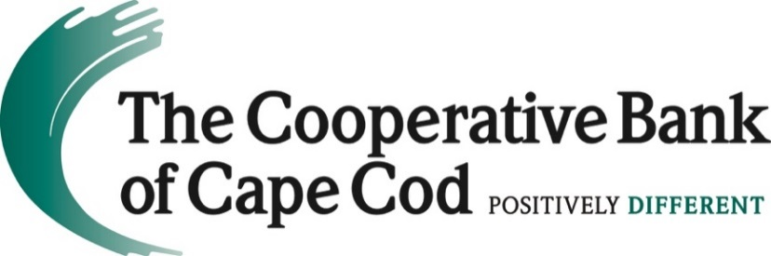

The Cooperative Bank of Cape Cod Nominee FAIR Project, Inc. Receives Grant from Massachusetts Bankers Association Charitable Foundation
Hyannis, MA (November 28, 2022) -- The Cooperative Bank of Cape Cod announces that FAIR (Financial Assistance in Reentry) Project, Inc., its nominee for a Massachusetts Bankers Association (MBA) Charitable Foundation award, has received an Honorable Mention designation with an accompanying $1,500 grant.
FAIR Project, Inc. is a Cape-based nonprofit organization that is dedicated to improving the lives of formerly incarcerated people through financial lending and community support. It helps recently released individuals legitimately overcome financial barriers to get resettled in their communities by providing low-interest loans. Repaid principal and interest are reinvested, which increases the organization’s capacity to serve more individuals.
“FAIR is very grateful to the Massachusetts Bankers Association for their generous donation, and to The Cooperative Bank of Cape Cod for nominating us,” said Jud Phelps, vice president, FAIR Project, Inc. Board of Directors. “The formerly incarcerated population on Cape Cod is a vulnerable group who face unique challenges. FAIR will put this donation to good use and make a significant difference in the life of a person who truly needs it.”
Additional information about FAIR Project, Inc. can be found here.
“FAIR Project gives hope for the future by providing a second chance to formerly incarcerated individuals returning to the community and looking to rebuild their lives,” said Lisa Oliver, Chair, President and CEO of The Cooperative Bank of Cape Cod. “The Coop is proud to support FAIR Project and its efforts to provide clients with resources needed for successful reentry and reducing recidivism.”
Past recipients of funding from the MBA Charitable Foundation nominated by the bank include Amplify POC Cape Cod, Calmer Choice, Cape Kid Meals, Duffy Health Center, and Pause A While.
About The Massachusetts Bankers Association Charitable Foundation
The Association established the Massachusetts Bankers Association Charitable Foundation in 1996 to highlight the contributions -- currently around $106 million -- that Massachusetts-based banks make to deserving community organizations throughout the Commonwealth. On behalf of the industry, the foundation makes major gifts annually to deserving non-profits nominated by member banks in their respective areas. To date, the Foundation has dispersed over $3.07 million in awards to local organizations.
Gifts from the Massachusetts Bankers Association Charitable Foundation are made on the basis of nominations by our member banks. Applications are not accepted from organizations themselves. Therefore, Massachusetts-based social service organizations that are local, not statewide, may want to talk to banks with whom they have relationships before the next award cycle begins each September.

About The Cooperative Bank of Cape Cod
The Cooperative Bank of Cape Cod is an independent mutual community bank with more than $1.3B in assets and 170 employees.
The Coop delivers a robust suite of digital and traditional banking products including mobile and online banking, person-to-person payments, business loans, mortgages, cash management, credit cards, merchant card transaction processing, payroll services and checking and savings accounts. The bank also offers dedicated staff and customized programs to support businesses of all sizes, a major driver of the regional economy, by offering products including construction loans, mortgage loans, lines of credit, term loans and time notes.
Through The Cooperative Bank of Cape Cod Charitable Foundation Trust, the bank is a prominent philanthropic partner with local nonprofits addressing needs and challenges of the community.
Headquartered in Hyannis, The Coop also operates nine full-service branch locations throughout Cape Cod and a mortgage office in Provincetown. For additional information, please visit www.thecooperativebankofcapecod.com, www.facebook.com/mycapecodbank or call 508-568-3400.
###

