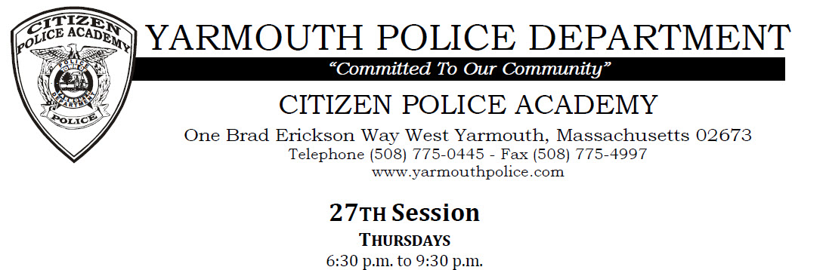

The Yarmouth Police Department is proud to announce the open enrollment for the 27th session of the Citizen Police Academy. The program is slated to begin on Thursday January 23rd and ends on April 9th. This program offers a comprehensive behind-the-scenes look at modern progressive law enforcement in Massachusetts and our community.
The Academy meets primarily on Thursday evenings from 6:30 PM to 9:30 PM in the Law Enforcement Training Center at the Yarmouth Police Headquarters.
The Citizen Police Academy is a program designed to open the lines of communication between the Yarmouth Police Department and the community. It is the sincere desire of the Yarmouth Police Department to develop a style of policing that reflects a collaborative effort between the community and police. This process requires an informed citizenry and it is the goal of the CPA to increase “Understanding through Education
Applications must be submitted via the online registration portal. To apply please visit the Yarmouth Police Department Website under the tab “ About us” or click on the following link:
http://yarmouthpolice.com/about-us/citizens-police-academy/

