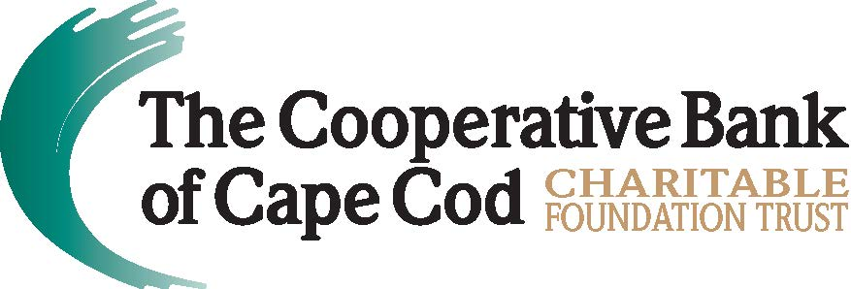

The Cooperative Bank of Cape Cod Charitable Foundation Trust
Awards $30,000 in Grants to Local Nonprofits
B FREE Wellness, Cape Cod Children’s Place, Cape Cod Military Support Foundation, Cape Cod Toy Library and WellStrong Named Beneficiaries for Fourth Quarter of FY2021
March 2, 2022 (Hyannis, MA) - The Cooperative Bank of Cape Cod Charitable Foundation Trust (The Coop Foundation) has awarded $30,000 in grants to five nonprofit organizations that enhance quality of life by addressing fundamental needs and challenges in the community.
During the quarterly meeting of the Board of Trustees, the following grants were awarded:
- $5,000 to B FREE Wellness, to help facilitate the organization’s move to a larger location in Hyannis, enabling it to expand programs as well as establish a wellness co-op by offering rental space to other wellness practitioners. B FREE transforms people’s lives by providing free and affordable movement, mindfulness and coaching programs to those affected by trauma, addiction and oppression.
- $10,000 to Cape Cod Children’s Place, which will fund Phase II of its “Creating a Culture of Resistance” initiative to support children and families impacted by trauma, especially on the Lower and Outer Cape which has been inordinately affected by the pandemic. Cape Cod Children’s Place builds resiliency and strength in Cape Cod families by providing resources, referrals, high-quality early childhood education, advocacy and support to sustain healthy communities for the region’s future.
- $5,000 to Cape Cod Military Support Foundation Inc., to renovate the former Sandwich Police Station into a second Empowerment Center. The current Center is located on the Base and can be a challenge to access for those who do not reside or work there. The new facility will allow for greater accessibility for clients and volunteers, as well as the expansion of programs and services, including a food and clothing pantry, to improve the lives of veterans, military personnel and their families. The on-Base Center will remain open as well.
- $5,000 to Cape Cod Toy Library Inc., an organization that provides enriching, culturally sensitive educational environments to promote learning through play experiences to foster healthy child development. The grant will be dedicated to the creation of an “Outdoor Play Oasis” at the Hyannis Public Library designed to engage families and enhance children’s play-based learning.
- $15,000/3 years to WellStrong, a fitness and wellness community for people in recovery from substance abuse disorder. The grant will be used to expand an already successful program that creates professional growth and career opportunities for members in recovery. The program promotes economic self-sufficiency by offering fitness certifications for up to five members per year for three years.
"The pandemic shined a spotlight on the Cape's nonprofits, illuminating the critical work they undertake, even during challenging times, to keep communities strong and provide those in need with assistance and compassion," said Lisa Oliver, President, Chair and CEO of The Cooperative Bank of Cape Cod. “The latest group of Foundation grant recipients serves the needs of some of our most vulnerable neighbors, including children, veterans, trauma survivors and those in recovery. The Coop Foundation is proud to support these remarkable organizations that are supporting the health and wellness needs of our communities.”
About The Cooperative Bank of Cape Cod Charitable Foundation Trust
The Cooperative Bank of Cape Cod Charitable Foundation Trust is a 501(c)3 registered nonprofit in the state of Massachusetts with a mission to cultivate vibrant and thriving communities. Established in 2018, The Coop Foundation solidifies and formalizes The Coop’s commitment as a mutual bank to give back to the community, earmarking funds for philanthropy that won’t decrease according to the bottom line, but increase as the assets of the Trust grows. The Coop Foundation serves as an extension of the Bank’s current community giving program by enhancing and expanding it. For more information, please visit mycapecodbank.com/charitable-giving.
About The Cooperative Bank of Cape Cod
The Cooperative Bank of Cape Cod is an independent mutual community bank with more than $1.3B in assets and 170 employees. The Coop delivers a robust suite of digital and traditional banking products including mobile and online banking, person-to-person payments, business loans, mortgages, cash management, credit cards, merchant card transaction processing, payroll services and checking and savings accounts. The bank also offers dedicated staff and customized programs to support small businesses, a major driver of the regional economy. Headquartered in Hyannis, The Coop also operates nine full-service branch locations throughout Cape Cod and a mortgage office in Provincetown. For additional information, please visit www.thecooperativebankofcapecod.com, www.facebook.com/mycapecodbank or call 508-568-3400.
###

