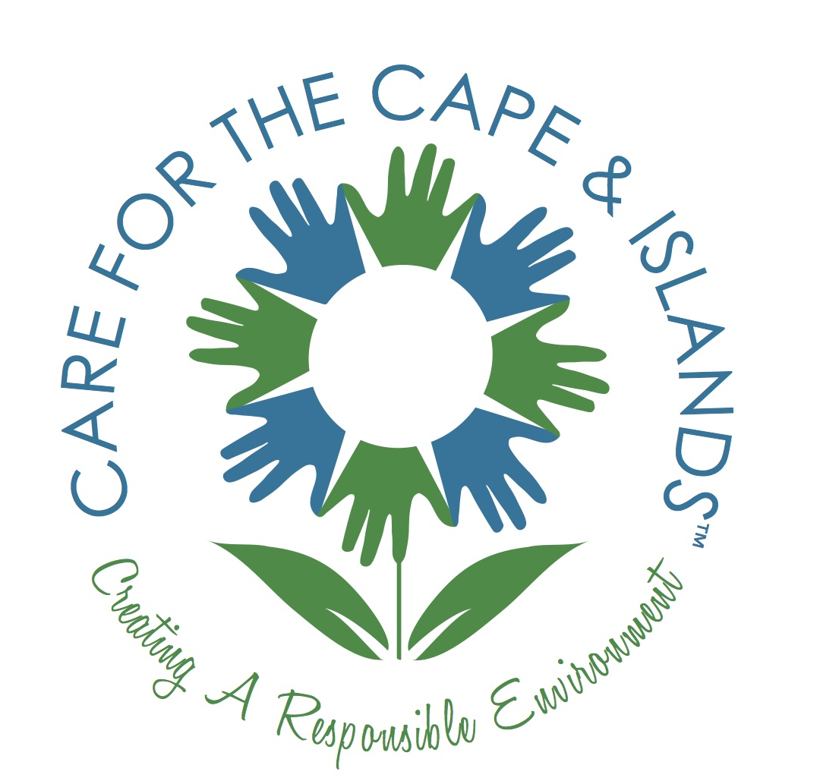
CARE for the Cape & Islands

FOR IMMEDIATE RELEASE

Contact: Jill Talladay
508-760-8187
info@careforthecapeandislands.org
careforthecapeandislands.org

December 4, 2019

C.A.R.E. (Creating A Responsible Environment) for the Cape and Islands Announces: Request for 2020 Grant Proposals.

Yarmouth Port, MA - Grant applications for 2020 projects are being accepted through January 10. Proposals must meet specific criteria and fit within at least one of five funding themes including Environmental Education, Environmental Stewardship, Food and Culture, Infrastructure for Community Livability, Sense of Place. To be considered for CARE for the Cape and Islands funding you must be a 501c3 and your project must directly affect visitors’ experiences.

Previous grants have been awarded for projects throughout Cape Cod, Martha’s Vineyard and Nantucket typically range from $1,000-$2,000. For example, a 2019 grant helped with the development of the new Pilgrim Trail to commemorate the Pilgrim’s first landing on Cape Cod and significance to our Native American Wampanoag tribe. CARE has also awarded grants for Marine Debris education, permanent historical art exhibits, and to area nonprofits for water bottle filling stations to help reduce the use of single use plastic bottles.

A complete description of the grant criteria and information on previously funded projects may be found on CARE’s website, https://careforthecapeandislands.org/project-criteria/. Applications will be accepted through January 10, 2019, and selected projects will be announced in early 2020.

CARE for the Cape and Islands was founded in 2012 “To Create A Responsible Environment” by connecting visitors, residents, businesses and organizations with educational and stewardship opportunities that support the long-term sustainability of the region. Through contributions of “time, talent and treasure” and mindful actions, this beautiful place will be preserved for future generations. For more information about partnership opportunities and grant applications, visit careforthecapeandislands.org.

