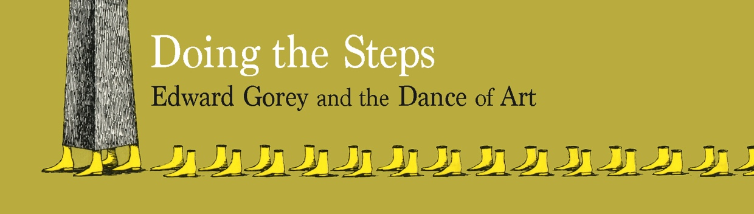

FOR IMMEDIATE RELEASE: MARCH 8, 2022
The Edward Gorey House opens its 2022 Season on Thursday, April 7, with:
Doing the Steps
Edward Gorey and the Dance of Art

The Edward Gorey House • 8 Strawberry Lane, Yarmouth Port, MA 02675
508-362-3909 • edwardgoreyhouse@verizon.net • www.edwardgoreyhouse.org
Contact: Gregory Hischak, Director/Curator

If you’re absolutely obsessed with something,
everything else seems meaningless.”
Edward Gorey to Anna Kisselcoff, NYTimes 1973

How do you explain the influence of dance on a visual artist? Probably, you show a lot
of that artist’s drawings of dancers, but in Edward Gorey’s case, it becomes quickly apparent that there’s a much bigger story to tell. Famous as an illustrator, set and costume designer, as well as book artist, playwright and collector, Gorey is also well-known in some circles as the man who attended the New York City Ballet every night for 30 years.

That is a startling feat and, to be honest, an urban legend as well. Edward Gorey did not attend every performance at the NYCB—but he saw more of them than probably anyone else, except maybe the NYCB’s choreographer and director George Balanchine. Ticket stubs stored at the House (and included in this exhibit) indicate about 160 shows a year, and frequently over 200 shows including virtually every annual Nutcracker performance for over thirty-plus years (including matinees). Not every show, but certainly a powerful testament to one man’s devotion to one ballet company and its choreographer.
In fact, it could be said that to really understand Gorey’s works one would have needed to sit through a lot of dance at the NYCB from approximately 1953 to 1979—give or take a few years. As this is no longer an option, Doing the Steps sets out to explore how dance comes to permeate so much of Gorey’s work.

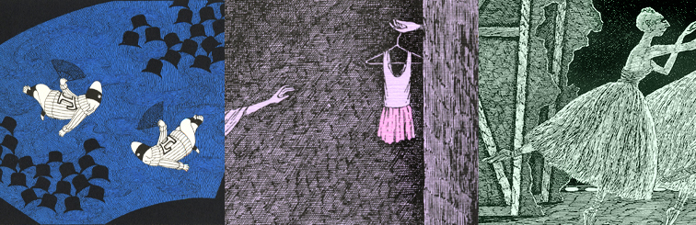

“Just do the steps” is probably Balanchine’s most famous remark (to his dancers). Properly considered, it somehow explains everything, and can be applied to whatever you can think of in both art and life.
Edward Gorey
1993 Ballet Review tribute to the dancer, Diana Adams

Gorey consistently cited George Balanchine as his greatest inspiration and muse—high praise from a man who borrowed liberally from Edward Lear, Lewis Carroll, Agatha Christie, the Symbolists, Dadaist, Surrealists and decades of film. This was not a collaborative relationship—Balanchine staged ballets and Gorey attended them. Gorey
was never asked to create a single set or costume design (in fact, Gorey passed up the award ceremony the night he won a Tony for Dracula’s costumes to attend the NYCB).
Doing the Steps explores both Gorey’s works relating directly to dance and the NYCB, as well as those demonstrating how Balanchine’s works became a vast creative reservoir for Gorey. Movement and pacing, the storyless stories and fragmented narratives —all aspects of Balanchine’s world—are reflected in Edward’s own works. In fact, Doing the Steps invites the notion that virtually all of Edward’s books function—as dance pieces.
Our 2022 exhibit is a celebration of the Edward Gorey House’s 20th season. We’ve designed Doing the Steps with only a rudimentary understanding of dance. Wild speculation has been invited to this dance party—but not so wild as to be implausible.

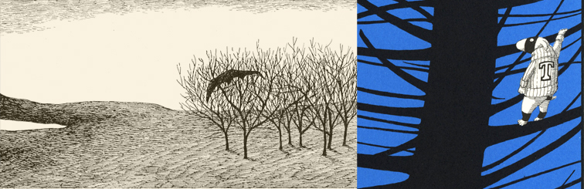

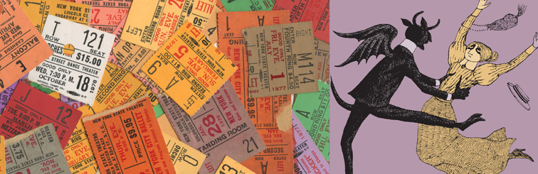

The House’s 2022 Season Covid policies will reflect guidelines and recommendations of the Town of Yarmouth as of April 7th. Proof of vaccinations are not required; facemasks will be mandatory at the start of our season and will be readdressed as needed. Tours are at the top of each hour (11am to 3pm; Noon to 3pm on Sundays) and, as capacity restrictions are currently still be in place, reservations are recommended but not required. Reservations can be made by emailing edwardgoreyhouse@verizon.net or calling 508-362-3909.

Additional Background Material about Edward Gorey
As an artist, Edward Gorey isn’t attached to a movement or a style, to a decade or even a century for that matter. Working in either New York or on Cape Cod for almost fifty years, Gorey’s work embraces a swath of Western arts & literature that includes Nonsense, Symbolism, Dada and Surrealism, while also reflecting the influence of Eastern arts, literature and philosophy. As a writer, illustrator, set and costume designer, his works are rife with the aesthetics of 19th Century engraving techniques, the cadences of an Agatha Christie novel and the visual dynamics of silent film. Twenty-one years after his death, Gorey’s work continues to remain several steps ahead of us.

2022 Hours for the Edward Gorey House are as follows: Spring Hours: April 7 to July 3:
Thu/Fri/Sat: 11am-4pm; Sun: 12-4pm. Summer Hours: July 6 to Oct 9: Wed thru Sat: 11am-4pm; Sun: 12-4pm. Fall/Winter Hours: Oct 14 to Dec 31: Fri/Sat: 11am-4pm; Sun: 12-4pm.
Reservations are not required—but recommended by calling 508-362-3909

House Admission: Adults: $8.00; Students, Teachers & Seniors: (65+): $5.00,
Children 6-12 years old: $2.00; Children under 6: free.

Images shown, and others, are available in high res upon request. Images used should include the credit Courtesy of the Edward Gorey Charitable Trust. For more information, please contact Gregory Hischak.

# # #

