



Time to Get Ready for the 2020 Season with
Hands-on Customer Service Training!

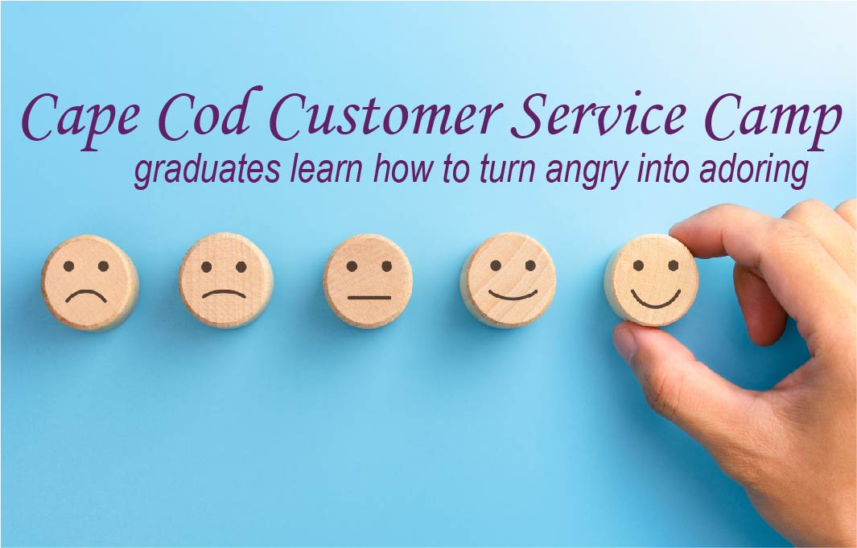



“Serving Your Success through Evidence-Based Training”

DID YOU KNOW…When your customers experience positive emotions during their customer service interaction, they are 15x more likely to tell their friends and 7x more likely to purchase your products or services?

At Cape Cod Customer Service Camp, your employees learn the
evidence-based tools they need to consistently boost your success:

Friday Mornings, 8:00 to 11:00 AM
2/28, 3/27, 4/24, 5/29, 6/5 & 6/26

Cape Cod Chamber Conference Room
5 Patti Page Way,
﻿Centerville, MA 02632
$99 per employee - group discounts available

Click Here to Register

Cape Cod Chamber of Commerce | 5 Patti Page Way, Centerville, MA 02632



