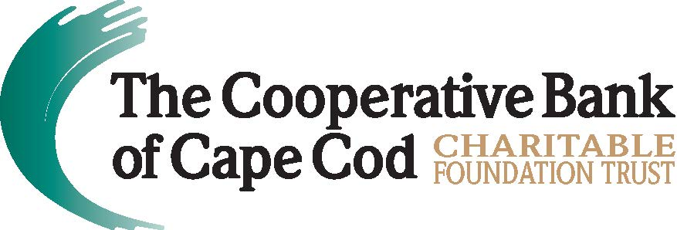

The Cooperative Bank of Cape Cod Charitable Foundation Trust
Awards $25,000 in Grants to Local Nonprofits
B FREE Coaching & Wellness, Falmouth Housing Trust, WE CAN and WellStrong Named Beneficiaries for Fourth Quarter of FY2023
Hyannis, Mass. (March 27, 2023) -- The Cooperative Bank of Cape Cod Charitable Foundation Trust (The Coop Foundation) has awarded $25,000 in grants to four local nonprofit organizations dedicated to enhancing the quality - and equality - of life in the communities it serves.
During the recent quarterly meeting of the Board of Trustees, the following grants were awarded:
- $10,000 to Falmouth Housing Trust for its New Project Fund, which is a critical resource for the organization to competitively engage in the current real estate market or have funds available to quickly act upon below-market housing opportunities. The Coop Foundation funds will be specifically used to support the Falmouth Housing Trust’s project to create four new affordable homes on Sam Turner Road, an expansion of an existing 18-home development that was built by the organization in the 1990s.

- $5,000 to B FREE Coaching & Wellness, which offers therapeutic programming that provides a critical intervention for residents of Barnstable County struggling with substance abuse disorder and mental illness. The grant will be used to support its suicide prevention programming, which includes an integrated approach to mental health services geared to marginalized communities including BIPOC, LGBTQ+, veterans and first responders, as well as those suffering from PTSD and trauma.

- $5,000 to WE CAN to increase access to its services to the diverse community of women living and working in the Mid-Cape area. The expansion will allow the organization to increase the number of legal, employment and financial counseling services and workshops; increase support services for women in crisis; and expand its network of volunteers to support program growth. This effort is a direct response to increased demand for WE CAN’s services for women from the Mid-Cape who now comprise approximately 40% of clients currently served by the organization.

- $5,000 to WellStrong, a fitness and wellness community for people in recovery from substance abuse disorder, The grant represents the second installment of a three-year $15,000 grant used to expand professional growth opportunities for members in recovery, promoting economic self-sufficiency by offering fitness certifications for five members per year for three years.
The new grants awarded mirror the bank’s corporate giving focus areas for fiscal year 2023 – Housing Initiatives and Solutions, and Social Justice and Racial Equity.
“The Coop is proud to support B FREE Coaching & Wellness, Falmouth Housing Trust, WE CAN and WellStrong, four deserving nonprofit organizations who are successfully and compassionately addressing critical needs throughout the region,” said Lisa Oliver, Chair, President and CEO, The Cooperative Bank of Cape Cod. “These organizations and their staff and volunteers work tirelessly to provide affordable housing, access to mental health services, support for substance abuse disorder, suicide prevention and counseling services to vulnerable and underserved populations on Cape Cod.”
In addition to the funds disbursed through The Coop Foundation, the bank recently pledged, through its Corporate Giving Program, a two-year commitment of $50,000 to the Women & Girls Fund at The Cape Cod Foundation.
“The Women & Girls Fund exists to help break the cycle of poverty by increasing economic opportunity and self-sufficiency for women through trainings and educational programs and break down barriers for girls by providing new, expanded, or more accessible educational opportunities, out-of-school programs, and mentorship opportunities,” said Kristin O’Malley, President and CEO of The Cape Cod Foundation. “Our community is aware of the need and with continued support, we can fuel initiatives that will redress systemic inequities and give women and girls new opportunities to thrive.”
About The Cooperative Bank of Cape Cod Charitable Foundation Trust
The Cooperative Bank of Cape Cod Charitable Foundation Trust is a 501(c)3 registered nonprofit in the state of Massachusetts with a mission to cultivate vibrant and thriving communities. Established in 2018, The Coop Foundation solidifies and formalizes The Coop’s commitment as a mutual bank to give back to the community, earmarking funds for philanthropy that won’t decrease according to the bottom line, but increase as the assets of the Trust grows. The Coop Foundation serves as an extension of the Bank’s current community giving program by enhancing and expanding it. For more information, please visit mycapecodbank.com/charitable-giving.
###

