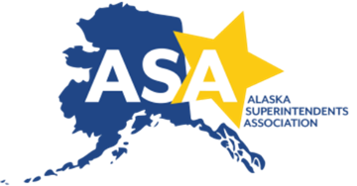
Alaska Superintendents Association
234 Gold Street • Juneau, AK 99801
907.586.9702 • (Fax) 907.364.3805

2026 Alaska Superintendent of the Year Nomination Form

The Alaska Superintendents Association (ASA) is pleased to offer you an opportunity to nominate a practicing superintendent for the 2026 ASA (state) and AASA (national) Superintendent of the Year program. Nominations may be made by anyone who has personal knowledge of an Alaska superintendent’s qualifications. Alaska Superintendent of the Year candidates should exemplify leadership for learning, strength in communication, professionalism, and community involvement. Nominees will be specifically evaluated using the following criteria:

- Leadership for Learning – creativity in successfully meeting the needs of students in his or her school system.
- Communication – strength in both personal and organizational communication.
- Professionalism – constant improvement of administrative knowledge and skills, while providing professional development opportunities and motivation to others on the educational team.
- Community Involvement – active participation in local community activities and an understanding of regional, national, and international issues.

You are invited to complete this form for a deserving superintendent. As the initiator of the nomination please:

- Complete this form as the primary nominator;
- Identify up to three additional persons who are supportive of the nominee and provide the names of these individuals; and
- Invite these additional persons to contribute a one-page supportive statement on behalf of the nominee.

Nominations and additional supportive statements must be received no later than Friday, July 18, 2025 by email at kmiller@alaskaacsa.org. If email is not possible, please mail to 234 Gold Street, Juneau, AK 99801.

If you have any questions about the process, please contact Dr. Lisa S. Parady, ASA Executive Director, at 907-586-9702 or lparady@alaskaacsa.org.

Name of nominated superintendent:

Name of person initiating this nomination:

Contact phone number:

Email address:

Relationship to candidate:

Names of additional persons providing supportive statements:

Statement on behalf of nominee (see criteria above):

