Leaving a Legacy
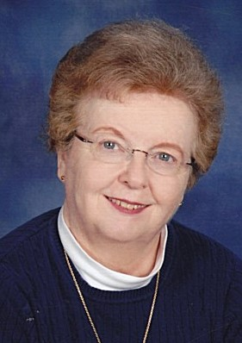
Janet Marie Keyes ‘67 loved everything about North Carolina Wesleyan…the sense of community and family, the campus, and the education and experiences it provided her. Being the fourth of ten children, Janet’s family says she probably loved it because she was away from home. Janet, born in Fulton, New York, lived with her family in Massachusetts, Ohio, Florida, Delaware and Virginia before coming to Rocky Mount, North Carolina in the Fall of 1963 to attend college at NC Wesleyan, following her brother, Thomas Keyes who had enrolled in 1961.
While at Wesleyan, Janet was involved in the SGA, serving as a senior class officer. She graduated with a Bachelor of Arts in History in 1967 and started her career teaching sixth grade in Leesburg, Virginia. She moved back to Rocky Mount where she worked for the Edgecombe County Department of Social Services in adoptions and foster care from 1969 until her retirement in 2006. Her family said she should have been a lawyer, because she could argue or debate quite well. Her siblings knew which topics to bring up just to get her started! But Janet had a great sense of humor and handled herself well.
She loved God and was faithful to her church, her family, and her friends. Faye Ellington Brady ’65, also a Wesleyan alumna, was one of Janet’s best friends. The two worked together from 1967 to 1972 and remained friends until Janet’s death. They frequently went to Elvis, Rod Stewart and Garth Brooks concerts. A love for the performing arts, Janet and Faye were both season ticket holders at The Dunn Center. They would invite others to attend with them. The two shared life together. Janet was the Godmother to Faye’s sons, John and David. Some of Faye’s fondest memories of Janet are the times they spent every Christmas baking cookies. Known for her peanut butter and sugar cookies, Janet always rolled out the cookie dough. Imagine the fun, fellowship and aroma of fresh baked cookies the two friends shared over the years.
Janet had a servant’s heart and always put others before herself, yet never boasting about what she had done. She mentored young women for Jobs for Life at her church, volunteered at the food bank and with Backpack for Buddies, and was a great neighbor to her elderly neighbor by taking her shopping and to visit her husband in the nursing home. After her retirement in 2006, Janet volunteered in the office of First United Methodist Church for years until she became ill and unable to do so.
Over the years, Janet’s love for NC Wesleyan never dwindled. She served on the Alumni Association Board for many years. She once stated she was going to quit and that turned into six more years serving on the board. A Day for Wesleyan volunteer, Janet generously gave not only of her time to her alma mater but she also donated to Wesleyan annually for forty years. Very early in her life, almost twenty years before she passed away, Janet made provisions for North Carolina Wesleyan. Janet Keyes went home to be with her Lord and Savior on June 6, 2021, still doing for others by leaving a part of her legacy at the school she loved.

