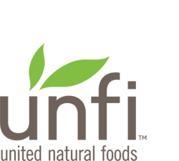

Friday, April 12, 2019

April 2019 Supplier Update

CBD
Due to the ambiguity and inconsistencies around CBD with respect to federal and state laws, UNFI has made the decision to only sell non-consumable CBD products in limited states with the provision that Suppliers sign specific agreements, give adequate insurance, and full indemnification. UNFI will also review labels and literature regarding the product to ensure that there are no claims suggesting that these products have psychotropic effects or will cure disease.
UNFI is not selling any consumable food, beverage, or dietary supplement containing CBD.
UNFI’s Legal Team has identified eight states where the risk of selling non-consumable CBD items is higher given legislation and/or enforcement activity at state and local levels in these states. This map identifies the states where UNFI has made the decision to suspend selling non-consumables until we have more clarity.
Reach out to Lisa Madsen at lmadsen@unfi.com with any questions.

