Christmas Tree Fundraiser
Orders due by Sunday, Nov. 8
Name/Phone # | 3/4’ tree $50 | 4/5’ tree $65 | 5/6’tree $110 | 6/7’tree $130 | 7/8’ tree $145 | 8 ring wreath $25 | 10 ring wreath $35 | 14 ring wreath $45 | 20 ring wreath $55 | 12 inch FF and WP Wreath $45 | 16” Door Swag $35 | Mailbox Huggie $30 | Large Cross $50 | Large mantle piece $30 | 25’WP garland $40 | 75’WP garland $75 | 25’ FF/WP mix garland $50 | 75’ FF/WP mix garland $80
Total

***Trees will either be Frasier Fir or Balsam Fir.***
FF=Frasier Fir; WP= White Pine; cross – 32x24; large mantle – 30”
Wreaths – 8 ring=16”; 10 ring=20”; 12 ring=22”; 14 ring=26”; 20 ring=32”
Make checks payable to Gray UMC.
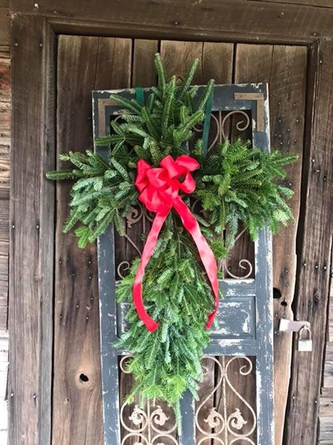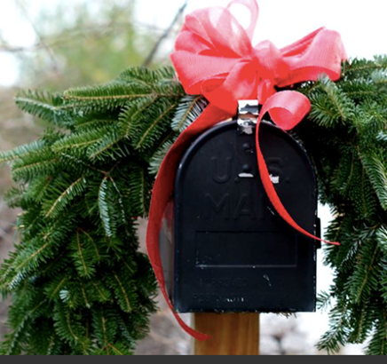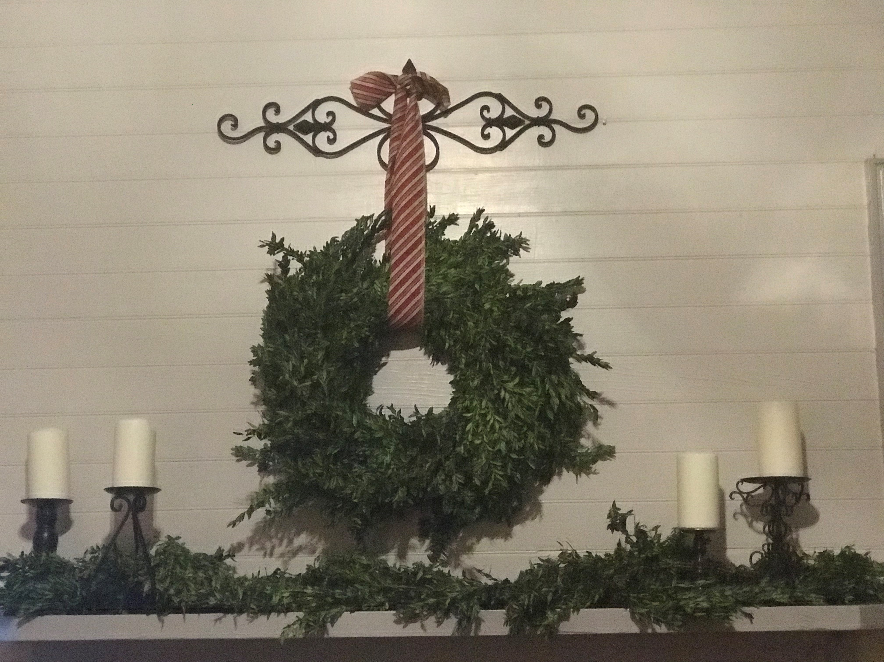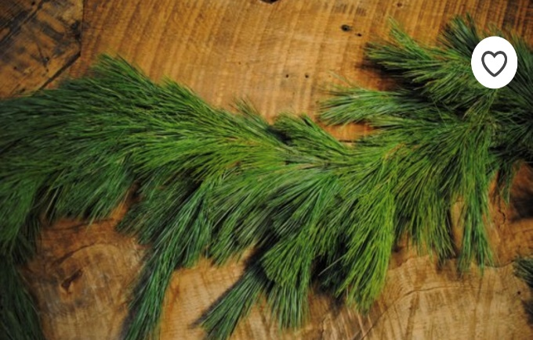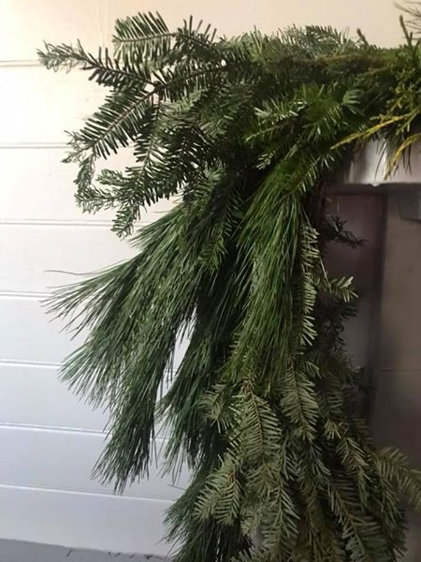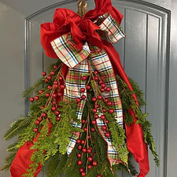
WP garland FF/WP mix garland 16” door swag

